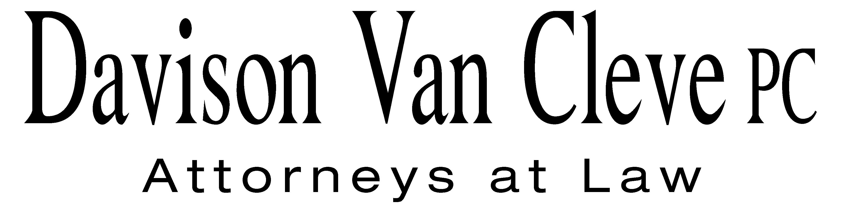
TEL (503) 241-7242 ● FAX (503) 241-8160 ● mail@dvclaw.com
Suite 400
333 SW Taylor
Portland, OR 97204

August 8, 2014

Via E-mail and Federal Express

Mr. Steven V. King
Executive Director
Washington Utilities and Transportation Commission
PO Box 47250
1300 S Evergreen Park Drive SW
Olympia, WA 98504-7250

Re: For an Accounting Order Authorizing Accounting Treatment Related to Payments for Major Maintenance Activities (UE-130583); Washington Utilities And Transportation Commission v. Puget Sound Energy (UE-130617); For an Order Authorizing the Sale of the Water Rights and Associated Assets of the Electron Hydroelectric Project in Accordance with WAC 480-143 and RCW 80.12 (Docket No. UE-131099); For an Order Authorizing the Sale of Interests in the Development Assets Required for the Construction and Operation of Phase II of the Lower Snake River Wind Facility (UE-131230) (consolidated)

Dear Mr. King:

Enclosed for the filing in the above-referenced dockets, please find the original and eight (8) copies of the Petition for Accounting Order of the Industrial Customers of Northwest Utilities.

Thank you for your assistance. If you have any questions, please do not hesitate to contact our office.

Sincerely,

/s/ Jesse O. Gorsuch
Jesse O. Gorsuch
Enclosures

cc: Service List

CERTIFICATE OF SERVICE

I HEREBY CERTIFY that I have this day served the attached Petition for Accounting Order of the Industrial Customers of Northwest Utilities upon all parties in these proceedings by causing a copy to be sent via electronic mail and First Class U.S. Mail, postage prepaid, to the following parties at the following addresses.
DATED in Portland, Oregon, this 8th day of August, 2014.
Davison Van Cleve, P.C.

/s/ Jesse O. Gorsuch
Jesse O. Gorsuch

Sally Brown  Assistant Attorney General  WUTC  PO Box 40128  Olympia, WA 98504-0128  sbrown@utc.wa.gov | Katherine Barnard  Puget Sound Energy, Inc.  P.O. Box 97034  Bellevue, WA 98009-9734  Katherine.Barnard@pse.com
Donna Barnett  Perkins Coie, LLP  10885 N.E. Fourth Street STE 700  Bellevue, WA 98004-5579  dbarnett@perkinscoie.com | Jason Kuzma  Perkins Coie, LLP  10885 N.E. Fourth St. STE 700  Bellevue, WA 98004-5579  JKuzma@perkinscoie.com
Simon ffitch  Lisa W. Gafken  Office of the Attorney General  800 Fifth Avenue STE 2000  Seattle, WA 98104-3188  simonf@atg.wa.gov  LisaW4@atg.wa.gov  Sheree Strom Carson  Perkins Coie, LLP  10885 NE Fourth Street  STE 700  Bellevue, WA 98004-5579  scarson@perkinscoie.com | Ken Johnson  Director, Rates & Regulatory Affairs  Puget Sound Energy (E012)  PO BOX 97034, PSE-08N  Bellevue, WA 98009-9734  ken.s.johnson@pse.com  Lisa A. Brautigam  Puyallup Tribe of Indians  3009 East Portland Ave.  Tacoma, WA 98404  lisa.brautigam@puyalluptribe.com

