Greetings,

The attached spreadsheets show staff's calculations in the Regulatory Services Staff Perspective Paper. I suggest that you start with:

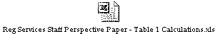

The following spreadsheets contain the Lurito Gallagher calculations set forth in Table 1.

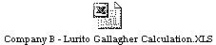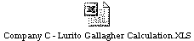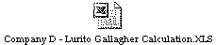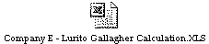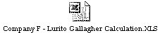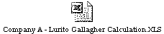

This is the spreadsheet to calculate the investment supported by operations.

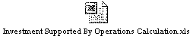

If you have any questions please contact Bob Colbo (360-664-1247) or me (360-664-1249)

Thank you,

Eugene K. Eckhardt
Assistant Director of Water and Transportation
Washington Utilities and Transportation Commission
PO Box 47250
Olympia, WA 98504-7250
Tel: (360) 664-1249
FAX: (360) 586-1150
E-mail: geckhard@wutc.wa.gov

