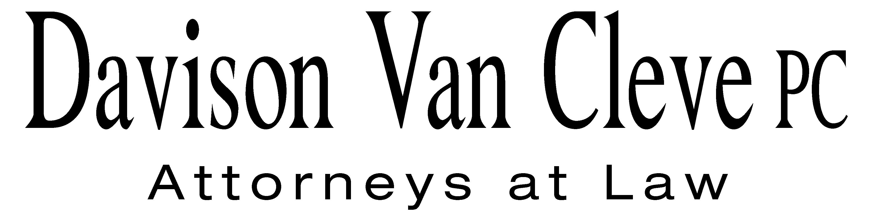
TEL (503) 241-7242 ● FAX (503) 241-8160 ● mail@dvclaw.com
Suite 400
333 SW Taylor
Portland, OR 97204

February 6, 2013

Via Email and Federal Express

Mr. David E. Danner
Washington Utilities and Transportation Commission
PO Box 47250
1300 S Evergreen Park Drive SW
Olympia, WA 98504-7250

Re: In the Matter of PUGET SOUND ENERGY, INC. Expedited Rate Filing
WN V-60, Tariff G, Electric Service, Advice No. 2013-01
Docket No. UE-130137

Dear Mr. Danner:

Enclosed please find an original and twelve (12) copies of the Petition to Intervene of the Industrial Customers of Northwest Utilities.

Additionally, please find an original and twelve (12) copies of the Notice of Appearance of Melinda J. Davison and Joshua D. Weber on behalf of the Industrial Customers of Northwest Utilities.

Thank you for your assistance.

Sincerely yours,

/s/ Sarah A. Kohler
Sarah A. Kohler
Enclosures

cc: Service List

CERTIFICATE OF SERVICE

I hereby certify that I have this day served the foregoing documents upon all parties of record in this proceeding by mailing a copy thereof in a sealed, first-class postage prepaid envelope to each individual’s last-known address, as listed below.
DATED this 6th day of February, 2013.
Davison Van Cleve, P.C.

/s/ Sarah A. Kohler
Sarah A. Kohler

PUGET SOUND ENERGY  KEN JOHNSON  PO BOX 97034 PSE-08N  BELLEVUE WA 98009-9734  ken.s.johnson@pse.com | PUBLIC COUNSEL  SIMON FFITCH  800 FIFTH AVENUE STE 2000  SEATTLE, WA 98104-3188  simonf@atg.wa.gov
WASHINGTON UTILITIES & TRANSPORTATION COMMISSION
GREG TRAUTMAN
PO BOX 40128
OLYMPIA, WA 98504
gtrautma@utc.wa.gov

