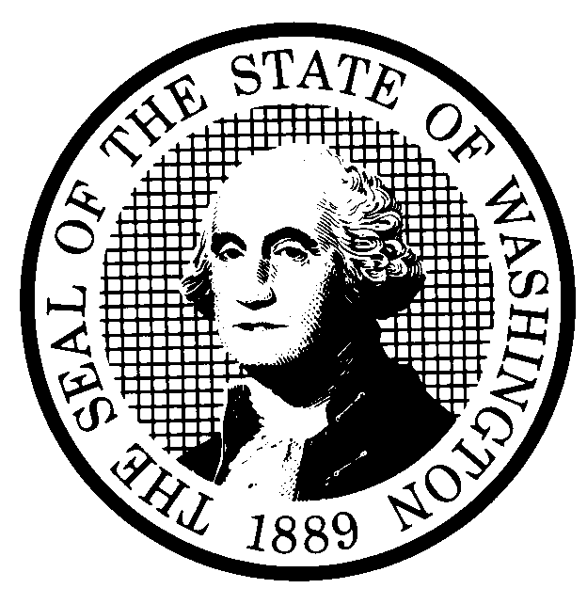 | PROPOSED RULE MAKING |  |  |  |  | CR-102 (June 2012)  (Implements RCW 34.05.320)  Do NOT use for expedited rule making
Agency: Washington Utilities and Transportation Commission
Preproposal Statement of Inquiry was filed as WSR 15-11-092; or  Expedited Rule Making--Proposed notice was filed as WSR ; or  Proposal is exempt under RCW 34.05.310(4) or 34.05.330(1). |  |  |  |  |  |  | Original Notice  Supplemental Notice to WSR  Continuance of WSR 15-22-105
Title of rule and other identifying information: (Describe Subject)

This rulemaking proposes amending rules in WAC 480-62, Railroad Companies – Operations. Docket TR-151079
Hearing location(s):  Commission’s Hearing Room 206  Second Floor, Richard Hemstad Building  1300 S. Evergreen Park Drive S.W.  Olympia, WA 98504-7250 |  |  |  | Submit written comments to:  Name:  Address:  e-mail  fax ( ) by (date)
Date: January 7, 2016 Time: 2:00 p.m. |  |  |  | Assistance for persons with disabilities: Contact  ______________ by  TTY ( ) or ( )
Date of intended adoption: January 7, 2016
(Note: This is NOT the effective date)
Purpose of the proposal and its anticipated effects, including any changes in existing rules:

The Washington Utilities and Transportation Commission (Commission) regulates public safety issues of railroads operating with Washington. Engrossed Substitute House Bill 1449, Chapter 274, Laws of 2015, adopts financial responsibility reporting requirements that railroads hauling crude oil must include in the annual reports they submit to the Commission. This proposal updates railroad annual reporting requirements on financial responsibility and safety standards for private crossings and provides opportunities for first-class cities to opt-in the commission crossing safety program.

The purpose of the continuance of WSR # 15-22-105 is to provide notice of a change in the date of the hearing to receive additional public comment regarding the adoption of the rule proposal in this docket. The date of the hearing has been changed from Wednesday, January 6, 2016, at 1:30 p.m. to Thursday, January 7, 2016, at 2:00 p.m.

Reasons supporting proposal: See above.
Statutory authority for adoption: RCW 80.01.040, RCW 81.04.160, RCW 81.24.010, RCW 81.44, RCW 81.53.010, and RCW 81.53.240 |  |  |  | Statute being implemented: N/A
Is rule necessary because of a:  Federal Law?  Federal Court Decision?  State Court Decision?  If yes, CITATION: |  | Yes  Yes  Yes | No  No  No |  | CODE REVISER USE ONLY
DATE
December 28, 2015
NAME (type or print)
Steven V. King
SIGNATURE
TITLE
Executive Director and Secretary

(COMPLETE REVERSE SIDE)
Agency comments or recommendations, if any, as to statutory language, implementation, enforcement, and fiscal matters:

None

Name of proponent: (person or organization) Washington Utilities and Transportation Commission |  |  | Private  Public  Governmental
Name of agency personnel responsible for:
 | Name | Office Location | Phone
Drafting............... Jason Lewis |  | 1300 S. Evergreen Park Drive SW, Olympia WA 98504 | (360) 664-1206
Implementation... Steven V. King |  | 1300 S. Evergreen Park Drive SW, Olympia WA 98504 | (360) 664-1115
Enforcement........Steven V. King |  | 1300 S. Evergreen Park Drive SW, Olympia WA 98504 | (360) 664-1115
Has a small business economic impact statement been prepared under chapter 19.85 RCW or has a school district fiscal impact statement been prepared under section 1, chapter 210, Laws of 2012?
Yes. Attach copy of small business economic impact statement or school district fiscal impact statement.

A copy of the statement may be obtained by contacting:
Name:
Address:

phone ( )
fax ( )
e-mail
No. Explain why no statement was prepared.

The proposed rules will not result in or impose more than minor costs. Because there will not be more than minor increases in costs resulting from the proposed rule changes, a SBEIS is not required under RCW 19.85.030(1).

Is a cost-benefit analysis required under RCW 34.05.328?

Yes A preliminary cost-benefit analysis may be obtained by contacting:
Name:
Address:

phone ( )
fax ( )
e-mail

No: Please explain:

The Commission is not an agency to which RCW 34.05.328 applies. The proposed rules are not significant legislative rules of the sort referenced in RCW 34.05.328(5).

