

Exhibit 10
Northwest Energy Efficiency Alliance
(NEEA)

2015

Report of Activities and Initiatives

March 1, 2016

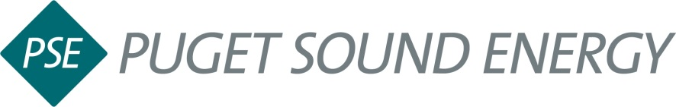

This page was intentionally left blank.

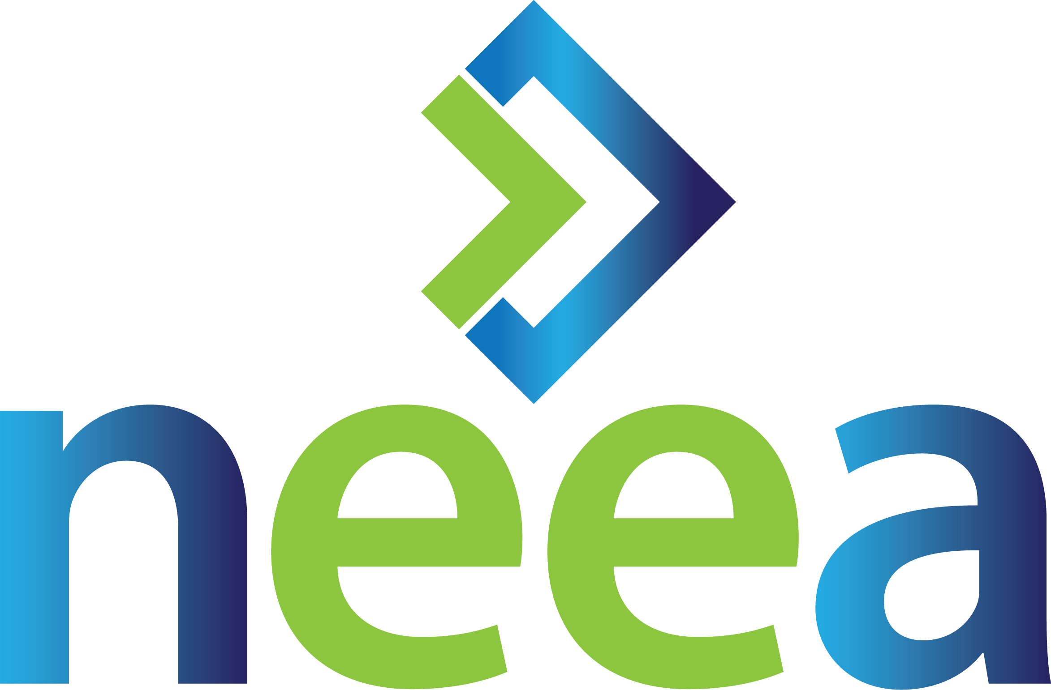

NEEA 2015 Annual Report for Puget Sound Energy
INTRODUCTION
The Northwest Energy Efficiency Alliance (NEEA) is a non-profit organization working in collaboration with Puget Sound Energy, the Bonneville Power Administration, Energy Trust of Oregon and more than 140 public and private Northwest utilities to accelerate the innovation and adoption of energy-efficient products, services and practices in the Northwest. On behalf of its funders, NEEA intervenes in the market to create lasting change by removing barriers or exploiting opportunities to accelerate the adoption of cost-effective energy efficiency.

NEEA’s vision is energy efficiency as a cornerstone of a vibrant and sustainable Northwest. Two interdependent strategic goals guide NEEA’s efforts to achieve this vision:

- Fill the Energy Efficiency Pipeline with new Products, Services and Practices
- Create market conditions that will accelerate and sustain the market adoption of emerging energy efficiency products, services, and practices.

This report summarizes NEEA’s 2015 regional energy efficiency activities on behalf of Puget Sound Energy. For additional information about NEEA’s programs or to read its 2015-2019 Business Plan, please visit www.neea.org.
GOAL 1: FILL THE ENERGY EFFICIENCY PIPELINE (ELECTRIC)
Ob behalf of the region, NEEA staff scan the market for emerging energy-efficient technologies (or services or practices) and review unsolicited proposals. New opportunities are screened against four criteria: energy savings, commercial availability, market potential, and potential for market transformation. Opportunities that meet all of these criteria are selected for further testing and investigation. These efforts are coordinated with Puget Sound Energy through the Regional Emerging Technology Advisory Committee, which NEEA staff facilitate.

2015 Emerging Technology Highlights
Scanning: In 2015, NEEA staff reviewed 13 unsolicited proposals and continued investigating a dozen other emerging energy-efficient technologies representing more than 1000 average megawatts (aMW) of 20-year potential energy savings for the region.
New Programs:
In 2015, NEEA staff prepared three programs, Manufactured Homes, Secondary Commercial Window Glazing and Commercial New Construction, for advancement in NEEA’s portfolio. Program teams are forming to prepare for each of these programs for Regional Portfolio Advisory Committee (RPAC) consideration and voting in 2016. These three programs represent an estimated total 20-year technical potential of 150 aMW for the region.
- Secondary Glazing Systems:
Product: High performance window cartridges mounted internally to existing window frames.
Market Intervention Strategy: Influence Attachment Energy Rating Council to adopt test method for Secondary Glazing Systems and to maintain performance data for available products on the market.

- New Construction – Code Advancement:
Product: Alternative language and options to code that enable easier code compliance and encourage more aggressive code changes.
Market Intervention Strategy: Leverage policy and market forces advancing toward net zero buildings to guide incremental codes changes that emphasize energy efficiency first. Evaluate technologies that meet more than one code requirement and offer additional energy savings benefits. Build understanding within the code community about the benefits of these technologies

- Manufactured Homes:
Product: Several tiers of higher performance manufactured homes
Market Intervention Strategy: Develop performance specification for tiers. Work with manufacturers and existing Northwest Energy Efficient Manufactured Housing Program (NEEM) infrastructure to test and address construction and market barriers to higher performance homes. Improve tracking of end location for new homes. Provide data and support for new Housing and Urban Development code.

Completed Research:
In 2015, NEEA staff commissioned and published 7 emerging technology research reports, all of which are available on neea.org.
- Combination Ductless Heat Pump and Heat Pump Water Heater Lab and Field Studies
- Secondary Glazing System Thermal, Moisture and Solar Performance Analysis and Validation
- Opportunities for Action on Industrial Energy Management Information Systems
- Residential Inverter-driven Heat Pump International Market Characterization
- Residential Inverter-driven Heat Pump Technical and Market Assessment
- Commercial New Construction Market Assessment
- Baseline Energy Modeling Approach for Residential M&V Applications

GOAL 2: CREATING MARKET CONDITIONS FOR ENERGY EFFICIENCY (ELECTRIC)

In partnership with Puget Sound Energy, NEEA identifies market barriers to the adoption of energy-efficient products, services and practices, and removes those barriers through strategic market interventions. NEEA’s 2015-2019 Business Plan directs NEEA to focus its market transformation efforts on four high-priority strategic markets: Residential New Construction, Residential Consumer Products, Commercial New Construction, and Commercial and Industrial Lighting.

REGIONAL MARKET STRATEGIES
In 2015, NEEA facilitated the developed a regional strategic market plan for the commercial and industrial lighting market. By coordinating efficiency investment and activity across the region, the plan will result in more targeted and coordinated program investments and deliver energy efficiency at an overall lower cost to the region. Puget Sound Energy’s Michael Lane, Supervising. Energy Management Engineer, was an active member of the collaborative that developed the Commercial and Industrial Strategic Market Plan, and continues to serve as a member of the steering committee that will oversee the plan’s implementation. Also in 2015, the region launched the development of the Consumer Products regional strategic market plan with NEEA staff acting as facilitator. Jeff Tripp, Manager of Residential Energy Management for Puget Sound Energy, is the co-chair of that collaborative.
CONSUMER PRODUCTS STRATEGIC MARKET
Heat Pump Water Heaters (HPWH) – On behalf of its funders, including Puget Sound Energy, NEEA works upstream with manufacturers, retailers and distributors to accelerate the market adoption of high-efficiency heat pump water heaters (HPWHs). Puget Sound Energy is a member of NEEA’s HPWH working group. In 2015, NEEA partnered with Puget Sound Energy on an in-store promotion of the GE GeoSpring Hybrid Water Heater aimed at driving sales by building customer awareness of utility rebates, and facilitated 112 HPWH Public Service Announcement spots in PSE territory to increase regional awareness. Also in 2015, NEEA staff launched an updated regional website (hotwatersolutionsnw.org), which provides enhanced and customizable integration with Puget Sound Energy’s website. On the technical side, NEEA staff advised Puget Sound Energy staff in establishing a rebate for 50-gallon GeoSpring units and provided replacement support, as needed, for AirGenerate units.

Ductless Heat Pumps (DHP) – In partnership with the region, NEEA is working to accelerate the adoption of inverter-driven ductless heat pumps in electrically heated homes by increasing availability, market capacity and consumer demand. In 2015, NEEA launched an updated Ductless Heat Pump regional website (GoingDuctless.com), which provides customizable integration with Puget Sound Energy’s website as well as resources for staff, the supply chain and consumers. Additionally, NEEA staff collaborated with Puget Sound Energy staff on strategy and tactics for a fall cross-promotion marketing opportunity and future program activities and Facilitated Puget Sound Energy’s participation in three supply chain training events. Finally, staff enrolled two new Master Installers serving Puget Sound Energy territory to ensure quality installations and support utility and customer satisfaction.
Retail Product Portfolio (RPP) Pilot – NEEA’s Retail Product Portfolio (RPP) initiative aims to leverage NEEA’s existing retail partnerships to expand energy-efficient retail product availability and drive efficient product manufacturing and standards. In 2015, NEEA agreed to participate in the national ENERGY STAR Retail Product Platform. Participating in the ENERGY STAR Retail Product Platform is an important step in gaining the scale necessary to influence the market and maximize savings. Puget Sound Energy is a member of the RPP Utility Work Group, which provides NEEA with broad-based advice, experience and feedback.
Super-Efficient Dryers – NEEA works with manufacturers to support the development, testing and introduction of super-efficient heat pump dryers. In 2015, NEEA staff provided data and analysis to the Regional Technical Forum to achieve Planning Unit Energy Savings for six tiers of electric residential clothes dryers, creating future pathway for Puget Sound Energy and other Northwest utilities to run their own dryer programs. Also in 2015, on behalf of the region NEEA partnered with Whirlpool Corporation and LG to provide incentives for the first residential heat pump clothes dryer available in the United States.
RESIDENTIAL NEW CONSTRUCTION
Next Step Homes –Through the Next Step Homes pilot, NEEA and Puget Sound Energy are identifying the most cost-effective methods to achieve maximum energy savings, while paving a pathway for future code adoption. Currently, there are more than 50 pilot homes located in Puget Sound Energy’s territory. In 2015, NEEA staff provided Puget Sound-area builders with technical support, emerging technology product information and training. Additionally, to better understand what motivates builders in the Puget Sound area to prioritize efficient homes, NEEA staff coordinated and attended a builder focus group in Seattle in June, 2015. Focus group results are available on neea.org.
At Puget Sound Energy’s request, NEEA staff completed a tiered savings analysis to explore five specification levels ranging from code to net-zero energy use in support of 2016 planning. NEEA staff also provided detailed cost information of the associated savings measures. Finally, in 2015, NEEA staff created the Efficient Homes Pilot Video in collaboration with Puget Sound Energy to educate consumers and promote the benefits of highly efficient homes. The video was used in a campaign from March 23 through May 26, significantly exceeding campaign goals and earning two national awards.
COMMERCIAL NEW CONSTRUCTION

Commercial Real Estate/ Existing Building Renewal – By engaging leading commercial real estate firms to adopt Strategic Energy Management (SEM) practices, NEEA and Puget Sound Energy are helping make energy efficiency competitive and quantifiable for commercial properties in the Puget Sound area. In 2015, NEEA recognized five leading commercial property management firms in the Puget Sound area for successfully adopting strategic energy management. Firms managing 48 million square feet of leased space achieved average annual electric savings of 4.5 percent and used utility incentives where available for 75% of implemented measures. Also in 2015, NEEA launched the Spark Building Renewal Tool (buildingrenewal.org), an online resource for commercial building owners in the Puget Sound Energy territory (and elsewhere) that provides a pathway for deep energy retrofits and supports decision-making. Finally, NEEA staff convened and led the region's first utility work group on commercial real estate, producing stakeholder input on program strategy and 12-18 month implementation roadmap.
COMMERCIAL LIGHTING
Luminaire-Level Lighting Controls (LLLC) – NEEA’s goal is to bring clarity to the luminaire-level lighting controls market by developing best practice specifications and influencing the technology’s adopted as standard industry practice. In 2015, on behalf of the region, NEEA staff collaborated with Design Lights Consortium to create a draft specification for advanced lighting controls. The draft was released to the public in September 2015 and the final specification will be completed in 2016. Puget Sound Energy is a member of the technical advisory committee for this initiative.
Reduced Wattage Lamp Replacement – NEEA’s commercial lighting initiative works upstream with lighting distributors to influence the stocking and sales practices of reduced wattage fluorescent lamps and drive consumer awareness and demand. In 2015, NEEA contracted with six electrical distributors in the Puget Sound territory. These distributors include: Platt Electric, Graybar, Pacific Lamp & Supply, Stoneway, Grainger and NorthCoast Electric. In aggregate, these six distributors touch sales upwards of 400,000 linear T8 lamps in Puget Sound Energy territory. During 2015, sales of low wattage fluorescent lamps sold in Puget Sound Energy territory increased from 8 percent to 20 percent across all T8 sales.

Commercial Lighting Regional Resources: To support Puget Sound Energy’s commercial lighting efficiency efforts, NEEA provides resources and tools aimed at building awareness, demand and capability for designing and installing energy-efficient commercial lighting. In 2015, NEEA staff updated the Lighting Layout Guide series, a best-practice tool for lighting professionals in the Northwest and launched Lighting Basics, a free on-line training that provides a comprehensive overview of lighting fundamentals for the commercial lighting retrofit market. Both tools and trainings can be found on the Northwest Lighting Network site: (nwlightingnetwork.com/tools).
OTHER MARKETS
Building Operator Certification (BOC) Expansion – Through the Building Operator Certification Expansion initiative NEEA provides training to improve building energy performance in the Puget Sound Energy territory through operation and maintenance best practices for HVAC, lighting, and controls systems. In 2015, NEEA staff documented an increase in market demand for building operator certification (BOC) in Washington State including sold-out classes and six new continuing education opportunities. Additionally, five new employers in the Northwest are recommending or requiring BOC certification, including Kidder-Mathews, one of the West Coast’s large real estate firms. Finally, King County, WA was the recipient of a 2015 Energy & Facilities Connection INNOVATION AWARD for adoption of BOC training and certification into the County’s professional development program for operating engineers, a direct result of the BOC Expansion initiative’s efforts to increase market demand.
Commercial and Industrial Strategic Energy Management – NEEA’s Commercial and Industrial Strategic Energy Management (SEM) Infrastructure Program provides a holistic set of tools that support utilities and the market to build market awareness, capability and demand for SEM. In 2015, NEEA staff worked to support Puget Sound Energy’s commercial and industrial SEM program efforts, including RCM, Bellevue Urban Smart, and others.
Certified Refrigeration Energy Specialist (CRES) Certification - Industrial refrigeration represents nearly nine percent of the Northwest’s industrial electric load. NEEA is working with utility and industry partners to build awareness and drive demand for Certified Refrigeration Energy Specialist certification. In 2015, NEEA developed and delivered a customized database to streamline the management of RETA’s (Refrigeration Engineers and Technicians Association) certification process. In exchange, RETA will provide quarterly data reports, which will allow NEEA staff to quantify program savings. In an effort to build market demand for certification training, NEEA staff created a CRES Utility Work Group to develop a regional strategy, ensure effective coordination and capitalize on synergies between CRES and utility programs.
Industrial Technical Training: To support the region’s industrial energy efficiency efforts and build market capacity, NEEA provides coordinated technical training on key industrial energy efficiency concepts. In 2015, Puget Sound Energy hosted two trainings in Bellevue with 56 total attendees. The training covered Energy Efficiency of Chilled Water Systems and Energy Efficiency of Cooling Towers. Additional training was provided through the program to 18 customers from 6 Puget Sound Energy facilities: 5 large industrial end-users, 2 non-industrial end-users, 3 consultant/energy professionals and 8 utility/public benefit administrators. Six Puget Sound Energy staff earned continuing education credits.
CODES AND STANDARDS
On behalf of the region, NEEA works at state and national levels to influence the adoption of increasingly stringent building energy codes and federal appliance and equipment standards. Working in collaboration with its partners, NEEA gives the Northwest a voice in codes and standards processes and is frequently the only efficiency organization directly representing utilities in these forums. NEEA also conducts and shares critical research in support of codes and standards work.
Energy Codes highlights for 2015 include:
- NEEA staff provided training to more than 832 people across Washington State, to influence higher code compliance rates and energy savings.
- NEEA staff supported the Washington 2016 code development process. The new energy code will be the most stringent in the nation when it takes effect on July 1, 2016.
- NEEA staff partnered with the Codes Innovation Database (CIDb) and Sustainable Connections to deliver a training in Bellingham addressing key elements of efficient hot water systems and how they may challenge the current codes in Washington.
Standards highlights for 2015 include:
- NEEA staff successfully influenced the final Department of Energy rule updating the energy conservation standard for General Service Fluorescent Lamps. On behalf of the region, NEEA participated in the rulemaking process and submitted comments in support. The new standard will save approximately 2.5 quads (1 quad = 293 million MWh) of energy and result in $627 million per year in net financial savings nationally.
- On behalf of the region, NEEA staff played a key role in the U.S. Department of Energy (DOE) negotiations that resulted in a new energy efficiency standard for commercial rooftop units: both rooftop air conditioners and warm air furnaces. This ruling represents the largest energy and pollution savings of any rule ever issued by the agency—and will benefit businesses and manufacturers in the Northwest. The new standard has two efficiency tiers that come into effect in 2018 and 2023, respectively.

NATURAL GAS MARKET TRANSFORMATION
In 2015, NEEA’s Board of Directors approved its first Natural Gas Market Transformation Business Plan for 2015-2019. The goal of the plan, which was developed collaboratively with Puget Sound Energy and others, is to accelerate the development and market adoption of efficient natural gas products, services, and practices, resulting in improved consumer choice and increased efficiency of natural gas use in the Northwest. This is the first regional effort to drive natural gas market transformation in the country. Participants include Puget Sound Energy as well as Avista Utilities, Cascade Natural Gas, Energy Trust of Oregon, and NW Natural. Fortis BC and the Northwest Gas Association are also represented on NEEA’s Natural Gas Advisory Committee.

2015 NATURAL GAS PORTFOLIO HIGHLIGHTS

Gas-fired heat pump water heaters: NEEA is working to accelerate product development of gas-fired heat pump water heater technology and to create market conditions that accelerate market adoption in order to influence a federal manufacturing standard. In 2015, NEEA completed a feasibility assessment for gas fired heat pump water heaters. Results show that the product design concept has the potential to save energy.

Combination space and water heating systems: NEEA seeks to create and leverage market partners to develop a combination space and water heating system at an efficiency exceeding current high-efficiency furnaces and stand-alone gas water heater technology. Doing so will ultimately create market momentum in the new construction and retrofit market to influence code. In 2015, NEEA launched prototype testing to evaluate the viability and performance of combination space and water heating system for natural gas customers.

Super-efficient gas clothes dryers: The goal of this program is to increase the market adoption of super-efficient, natural gas-powered clothes dryers to influence the enactment of more stringent ENERGY STAR specification and ultimately federal efficiency standards. In 2015, NEEA engaged a laboratory partner to assess baseline energy consumption and energy savings of efficient gas dryers.

Rooftop HVAC: NEEA seeks to increase market adoption of rooftop HVAC units containing gas-fired heating units in both new and retrofit markets. In 2015, NEEA launched a Rooftop HVAC pilot and installed baseline monitoring equipment on two of four site.
PROVIDING ENERGY EFFICIENCY SERVICES AND RESOURCES TO PUGET SOUND ENERGY
NEEA is the only alliance of public and private electric utilities with national and global upstream market partners that represents the entire four-state region in the Northwest. As a regional alliance, NEEA can leverage resources across the Northwest to accelerate energy efficiency. In 2015, NEEA pooled the investment of the region to conduct research and facilitate regional collaboration and information sharing on behalf of the region.
EVALUATION AND MARKET RESEARCH
NEEA conducts independent, third-party evaluations of all of its market transformation programs. Market research and evaluation drives NEEA’s program design, defines the challenges within its work, and provides critical market data and analyses about regional energy consumption for NEEA and its stakeholders. NEEA published 35 market research and evaluation reports in 2015, all of which are all publicly available at neea.org/reports.
REGIONAL SERVICES
EFFICIENCY Exchange – In March, 2015, NEEA co-hosted the annual Efficiency Exchange conference in collaboration with Bonneville Power Administration and the Northwest Power and Conservation Council. The regional conference, which provides a forum for energy efficiency professionals to share knowledge, explore emerging innovations and discuss the direction of utility efficiency programs, drew a sold-out crowd of 500 attendees, including 31 people from Puget Sound Energy.

ConduitNW.org – Developed in partnership with the Bonneville Power Administration, “Conduit” is an online community that facilitates information sharing, coordination and collaboration among energy efficiency stakeholders in the Northwest. Conduit allows Puget Sound Energy staff to share best-practices, learn about new technologies, promote events and leverage the collective knowledge of the region. Conduit currently has over 2,000 members across the Northwest, and 79 active users from Puget Sound Energy.
STAKEHOLDER ENGAGEMENT
NEEA’s programs are coordinated through regional working groups and advisory committees, whose membership includes representatives from Puget Sound Energy staff. The Regional Portfolio Advisory Committee (RPAC) is the body responsible for overseeing NEEA’s market transformation portfolio. NEEA staff formally solicit RPAC approval at critical program decision-points. In 2015, NEEA staff submitted two programs to RPAC for advancement votes, as well as the draft Regional Strategic Market Plan for Commercial and Industrial Lighting. In each case, RPAC voted unanimously in favor of going forward.
NEEA staff are grateful for the time and energy Puget Sound Energy staff have dedicated to participate in NEEA’s advisory committees:
Board of Directors: Bob Stolarski, Director, Customer Energy Management, NEEA Board Chair
Regional Portfolio Advisory Committee: Jeff Tripp, Manager, Residential Energy Management
Commercial Advisory Committee: Mark Lenssen, Supervising Engineer
Industrial Advisory Committee: Chao Chen, Supervising Industrial Energy Management Engineer
Residential Advisory Committee: Dennis Rominger, Market Manager
Emerging Technologies Advisory Committee: Rem Husted, Energy Management Engineer
Natural Gas Advisory Committee: Andy Hemstreet, EES Regulatory Compliance Consultant; Rem Husted, Consulting Energy Management Engineer
Cost Effectiveness Advisory Committee: Rebecca Blanton, Senior Market Analyst

ADDITIONAL INFORMATION

For additional information, NEEA’s 2015 Quarterly Performance Reports and the 2014 Annual Report are available online.

NEEA is committed to serving its regional stakeholders across diverse geographic areas and markets. We encourage stakeholder participation and appreciate input at all NEEA Board meetings, Advisory Committee meetings and energy efficiency events around the region. The next NEEA Board of Directors meeting is February, 2016, in Seattle, WA and the general public is invited to attend. Meeting details will be posted on neea.org in advance.

Please contact Virginia Mersereau, NEEA Communications Manager, at vmersereau@neea.org for any questions or comments about this report.

