United Telephone Company of the Northwest d/b/a CenturyLink
Section 2
WN U-11 1st Revised Sheet 2-41
Access Service Cancels Original Sheet 2-41
Washington

2. General Regulations  2.4 Payment Arrangements and Credit Allowances  2.4.8 Ordering, Rating and Billing of Access Services Where More Than One Exchange Telephone Company or Rate Schedule is Involved  B. (Cont’d)  7. When a Special Access Service, including those involving a Hub, but excluding those ordered as WATS Access Line Service, is ordered by a customer where both ends of the Channel Mileage element, an end of the Channel Mileage element and an interconnection point, an end of the Channel Mileage element and a Hub or interconnection point and a Hub are in the same Telephone Company operating territory and the same exchange but in different states which have different rate schedules, the Exchange Telephone Company will accept the order in either state except for orders involving Hubs. For orders involving Hubs, the order must be placed in the state where the Hub is located. An interconnection point will be determined by the Exchange Telephone Company and will be used to determine the billing for each state. All appropriate charges in each state rate schedule are applicable. The rate for the Channel Mileage element will be determined as set forth in 8., following.  8. The rate for the Transport or Channel Mileage element for services provided as set forth in 2. through 7., preceding is determined in as follows: When Terminating Tandem Switched Transport is provided through a CenturyLink Operating Company (CLOC) ILEC Access Tandem and the Terminating End Office is not owned by a CLOC ILEC or through an ILEC Access Tandem not owned by a CLOC ILEC and the Terminating End Office is owned by a CLOC ILEC, Terminating – Tandem 3rd Party rates are applicable; otherwise, Terminating – Tandem End Office rates are applicable. When originating Tandem Switched Transport is provided, Originating rates are applicable.  a. Determine the appropriate Transport or Channel Mileage by computing the airline mileage between the two ends of the Transport or Channel Mileage element. Determine the airline mileage for the Transport element using the V&H method as set forth in Section 6.7.11., following. Determine the airline mileage for the Channel Mileage element using the V & H method as set forth in United Telephone of the Northwest Private Line Transport Services Catalog.  b., Determine the rate for the airline mileage determined in a., preceding using the Telephone Company's tariff. Multiply such rate by the Telephone Company's billing percentage factor and divide by 100 to obtain the Transport element or Channel Mileage element charges.  9. The interconnection points will be determined by the Exchange Telephone Companies involved. | (C-N)  (N)

Advice No. WA 17-09A
Issued: May 31, 2017 Effective: July 1, 2017
By Phil Grate, Director – Washington (T)

United Telephone Company of the Northwest d/b/a CenturyLink
Section 2
WN U-11 1st Revised Sheet 2-42
Access Service Cancels Original Sheet 2-42
Washington

2. General Regulations  2.4 Payment Arrangements and Credit Allowances  2.4.8 Ordering, Rating and Billing of Access Services Where More Than One Exchange Telephone Company or Rate Schedule is Involved (Cont’d)  C. Example 1: Originating Switched Access  (See Diagram 1)  1. Layout  a. Feature Group C Switched Access is ordered to End Office.  b. Originating End Office and Access Tandem are in operating territory of a Telephone Company (TC-A).  c. Customer Designated Premises is in operating territory of a Telephone Company (TC-B).  - Assumptions:  • TC-A Direct Trunk Transport BP = 40%  • TC-B Direct Trunk Transport BP = 60%  • Direct Trunked Transport mileage = 26 mi.  • Tandem Switched Transport mileage = 23 mi.  Diagram 1  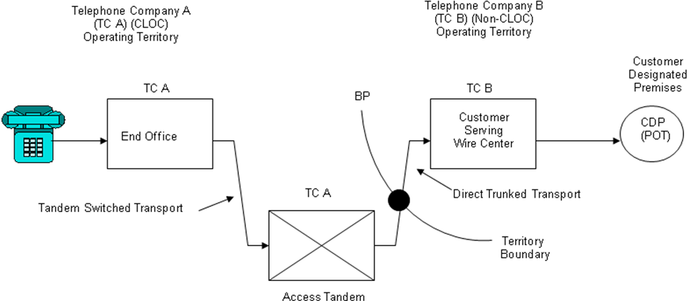 | (C)  (N)  (T)  (C)  (C)  (N)  (N)  (C)  (C)

Advice No. WA 17-09A
Issued: May 31, 2017 Effective: July 1, 2017
By Phil Grate, Director – Washington (T)

United Telephone Company of the Northwest d/b/a CenturyLink
Section 2
WN U-11 1st Revised Sheet 2-43
Access Service Cancels Original Sheet 2-43
Washington

2. General Regulations  2.4 Payment Arrangements and Credit Allowances  2.4.8 Ordering, Rating and Billing of Access Services Where More Than One Exchange Telephone Company or Rate Schedule is Involved  C. Example 1: Originating Switched Access (Cont’d)  (See Diagram 1)  - Telephone Company A charges are:  End Office charges = 9,000 min. x EO rate  Tandem Switched Facility charge  = 9,000 min. x 23 mi. x TSF rate  Tandem Switched Termination charge  = 2 terminations x 9,000 min. x TST rate  Tandem Switching charge  = 9,000 min x TS rate  Direct Trunked Facility charge  = 26 miles x DTF rate x 40%  Direct Trunked Termination charge  = 1 termination x DTT rate  Common Transport Multiplexing charge  = 9,000 min x CTM rate | (T)  (N)  (D)  (N)  (N)

Advice No. WA 17-09A
Issued: May 31, 2017 Effective: July 1, 2017
By Phil Grate, Director – Washington (T)

United Telephone Company of the Northwest d/b/a CenturyLink
Section 2
WN U-11 Original Sheet 2-43.1
Access Service
Washington

2. General Regulations  2.4 Payment Arrangements and Credit Allowances  2.4.8 Ordering, Rating and Billing of Access Services Where More Than One Exchange Telephone Company or Rate Schedule is Involved (Cont’d)  D. Example 2: Terminating Switched Access – Tandem 3rd Party  (See Diagrams 2A and 2B)  - Feature Group D Switched Access is ordered to End Office.  - Terminating Access Tandem is owned by CLOC ILEC carrier (TC-A) and End Office is owned by a non-CLOC ILEC carrier (TC-B)  - Assumptions:  • TC-A Direct Trunk Transport BP = 40% (where applicable Diagram 2A)  • TC-B Direct Trunk Transport BP = 60% (where applicable Diagram 2A)  • Direct Trunk Transport mileage = 26 mi.  • TC-A Tandem Switched Transport BP = 20%  • TC-B Tandem Switched Transport BP = 80%  • Tandem Switched Transport mileage = 23 mi. | (N)  (N)

Advice No. WA 17-09A
Issued: May 31, 2017 Effective: July 1, 2017
By Phil Grate, Director – Washington (T)

United Telephone Company of the Northwest d/b/a CenturyLink
Section 2
WN U-11 Original Sheet 2-43.2
Access Service
Washington

2. General Regulations  2.4 Payment Arrangements and Credit Allowances  2.4.8 Ordering, Rating and Billing of Access Services Where More Than One Exchange Telephone Company or Rate Schedule is Involved  D. Example 2: Terminating Switched Access – Tandem 3rd Party (Cont’d)  (See Diagrams 2A and 2B)  - Diagram 2A  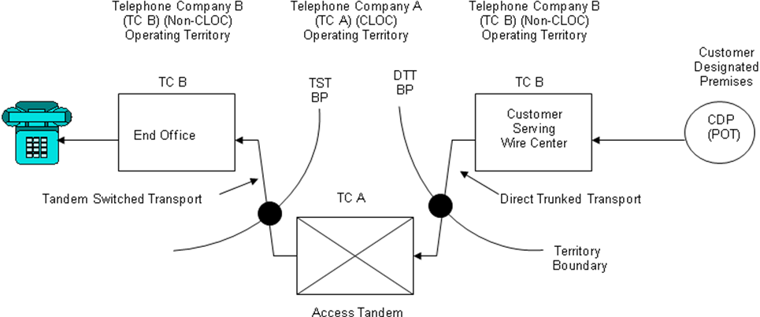  - Diagram 2B  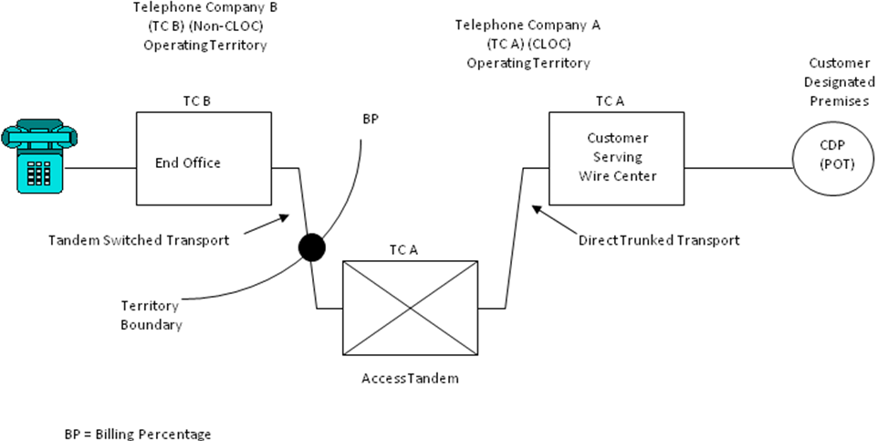 | (N)  (N)

Advice No. WA 17-09A
Issued: May 31, 2017 Effective: July 1, 2017
By Phil Grate, Director – Washington (T)

United Telephone Company of the Northwest d/b/a CenturyLink
Section 2
WN U-11 Original Sheet 2-43.3
Access Service
Washington

2. General Regulations  2.4 Payment Arrangements and Credit Allowances  2.4.8 Ordering, Rating and Billing of Access Services Where More Than One Exchange Telephone Company or Rate Schedule is Involved  D. Example 2: Terminating Switched Access – Tandem 3rd Party (Cont’d)  (See Diagrams 2A and 2B)  - Example 2 Telephone Company A charges are:  Tandem Switched Facility – 3rd Party charge  = 9,000 min. x 23 mi. x TSF-3rd Party rate x 20%  Tandem Switched Termination – 3rd Party charge  = 1 termination x 9,000 min. x TST-3rd Party rate  Tandem Switching – 3rd Party charge  = 9,000 min. x TS-3rd Party rate  Direct Trunked Facility charge  2A = 26 miles x DTF rate x 40%  2B = 26 miles x DTF rate  Direct Trunked Termination charge  2A = 1 termination x DTT rate  2B = 2 termination x DTT rate  Common Transport Multiplexing – 3rd Party charge  = 9,000 min x CTM-3rd Party rate | (N)  (N)

Advice No. WA 17-09A
Issued: May 31, 2017 Effective: July 1, 2017
By Phil Grate, Director – Washington (T)

United Telephone Company of the Northwest d/b/a CenturyLink
Section 2
WN U-11 Original Sheet 2-43.4
Access Service
Washington

2. General Regulations  2.4 Payment Arrangements and Credit Allowances  2.4.8 Ordering, Rating and Billing of Access Services Where More Than One Exchange Telephone Company or Rate Schedule is Involved (Cont’d)  E. Example 3: Terminating Switched Access – Tandem End Office  (See Diagram 3)  - Feature Group D Switched Access is ordered to End Office.  - Terminating End Office and Access Tandem are both owned by a CLOC ILEC (TC-A)  - Assumptions:  • TC-A Direct Trunk Transport BP = 40%  • TC-B Direct Trunk Transport BP = 60%  • Direct Trunk Transport mileage = 26 mi.  • Tandem Switched Transport mileage = 23 mi.  Diagram 3  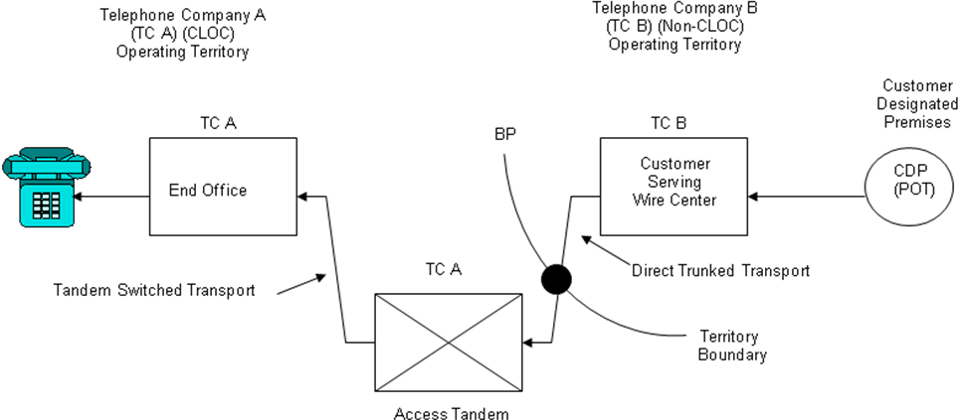 | (N)  (N)

Advice No. WA 17-09A
Issued: May 31, 2017 Effective: July 1, 2017
By Phil Grate, Director – Washington (T)

United Telephone Company of the Northwest d/b/a CenturyLink
Section 2
WN U-11 Original Sheet 2-43.5
Access Service
Washington

2. General Regulations  2.4 Payment Arrangements and Credit Allowances  2.4.8 Ordering, Rating and Billing of Access Services Where More Than One Exchange Telephone Company or Rate Schedule is Involved  E. Example 3: Terminating Switched Access – Tandem End Office (Cont’d)  (See Diagram 3)  - Telephone Company A charges are:  End Office Charges = 9,000 min. x EO rate  Tandem Switched Facility – End Office charge  = 9,000 min. x 23 mi. x TSF-End Office rate  Tandem Switched Termination – End Office charge  = 2 terminations x 9,000 min. x TST-End Office rate  Tandem Switching – End Office charge  = 9,000 min. x TS-End Office rate  Direct Trunked Facility Charge  = 26 miles x DTF rate x 40%  Direct Trunked Termination charge  = 1 termination x DTT rate  Common Transport Multiplexing – End Office charge  = 9,000 min x CTM-End Office rate | (N)  (N)

Advice No. WA 17-09A
Issued: May 31, 2017 Effective: July 1, 2017
By Phil Grate, Director – Washington (T)

United Telephone Company of the Northwest d/b/a CenturyLink
Section 2
WN U-11 Original Sheet 2-43.6
Access Service
Washington

2. General Regulations  2.4 Payment Arrangements and Credit Allowances  2.4.8 Ordering, Rating and Billing of Access Services Where More Than One Exchange Telephone Company or Rate Schedule is Involved (Cont’d)  F. Example 4: Originating Switched Access – CLOC owns only the End Office  (See Diagram 4)  - Feature Group D Switched Access is ordered to End Office  - End Office is owned by CLOC (TC-A)  - Access Tandem is owned by a non-CLOC ILEC (TC-B)  - Assumptions:  • Direct Trunk Transport mileage = 26 mi.  • TC-A Tandem Switched Transport BP = 80%  • TC-B Tandem Switched Transport BP = 20%  • Tandem Switched Transport mileage = 23 mi.  Diagram 4  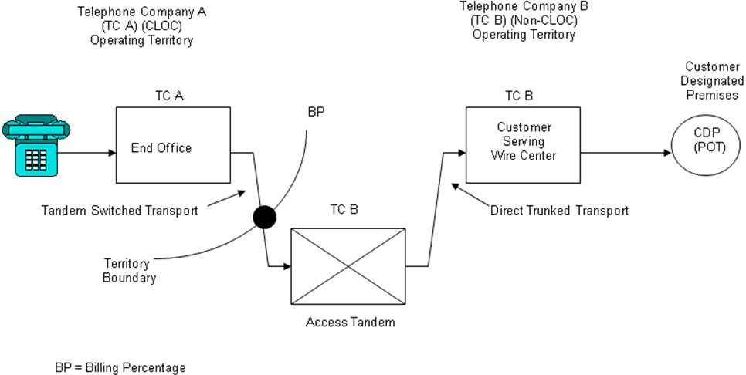 | (N)  (N)

Advice No. WA 17-09A
Issued: May 31, 2017 Effective: July 1, 2017
By Phil Grate, Director – Washington (T)

United Telephone Company of the Northwest d/b/a CenturyLink
Section 2
WN U-11 Original Sheet 2-43.7
Access Service
Washington

2. General Regulations  2.4 Payment Arrangements and Credit Allowances  2.4.8 Ordering, Rating and Billing of Access Services Where More Than One Exchange Telephone Company or Rate Schedule is Involved  F. Example 4: Originating Switched Access – CLOC owns only the End Office (Cont’d)  (See Diagram 4)  - Telephone Company A charges are:  End Office charges = 9,000 min. x EO rate  Tandem Switched Facility charge  =9,000 min. x 23 mi. x TSF rate x 80%  Tandem Switched Termination charge  = 1 termination x 9,000 min. x TST rate | (N)  (N)

Advice No. WA 17-09A
Issued: May 31, 2017 Effective: July 1, 2017
By Phil Grate, Director – Washington (T)

United Telephone Company of the Northwest d/b/a CenturyLink
Section 2
WN U-11 Original Sheet 2-43.8
Access Service
Washington

2. General Regulations  2.4 Payment Arrangements and Credit Allowances  2.4.8 Ordering, Rating and Billing of Access Services Where More Than One Exchange Telephone Company or Rate Schedule is Involved (Cont’d)  G. Example 5: Terminating Switched Access – Tandem 3rd Party  (See Diagram 5)  - Feature Group D Switched Access is ordered to End Office  - End Office is owned by Telephone Company (CLOC) (TC-A)  - Access Tandem is owned by a non-CLOC ILEC (TC-B)  Diagram 5  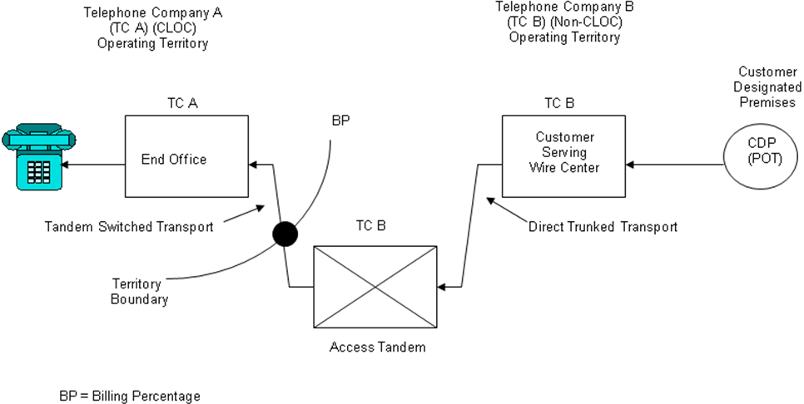 | (N)  (N)

Advice No. WA 17-09A
Issued: May 31, 2017 Effective: July 1, 2017
By Phil Grate, Director – Washington (T)

United Telephone Company of the Northwest d/b/a CenturyLink
Section 2
WN U-11 Original Sheet 2-43.9
Access Service
Washington

2. General Regulations  2.4 Payment Arrangements and Credit Allowances  2.4.8 Ordering, Rating and Billing of Access Services Where More Than One Exchange Telephone Company or Rate Schedule is Involved  G. Example 5: Terminating Switched Access – Tandem 3rd Party (Cont’d)  (See Diagram 5)  - Telephone Company A charges are:  End Office charges = 9,000 min. x EO rate  Tandem Switched Facility 3rd Party charge  = 9,000 min. x 23 mi. x TSF-3rd Party rate x 80%  Tandem Switched Termination 3rd Party charge  = 1 termination x 9,000 min. x TST-3rd Party rate | (N)  (N)

Advice No. WA 17-09A
Issued: May 31, 2017 Effective: July 1, 2017
By Phil Grate, Director – Washington (T)

United Telephone Company of the Northwest d/b/a CenturyLink
Section 6
WN U-11 1st Revised Sheet 6-20
Access Service Cancels Original Sheet 6-20
Washington

6. Switched Access Service  6.1 General  6.1.3 Rate Categories  A. Switched Transport (Cont’d)  3. Tandem Switched Transport  Tandem-Switched Transport provides the communication path between the access tandem and an end office that subtends that tandem, and includes tandem switching functions. Tandem-Switched Transport is available for use with all trunk side Switched Access services. Tandem-Switched Transport is not available for use with line side Switched Access services. For examples of Tandem Switched Transport see Section 2.4.8 preceding.  Tandem-Switched Transport provides for the transmission facilities between the access tandem and an end office that subtends the tandem. Tandem-Switched Transport is composed of four sub elements:  a. Tandem-Switched Transmission, which provides for the transmission facilities from the Telephone Company's access tandem switch to an end office subtending that tandem. This includes the transmission medium itself as well as certain circuit equipment that is used at the ends of the interoffice links and employed to derive the channels on the transmission medium, and circuit equipment used within the network to manage the circuits at intermediate locations.  Tandem-Switched Transmission rates consist of a Tandem-Switched Facility rate which is applied on a per mile band, per mile basis and a Tandem-Switched Termination rate which is applied per mile band at each end of each measured segment of the Tandem-Switched Facility (e.g., at the end office, FGA dial tone office, host office and tandem).  When the Tandem-Switched Transport Facility is zero (i.e., collocated serving wire centers), neither the Tandem-Switched Transport Facility (per mile) rate nor the Tandem-Switched Transport Termination (fixed) rate will apply. | (C)  (C)

Advice No. WA 17-09A
Issued: May 31, 2017 Effective: July 1, 2017
By Phil Grate, Director – Washington (T)

United Telephone Company of the Northwest d/b/a CenturyLink
Section 6
WN U-11 2nd Revised Sheet 6-136
Access Service Cancels 1st Revised Sheet 6-136
Washington

6. Switched Access Service  6.8 Rates and Charges  6.8.2 Switched Transport (Cont’d)  C. Tandem-Switched Transport  Monthly Rates  Termination (Fixed) Facility (Per Mile)  1. Tandem-Switched Transmission  • Zone 1 - Originating  - 0 $0.000000 $0.000000  - Over 0 to 8 0.000199 0.000020  - Over 8 to 25 0.000255 0.000022  - Over 25 to 50 0.000263 0.000023  - Over 50 0.000265 0.000023  • Zone 1 – Terminating- Tandem 3rd Party  - 0 $0.000000 $0.000000  - Over 0 to 8 0.000225 0.000025  - Over 8 to 25 0.000225 0.000025  - Over 25 to 50 0.000225 0.000025  - Over 50 0.000225 0.000025  • Zone 1 – Terminating – Tandem End Office  - 0 $0.000000 $0.000000  - Over 0 to 8 0.000107 0.000000  - Over 8 to 25 0.000107 0.000000  - Over 25 to 50 0.000107 0.000000  - Over 50 0.000107 0.000000  (M) Material moved to Sheet 136.1. | (C)  (N)  (N)  (M)  (M)

Advice No. WA 17-09A
Issued: May 31, 2017 Effective: July 1, 2017
By Phil Grate, Director – Washington (T)

United Telephone Company of the Northwest d/b/a CenturyLink
Section 6
WN U-11 1st Revised Sheet 6-136.1
Access Service Cancels Original Sheet 6-136.1
Washington

6. Switched Access Service  6.8 Rates and Charges  6.8.2 Switched Transport  C. Tandem-Switched Transport (Cont’d)  Monthly Rates  Termination (Fixed) Facility (Per Mile)  1. Tandem-Switched Transmission  • Zone 2 – Originating  - 0 $0.000000 $0.000000  - Over 0 to 8 0.000199 0.000020  - Over 8 to 25 0.000255 0.000022  - Over 25 to 50 0.000263 0.000023  - Over 50 0.000265 0.000023  • Zone 2 – Terminating – Tandem 3rd Party  - 0 0.000000 0.000000  - Over 0 to 8 0.000255 0.000035  - Over 8 to 25 0.000255 0.000035  - Over 25 to 50 0.000255 0.000035  - Over 50 0.000255 0.000035  • Zone 2 – Terminating – Tandem End Office  - 0 0.000000 0.000000  - Over 0 to 8 0.000110 0.000000  - Over 8 to 25 0.000110 0.000000  - Over 25 to 50 0.000110 0.000000  - Over 50 0.000110 0.000000  (M) Material moved from Sheet 136.  (M1) Material moved to Sheet 136.2. | (M)  (C-M)  (M)  (M)  (N)  (N)  (M1)  (M1)

Advice No. WA 17-09A
Issued: May 31, 2017 Effective: July 1, 2017
By Phil Grate, Director – Washington (T)

United Telephone Company of the Northwest d/b/a CenturyLink
Section 6
WN U-11 Original Sheet 6-136.2
Access Service
Washington

6. Switched Access Service  6.8 Rates and Charges  6.8.2 Switched Transport  C. Tandem-Switched Transport (Cont’d)  Rate Per Access Minute  Originating Terminating Terminating  3rd Party End Office  2. Tandem Switching  - Zone 1 $0.003306 $0.000150 $0.000150  - Zone 2 0.003306 0.000160 0.000160  3. Common Transport  Multiplexing  - Zone 1 0.000198 0.000225 0.000000 (R)  - Zone 2 0.000198 0.000240 0.000000 (R)  (M) Material moved from Sheet 136.1. | (M)  (C-M)  (N)  (M)  (C-M)  (C-M)  (M)  (M)  (C-M)  (C-M)

Advice No. WA 17-09A
Issued: May 31, 2017 Effective: July 1, 2017
By Phil Grate, Director – Washington (T)

United Telephone Company of the Northwest d/b/a CenturyLink
Section 6
WN U-11 5th Revised Sheet 6-144
Access Service Cancels 4th Revised Sheet 6-144
Washington

6. Switched Access Service

6.8 Rates and Charges (Cont’d)

6.8.3 Local Switching

Rate Per Access Minute

A. Premium Rates

- Originating $0.014441

- Terminating 0.000000 (R)

B. End Office Shared Port

- Originating 0.000590

- Terminating 0.000000

Monthly
Rates

C. End Office Dedicated Trunk Port[1]

- Per DS0 $ 2.42

- Per DS1, per channel 50.00

[1] The End Office Dedicated Trunk Port rate was calculated based upon a 50/50 split between originating and terminating traffic using this flat-rated port. The FCC in their FCC 11-161 ICC Transformation order in section 51.907(d)(1) allowed Price Cap Carriers to use an equal split to divide the charge between originating and terminating elements. When the terminating portion of the rate is reduced and then combined with the originating portion of the rate a single flat rate is generated for billing purposes. The Originating portion of the DS0 charge is $2.42 and the Originating portion of the DS1 charge is $50.00.

Advice No. WA 17-09A
Issued: May 31, 2017 Effective: July 1, 2017
By Phil Grate, Director – Washington (T)

