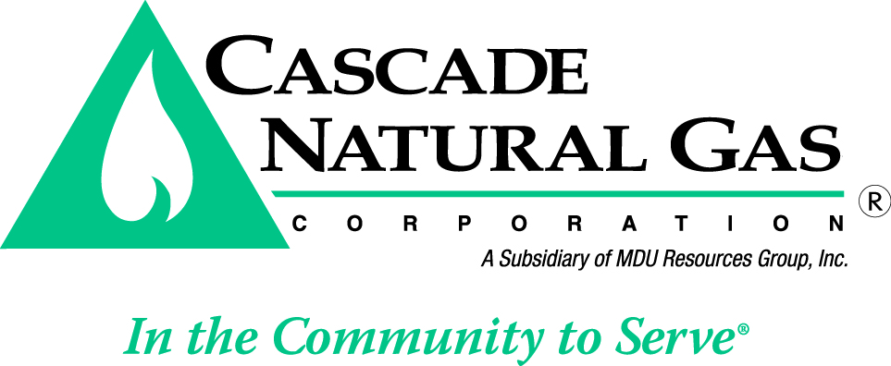

Important Tax Notice

Customers residing within the city limits of Sumas, Washington:

NOTICE OF ORDINANCE CHANGE – City Tax

The City Council of Sumas has imposed a new city tax on natural gas usage within the city limits under Ordinance No. 1682. The city council has imposed a natural gas use tax of 1 percent on the gross revenues. The amount of tax paid shall be limited to $500.00 per month.

The new natural gas use tax will be reflected in all bills of customers living within the city limits of Sumas rendered on and after July 1, 2016. The 1 percent Natural Gas Use Tax will be paid by the customers on their monthly billing statements as “City Tax”.
Customer Service: 1-888-522-1130
7 a.m.-7 p.m. Monday-Friday • www.cngc.com
06/16

