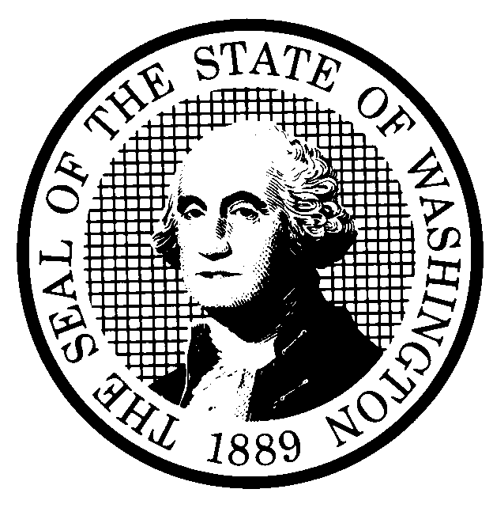 | PREPROPOSAL STATEMENT OF INQUIRY |  | CR-101 (June 2004)  (Implements RCW 34.05.310)  Do NOT use for expedited rule making
Agency: Washington Utilities and Transportation Commission
Subject of possible rule making: The Washington Utilities and Transportation Commission (Commission) initiates this rulemaking to consider amending WAC 480-120-021, Definitions; WAC 480-120-061, Refusing service; WAC 480-120-103, Application for service; WAC 480-120-174, Payment arrangements; repealing WAC 480-120-259, Washington Telephone Assistance Program, WAC 480-120-352, Washington Exchange Carrier Association (WECA), and adopting WAC 480-120-XXX a reinstatement of WAC 480-120-440, Repair standards for service interruptions and impairments, excluding major outages, repealed in 2015 and filed with the Code Reviser at WSR 15-08-043 under Commission Docket UT-140680.
This rulemaking has been assigned Docket UT-160196.
Statutes authorizing the agency to adopt rules on this subject: RCW 80.01.040, and RCW 80.04.160.
Reasons why rules on this subject may be needed and what they might accomplish:
The Commission needs to revise provisions in WAC chapter 480-120 as a follow up to the rulemaking in Docket UT-140680. The Commission inadvertently repealed WAC 480-120-440 in that proceeding, and the rule contained important service outage restoral requirements, as well as notice requirements related to planned outages. Other rules in WAC 480-120 contain cross-references to rules that were repealed. The Washington Telephone Assistance Program no longer exists, and rules related to that program are moot. Similarly, WECA has been discontinued because the Commission now handles WECA’s primary function of administering a universal service fund pursuant to rules in WAC chapter 480-123, so WAC 480-120-352 is unnecessary.
Identify other federal and state agencies that regulate this subject and the process coordinating the rule with these agencies: None
Process for developing new rule (check all that apply):
Negotiated rule making
Pilot rule making
Agency study
Other (describe) The Commission will ask for initial written comments, and will provide the opportunity for stakeholders to submit additional written comments on proposed CR-102 rules prior to adoption.
How interested parties can participate in the decision to adopt the new rule and formulation of the proposed rule before publication:
Interested persons may file comments with the Executive Director and Secretary, Washington Utilities and Transportation Commission, PO Box 47250, 1300 S. Evergreen Park Drive, Olympia, Washington, 98504-7250; Telephone (360) 664-1234; Fax (360) 586-1150, email at records@utc.wa.gov, or through the Commission’s Web portal at www.utc.wa.gov/e-filing by 5:00 p.m., April 4, 2016. For specific information regarding opportunities for written comments and to ensure receipt of further information concerning this rulemaking, please see the attachment to this form.
DATE  March 2, 2016 |  | CODE REVISER USE ONLY
NAME (TYPE OR PRINT)
Steven V. King
SIGNATURE
TITLE
Executive Director and Secretary

WASHINGTON UTILITIES AND TRANSPORTATION COMMISSION
CR-101 - ATTACHMENT
DOCKET UT-160196

Interested persons may contact the Executive Director and Secretary, Washington Utilities and Transportation Commission, P. O. Box 47250, Olympia, Washington, 98504-7250, 360-664-1174 (Fax: 360-586-1150).

WRITTEN COMMENTS
Written comments may be submitted to the Commission at the address given above and should be filed with the Commission no later than Monday, April 4, 2016.

Electronic copies. The Commission requests that comments be provided in electronic format to enhance public access, for ease of providing comments, to reduce the need for paper copies, and to facilitate quotations from the comments. Comments may be submitted via the Commission’s Web portal at www.utc.wa.gov/e-filing or by electronic mail to the Commission’s Records Center at records@utc.wa.gov. Please include:

- The docket number of this proceeding (UT-160196)
- The commenting party’s name
- The title and date of the comment or comments

An alternative method for submitting comments may be by mailing/delivering an electronic copy on a flash drive, DVD, or compact disk including the filed document(s). Parties must furnish electronic copies in MS Word 6.0 (or later) supplemented by a separate file in .pdf (Adobe Acrobat) format. Include all of the information requested above. The Commission will post on the Commission’s web site all comments that are provided in electronic format. The web site is located at http://www.utc.wa.gov/160196. If you are unable to file your comments electronically or to submit them on a disk, the Commission will always accept a paper document.

Opportunity for further comment is anticipated. Information about the schedule and other aspects of the rulemaking, including comments, will be posted on the Commission’s web site as it becomes available. If you wish to receive further information on this rulemaking you may (1) call the Commission’s Records Center at 360-664-1234, (2) e-mail the Commission at <records@utc.wa.gov>, or (3) mail written comments to the address above to the attention of Steven V. King, Executive Director and Secretary. When contacting the Commission, please refer to Docket UT-160196 to ensure that you are placed on the appropriate service list. Questions may be addressed to John Cupp (360) 664-1113 or e-mail at jcupp@utc.wa.gov.

TO CONTINUE RECEIVING NOTICES AND INFORMATION ABOUT THIS RULEMAKING -- The Commission wants to ensure its mailings are sent to persons who are interested in the topic and want to receive that information. ANY PERSON WHO COMMENTS will continue to receive notices and information. If you do not submit comments but wish to remain on the mailing list for this rulemaking, please advise the Records Center by any one of the following methods: (1) send a note with your name, address (or a copy of your mailing label), and telephone number referencing Docket UT-160196, and the words "Please keep me on the mailing list"; or (2) E-mail your name, address, and telephone number, referencing Docket UT-160196, and the words "Please keep me on the mailing list" to <records@utc.wa.gov>. Please note that all information in the mailings will be accessible through the Commission's Internet web site at <http://www.utc.wa.gov/160196>. THOSE INTERESTED PERSONS WHO DO NOT RESPOND MAY NOT RECEIVE FURTHER MAILINGS OR INFORMATION ON THE RULEMAKING.
NOTICE

