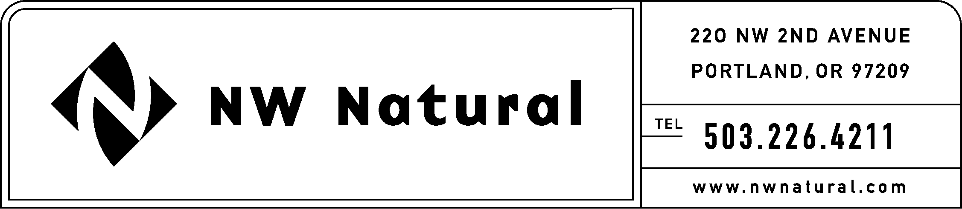
GAIL HAMMER
Rates and Regulatory Affairs
Phone: 503.226.4211 ext. 5865
Fax: 503.721.2516
gail.hammer@nwnatural.com

October 13, 2015

Steven King, Executive Director and Secretary
Washington Utilities and Transportation Commission
1300 S. Evergreen Park Drive, S.W.
P.O. Box 47250
Olympia, Washington 98504-7250

RE: UG-151776, NW Natural’s 2016 IRP Revised Work Plan
DO NOT REDOCKET

On August 28, 2015, NW Natural filed its 2016 IRP Work Plan with WUTC Staff in compliance with Washington Administrative Code (“WAC”) 480-90-238, which states,

(4) The work plan must outline the content of the integrated resource plan to be developed by the utility and the method for assessing potential resources.

and

(5) The work plan must outline the timing and extent of the public participation.

The Company now files a revised IRP Work Plan after determining that the 2015 Technical Working Group meeting agendas could be consolidated into 2016 Technical Working Group meeting agendas. The revised schedule will allow for more substantial meetings and more efficient use of stakeholder time. The remainder of the Work Plan is unchanged.

If you have any questions regarding this plan, please contact me at
1-503-226-4211, extension 5865.

Sincerely,

/s/ Gail Hammer

Gail Hammer
NW Natural

Enclosures

