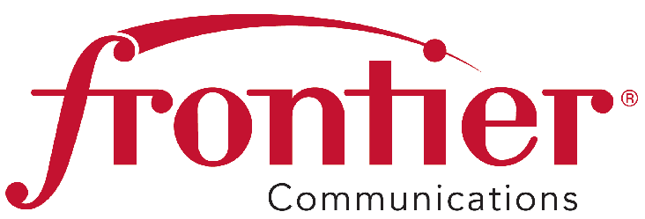
August 28, 2015

Frontier Communications Northwest Inc.

1800 – 41st Street
Suite N-100
Everett, WA 98203
Fax: 425-261-5262

Advice No. 3350

Mr. Steven King, Executive Director and Secretary
Washington Utilities and Transportation Commission
P. O. Box 47250
1300 S. Evergreen Park Drive SW
Olympia, WA 98504-7250

RE: WITHDRAWAL OF ADVICE NO. 3350 FILING; DOCKET NO. UT-151745

Dear Mr. King:

Per discussion with Commission Staff, Frontier Communications Northwest Inc., herby withdraws Advice Letter 3350, which was filed through the electronic-filing system (e-file) on August 25, 2015 and assigned Docket No. UT-151745.

Pursuant to WAC 480-80-103(4) and WAC 480-80-104(8), I certify that I am authorized to make this filing on behalf of the company. If you have questions regarding this filing, please contact Cathy Dahlquist at (425) 261-6380.

Sincerely,
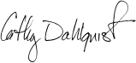
Cathy Dahlquist
Manager, Government & External Affairs

CD: lms
Enclosures

