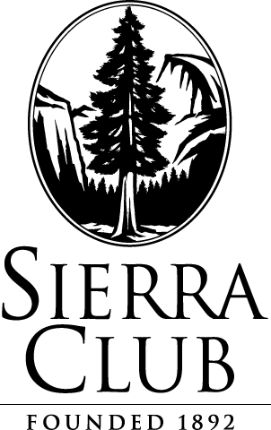
July 31, 2015

Via Electronic Filing and FedEx

Attn: Steven King, Executive Director and Secretary
Washington Utilities and Transportation Commission
1300 S. Evergreen Park Drive S.W.
P.O. Box 47250
Olympia, WA 98504-7250

Re: Sierra Club, Climate Solutions, and Washington Environmental Council’s Petition For an Adjudicatory Proceeding Relating to the Prudency of Continued Investments in Colstrip Plant Units 1 and 2.

Please find enclosed an original and 12 copies of the above captioned Joint Petition. This filing has been e-filed with the Commission and served upon parties via FedEx.
Please let me know if you have any questions. Thank you.

Respectfully submitted,

/s/ Alexa Zimbalist
Alexa Zimbalist
Legal Assistant
Sierra Club Environmental Law Program
85 Second St., 2nd Floor
San Francisco, CA 94105
(415) 977-5649
alexa.zimbalist@sierraclub.org

cc: Service List
85 Second Street, Second Floor San Francisco, CA 94105-3441 TEL: (415) 977-5649 FAX: (415) 977-5793 www.sierraclub.org

