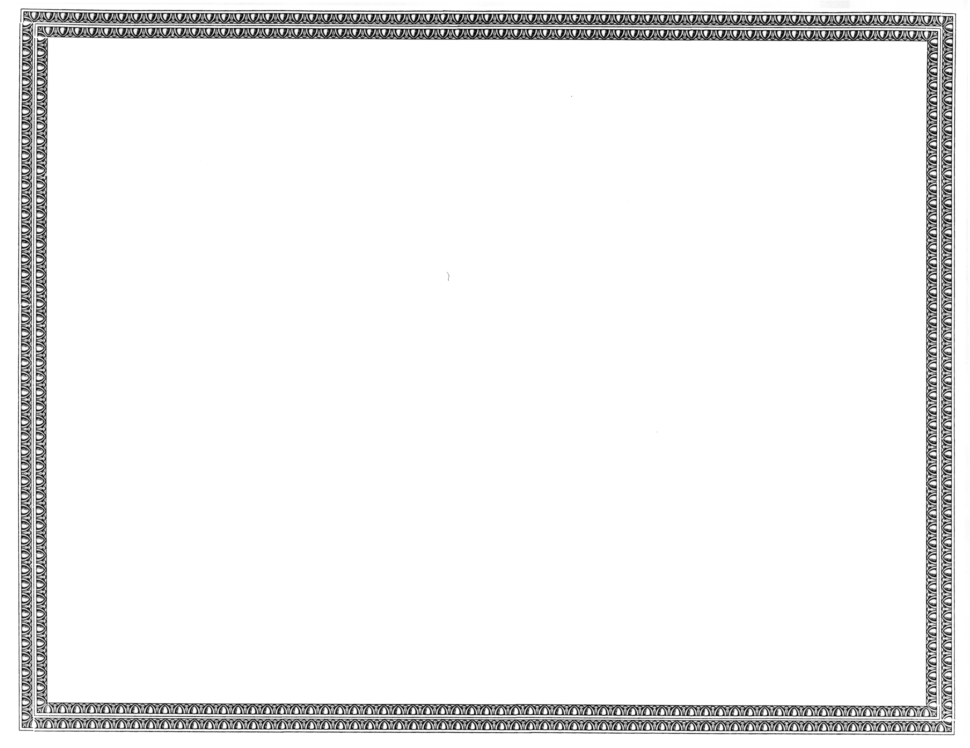



REGISTRATION
OF

New Century Telecom, Inc.

AS A COMPETITIVE
TELECOMMUNICATIONS COMPANY

Docket Number UT-130917 June 19, 2013
Effective Date

STEVEN V. KING

Acting Executive Director and Secretary

CERTIFICATE IS NOT TRANSFERABLE

