November 16, 2010

Mr. David Danner
Executive Director & Secretary
Washington Utilities and Transportation Commission
1300 S. Evergreen Park Drive SW
P. O. Box 47250
Olympia, Washington 98504-7250

RE: Avista Corporation Affiliated Interest Filing (Steam Plant Square LLC) pursuant to RCW 80.16.020.

Dear Mr. Danner:
Pursuant to RCW 80.16.020 and WAC 480-90-245, please find enclosed for filing an original and three copies of the “Multi Tenant Lease Agreement” between Avista Corp. and Steam Plant Square, LLC, an Affiliated Interest, for the Property Lease and Conditional Use Agreement by and between Avista and Steam Plant Square, LLC, an affiliate of Avista. The Multi Tenant Lease Agreement is attached hereto as Attachment A.
In 2007, the Company initiated a multi-year HVAC renovation project that involves replacing central air handling units and distribution systems in three buildings - the Spokane Service Center, the general office building, and the cafeteria auditorium building. The existing heating, ventilating, and air conditioning systems are approximately fifty years old and are in need of replacement. The project will also achieve asbestos abatement and life safety (fire sprinkler) additions. New controls will also be installed which will enable energy conservation. This project is currently planned to be completed in 2013. To complete this renovation, the building is being remodeled floor-by-floor, evacuating 23,000 square feet of office space. As a result displaced workers are being shifted to other floors, as well as one offsite location, Steam Plant Square, LLC, which is an Affiliated Interest pursuant to RCW 80.16.020 and WAC 480-90-245.
In accordance with WAC 480-07-160, Avista Corporation requests confidential treatment of the Details of Transaction provided in Attachment A. These exhibits are marked "Confidential.".
Please direct any questions regarding this filing to Liz Andrews at (509) 495-8601.

Sincerely,
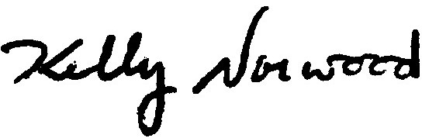
Kelly O. Norwood
Vice President, State and Federal Regulation
Enclosure

