SENT ELECTRONICALLY

August 30, 2007

Carole J. Washburn,
Executive Secretary
Washington Utilities and Transportation Commission
1300 South Evergreen Park Drive, S.W.
P.O. Box 47250
Olympia, Washington 98504-7250

Subject: Rulemaking to Consider Possible Corrections and Changes to Selected Rules in Chapter 480-93 WAC, Gas Companies – Safety, in Accordance with Changes in RCW Title 80 and 81. Docket PG-070975

Dear Ms. Washburn:

Thank you for the opportunity to comment on the Commission’s proposal to consider possible corrections and changes to selected rules in Chapter 480-93 WAC. Avista Utilities is interested in this rulemaking and looks forward to the opportunity to review the proposed changes when they are available for comment.

Sincerely,

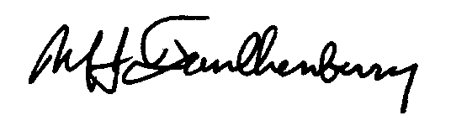

Michael J. Faulkenberry
Chief Gas Engineer

:jm

c: File
Jody Morehouse
Linda Burger
Linda Gervais
Collins Sprague

