 |  |  |  |  |  |  | Commission Docket No. |  |  |  |  |  |  |  | UT-030293
 |  |  |  |  |  |  | Agenda Date Assigned
BEFORE THE WASHINGTON UTILITIES AND TRANSPORTATION COMMISSION

LESS THAN REQUIRED NOTICE REQUESTED BY:

Verizon Northwest Inc. 313-013-420
(Utility Name) |  |  |  |  |  |  |  |  |  |  |  |  | (Utility UBI Number)
Utility proposes |  | Amendment No. 1 to the Agreement for Analog Video Service UT-030293 |  |  |  |  |  |  |  |  |  |  | Number |  | Contract No. 1337ICB
(Contract Title)

Indicate below, or attach, an explanation of the reason the company requests permission to file the proposed provisions with less than required notice.

Verizon Northwest respectfully requests this ICB contract become effective May 12, 2007 to avoid an interruption in service to the customer. With no provision to extend the term, if the Amendment No. 1 is not effective on or before May 12, 2007 service would have to be disconnected because the company can not provide service without an effective contract.

David S. Valdez-Sr. VP West, Public Affairs, Policy and Communications  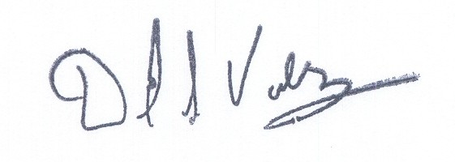 |  |  | is authorized to make filings on behalf of |  |  |  |  |  |  |  |  |  |  | Verizon Northwest Inc.
Signature and Title of Company Officer
I request these provisions become effective on |  |  |  | May 12, 2007
 |  |  |  |  |  |  |  |  | (Date)
 |  |  |  |  |  |  |  |  | Senior Vice President-West, Public Affairs, Policy and Communications
(Signature of Authorized Agent) |  |  |  |  |  |  |  |  | (Title)
David S. Valdez
(Print Name)
( 425 ) 261-5691 |  |  |  |  | (425 ) 261-5262 |  |  |  |  |  |  | David.s.valdez@verizon.com
(Telephone Number) |  |  |  |  | (Fax Number) |  |  |  |  |  |  | (E-Mail Address)
1800 41st St. MC: WA0105RA |  |  |  |  | Everett |  |  |  |  |  |  | WA |  |  |  | 98201
(Mailing Address) |  |  |  |  | (City) |  |  |  |  |  |  | (State) |  |  |  | (Zip Code)
WASHINGTON UTILITIES AND TRANSPORTATION COMMISSION

O R D E R
The Commissioners, having determined this order is consistent with the public interest, directed the Secretary to enter this order granting the provisions requested above.
DATED and signed at Olympia, Washington, this |  |  |  |  |  |  |  | Day of
 |  |  |  |  |  |  |  |  | (Month and Year)
 |  |  |  |  |  |  |  |  | Secretary
Util LRN Form 05/16/05

