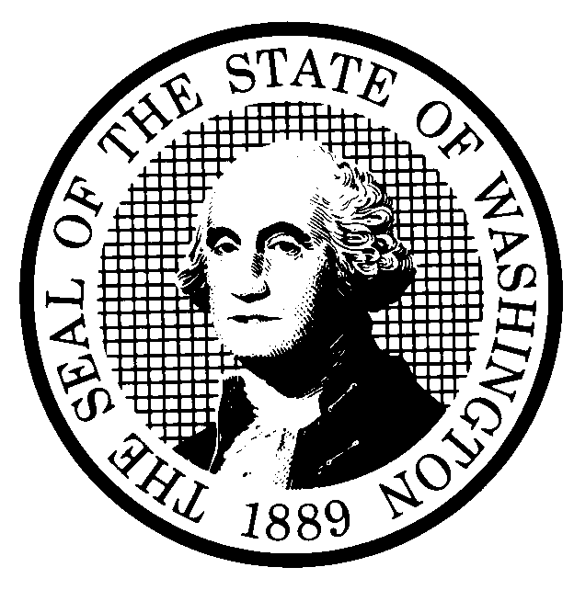 | PREPROPOSAL STATEMENT OF INQUIRY  (RCW 34.05.310) |  |  | CR-101 (7/22/01)  Do NOT use for expedited rule making
Agency: WASHINGTON UTILITIES AND TRANSPORTATION COMMISSION

Subject of possible rule making: Rules relating to natural gas pipeline operators will be reviewed for content and readability pursuant to Executive Order 97-02, with attention to the following criteria: Need, Effectiveness and Efficiency, Clarity, Intent and Statutory Authority, Coordination, Cost, and Fairness. All provisions currently codified in chapter 480-93 WAC might be affected. The review, under Docket No. UG-011073, will include consideration of whether substantive changes or additional rules are required for gas companies’ safety regulation generally, and in concert with the Federal Department of Transportation – Office of Pipeline Safety.

(a) Statutes authorizing the agency to adopt rules on this subject:
RCW 80.01.040 and RCW 80.04.160
(b) Reasons why rules on this subject may be needed and what they might accomplish:
Executive Order 97-02 requires agencies to review significant rules with attention to the criteria set out above. This includes reviewing whether current rules provide the results that they were originally intended to achieve and whether the rules are consistent with laws, and with appropriate and lawful policies.
(c) Identify other federal and state agencies that regulate this subject and the process coordinating the rule with these agencies: Federal Department of Transportation – Office of Pipeline Safety, and the Washington State Department of Ecology. The Commission will invite those agencies to participate actively in the rulemaking.
(d) Process for developing new rule (check all that apply):
Negotiated rule making
Pilot rule making
X Agency study
X Other (describe)
The Commission will ask for initial written comments by September 12, 2001, and will provide the opportunity for additional comments. The Commission will schedule one or more workshops with representatives of affected constituencies in a manner designed to develop consensus among affected interests regarding any rule proposal. The first workshop will be held on September 25, 2001.
(e) How interested parties can participate in the decision to adopt the new rule and formulation of the proposed rule before publication:
(List names, addresses, telephone, fax numbers of persons to contact; describe meetings, other exchanges of information, etc.)
SEE ATTACHED

 |  |  | CODE REVISER USE ONLY
NAME (TYPE OR PRINT)
CAROLE J. WASHBURN

SIGNATURE
TITLE  SECRETARY |  | DATE  8/9/01

WASHINGTON UTILITIES AND TRANSPORTATION COMMISSION
CR-101 - ATTACHMENT
DOCKET NO. UG-011073

(e) Interested persons may contact the Secretary, Washington Utilities and Transportation Commission, P. O. Box 47250, Olympia, Washington, 98504-7250, 360-664-1174 (Fax: 360-586-1150).

WRITTEN COMMENTS

Written comments may be submitted to the Commission at the address given above and should be filed with the Commission no later than September 12, 2001.
Electronic copies. The Commission also requests, but does not require, that comments be provided in electronic format to facilitate quotations from the comments, to enhance public access, and to reduce the need for additional paper copies. Please help us by sending an electronic copy with your paper filing on a 3-1/2 inch, IBM-formatted, high density disk, in .pdf Adobe Acrobat format, reflecting the pagination of your original. Also send us the text in your choice of .doc (Word 97 or later) or .wpd (Wordperfect 6.0 or later) and include all of the following information on the label of the diskette:
* The docket number of this proceeding (UG-011073)
* The commenting party's name
* The title and date of the comment or comments; and
* The type of software used
Please use the three-letter extension noted above for all electronic files. You may also send your comments by electronic mail to the Commission's Records Center at <records@wutc.wa.gov>; if you choose this means of submitting comments, include all of the information requested above for the diskette label. The Commission will post on the Commission's web site all comments that are provided in electronic format. The web site is located at <http://www.wutc.wa.gov>.
Opportunity for further comment is anticipated. Information about the schedule and other aspects of the rulemaking, including comments, will be posted on the Commission’s web site as it becomes available. If you wish to receive further information on this rulemaking you may (1) call the Commission’s Records Center at 360-664-1234, (2) e-mail the Commission at <records@wutc.wa.gov>, or (3) mail written comments to the address above to the attention of Carole J. Washburn, Secretary. When contacting the Commission, please refer to Docket No. UG-011073 to ensure that you are placed on the appropriate service list.

NOTICE OF WORKSHOP

A workshop will be held on September 25, 2001, beginning at 9:00 a.m., in the Commission’s Hearing Room, Second Floor, Chandler Plaza, 1300 S. Evergreen Park Drive S.W., Olympia, Washington. The Commission’s teleconference bridge line will be available for this workshop. A limited number of teleconference ports will are available and will be assigned one to an organization, first come first served. Persons wishing to attend via the teleconference bridge line must contact Kippi Walker at 360-664-1139 no later than 5:00 p.m., Friday, September 21, 2001. Questions may be addressed to Sondra Walsh at 360-664-1286 or e-mail at swalsh@wutc.wa.gov.

WASHINGTON UTILITIES AND TRANSPORTATION COMMISSION
CR-101 - ATTACHMENT
DOCKET NO. UG-011073

NOTICE

TO CONTINUE RECEIVING NOTICES AND INFORMATION ABOUT THIS RULEMAKING -- The Commission wants to ensure its mailings are sent to persons who are interested in the topic and want to receive that information. ANY PERSON WHO COMMENTS will continue to receive notices and information. If you do not submit comments but wish to remain on the mailing list for this rulemaking, please advise the Records Center by any one of the following methods: (1) send a note with your name, address (or a copy of your mailing label), and telephone and fax numbers referencing Docket No. UG-011073, and the words "Please keep me on the mailing list"; or (2) E-mail your name, address, telephone and fax numbers, referencing Docket No. UG-011073, and the words "Please keep me on the mailing list" to records@wutc.wa.gov. Please note that all information in the mailings will be accessible through the Commission's Internet web site at <http://www.wutc.wa.gov/>. THOSE PARTIES WHO DO NOT RESPOND MAY NOT RECEIVE FURTHER MAILINGS OR INFORMATION ON THE RULEMAKING.

