BEFORE WASHINGTON UTILITIES AND TRANSPORTATION COMMISSION

In the Matter of the Review of Unbundled Loop and Switching Rates and Review of the Deaveraged Zone  Rate Structure | )))))) | Docket No. UT-023003  JOINT DECLARATION OF STEVEN E. TURNER AND DAVID C. COOK IN SUPPORT OF MOTION TO STRIKE VERIZON COST MODEL

Steven E. Turner and David C. Cook, each having been duly sworn, depose and state as follows:
    - We, Steven E. Turner and David C. Cook, have been engaged by AT&T Communications of the Pacific Northwest, Inc., and MCI (formerly known as WorldCom, Inc.) to review the VzCost Model filed by Verizon with the Commission in this proceeding. We have extensive experience in analyzing cost models developed for use in estimating the forward looking costs of local telecommunications network elements. A brief resume setting forth the experience of Mr. Turner is attached as Exhibit A. A brief resume of Mr. Cook’s experience is attached as Exhibit B.
    - We have been attempting to analyze Verizon’s allegations in this proceeding regarding network element costs and investment since Verizon filed its direct case in June of 2003. This analysis has been hampered by Verizon’s failure to provide any reasonable access to its VzCost Model. When Verizon initially filed its model with the proceedings, it refused to provide us with any access to the model. In addition, it withheld substantial back-up information concerning the model. We were not able to obtain access to the VzCost Model or the confidential back-up information until August 11, 2003. Even then, Verizon retained certain of the confidential information filed with the Commission. We finally obtained the last of the withheld information on or about September 3, 2003.
    - We have made extensive efforts to review the VzCost Model since obtaining access to it on August 11. These efforts have been frustrated by the structure and instability of the model. Until August 26, 2003, we were unable to accomplish any meaningful review of the model. The reason for this is that the model generated numerous errors almost every time we attempted to review it or would lock up completely on occasion. Some of these problems were cured by a new model release issued by Verizon on August 26, 2003. Even now, however, the model continues to generate errors that prevent us from analyzing it. For example, on September 10, 2003, Verizon issued a new version of the model, version 3.1.4. Since that “upgrade” we have been unable to run the model’s VzLoop module. The model generates the following error after failure:

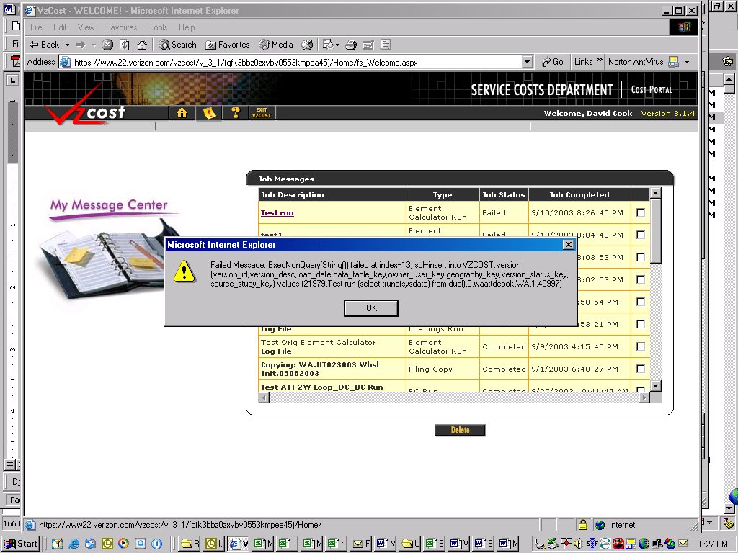

    - One of the reasons that VzCost is so unstable is that it is a new cost model. We understand that the model has been filed in only one other state to date. Although we have had substantial experience analyzing cost models, we are analyzing VzCost for the first time. We have spent substantial amounts of time simply attempting to understand the model. The model is not intuitive. There are numerous aspects of the model that cannot be determined unless a user has both extensive experience with web-based systems and databases and has thoroughly reviewed the user model provided by Verizon. The user manual itself is more than 700 pages. The process of learning to use the model, therefore, has been cumbersome, requiring substantial trial and error to produce results.
    - Even when we have been able to produce results from the VzCost model, we are not confident that those results are correct. In the first place, it takes approximately seven to eight hours to generate a model run. Simply performing a sensitivity run by changing one model parameter takes most of a business day. Moreover, even when run using Verizon’s original inputs and parameters, the model produces a large “exception log”. Typically such an exception log indicates that something unexpected occurred during the running of the model that could have created an error. We have also attempted to run the model making only one change to an input. The run generated a similar exception log. We therefore contacted the Verizon helpdesk for the VzCost model. We were advised by Verizon that the exception log is “normal” and that it was experienced during the model run filed in this case. In any run of the model, therefore, there is no way to tell whether errors have occurred, how severe the errors are, or how the errors may affect results.
    - The design of the model also makes changing it extremely difficult. Verizon has not provided the source code for the model, making it impossible to determine whether the logic inside the model matches the documentation provided by Verizon. Moreover, even with the source code, modifying VzCost is extremely cumbersome. For example, the model uses a compiled program called VzLoop for calculating loop costs. VzLoop is written in the Pascal computer language. The program accesses data in database tables to create loop investments. VzCost then takes these raw loop investments to create the cost elements used to generate unbundled loop costs. It is important for any expert analyzing the cost model to be able to modify the model’s calculations to determine how those modifications affect cost. This is extremely difficult with VzLoop. Modifying the program requires expert level competency in Pascal. Locating the proper algorithms to modify requires an extensive effort. To perform a valid modification, the expert must then understand all of the dependencies of the coded algorithm to the rest of the program. Even then, the process of compiling the code may introduce new sources of error. Given these complexities, it is impractical, if not impossible, for anyone other than Verizon’s own development team to modify the model.
    - Based on our extensive experience with cost models, it is our opinion that the Verizon VzCost model is not appropriate for use by the Commission in determining forward-looking costs for network elements. The model is cumbersome and opaque. It cannot be reliably analyzed or easily changed. All of these factors make the model unreliable in estimating costs.
    - It is not possible to complete any adequate review of the VzCost model in the time remaining before rebuttal testimony must be filed in this matter on October 3, 2003. If the Commission does not reject the VzCost model, we estimate that it will take at least three additional months to perform a meaningful analysis of the model, within the constraints described above.
We, and each of us, declare that the foregoing is true and correct under penalty of perjury under the laws of the State of Georgia.
Signed this 12th day of September, 2003, at Canton, Georgia.

STEVEN E. TURNER DAVID C. COOK

