BEFORE THE WASHINGTON UTILITIES AND TRANSPORTATION COMMISSION

THE BURLINGTON NORTHERN AND SANTA FE RAILWAY COMPANY,  Petitioner,  v.  CITY OF SPRAGUE,  Respondent.  . . . . . . . . . . . . . . . . . . . . . . . . . . . . . . . . . | )  )  )  )  )  )  )  )  )  )  )  )  )  ) | DOCKET NO. TR-010684  FOURTH SUPPLEMENTAL ORDER  FINAL ORDER REVERSING INITIAL ORDER; GRANTING PETITION TO CLOSE "D" STREET CROSSING, ON CONDITION

- Synopsis: In this final order, the Commission reverses an initial order and grants Burlington Northern and Santa Fe Railway Company’s amended petition to close the "D" Street crossing in Sprague, Washington, subject to conditions.

- INTRODUCTION

- Nature of Proceeding: Docket No. TR-010684 involves an amended petition by Burlington Northern and Santa Fe Railway Company ("Burlington Northern" or "BNSF") for permission to close one of two at-grade crossings in the City of Sprague, Washington.

- Appearances: Daniel Kinerk, attorney, Seattle, Washington, represents Burlington Northern. Sylvia Fox, Mayor of the City of Sprague, represents the City of Sprague. Jonathan Thompson, Assistant Attorney General, represents Washington Utilities and Transportation Commission Staff ("Commission Staff" or "Staff").

- Procedural History: Burlington Northern initially filed its petition to close the "D" Street at-grade railway crossing in the City of Sprague on May 8, 2001. The Commission set the matter for a prehearing conference to take place on March 26, 2002. At the prehearing conference the parties agreed to a schedule calling for evidentiary and public hearings to take place in May 2002. The hearings were continued, at the request of the City of Sprague, until September 2002. On September 12, 2002, Burlington Northern filed an amended petition seeking, in the alternative, to close either the "D" Street crossing or a crossing at "F" Street.

- The Commission convened an evidentiary hearing upon due and proper notice to all interested parties before Administrative Law Judge Theodora M. Mace on September 18 and 19, 2002, in Sprague, Washington. A hearing to receive testimony from members of the public took place on September 18, 2002, in Sprague, Washington. In addition to 28 exhibits submitted during the evidentiary hearing, Burlington Northern submitted a post-hearing exhibit pursuant to a bench request made during the hearing, and Commission Staff submitted a post-hearing exhibit consisting of letters about the proposed crossing closure submitted by members of the public.

- Initial Order: The initial order proposed that the Commission deny the petition to close the "D" Street or the "F" Street at-grade railway crossings in the City of Sprague, finding that the risks of alternative routes outweighed danger at the crossing.

- Petition for Administrative Review: BNSF filed a timely petition for administrative review on November 8, 2002, challenging the findings of the initial order and asking that the Commission reverse the order and close the "D" Street crossing. Its arguments are reflected in the discussions in this Order.

- Answers to petition: No party of record filed an answer to the petition for administrative review. The matter is therefore ready for review and decision by the Commission.
- Conclusion: The Commission grants the petition for administrative review and reverses the initial order, finding the evidence to demonstrate that the dangers of maintaining the "D" Street crossing outweigh both the benefits of allowing the crossing to remain open and the dangers and inconveniences of closure. As conditions of closure, the Commission directs the construction and maintenance of a pedestrian crossing at the site of the current "D" Street crossing, directs removal of the signal facility and ballast on Railroad Avenue near the crossing to improve access for trucks at the Grange facility on "D" Street, and requires that the railroad maintain both Railroad and First streets (frontage roads on the north and south side of the BNSF tracks, respectively), open between "B" and "F" Streets .

FACTUAL BACKGROUND

- Sprague is a city with a population of approximately 500, located about 40 miles southwest of Spokane. It is located in a rural area of eastern Washington in which farming is the principal industry.

- Burlington Northern operates a main line track and two siding tracks that run east and west through Sprague. Three streets running north and south in Sprague currently cross the Burlington Northern line at grade. These are "B,", "D,", and "F" Streets. The "B" Street crossing is the easterly of the three, and the "F" Street crossing the furthest west. The crossings are approximately 600 feet apart. See, Fig. 1 (Ex. 18). The Commission closed crossings at "C" and "E" Streets in 1987 by orders in Cause Nos. TR-2005 and TR-2006.

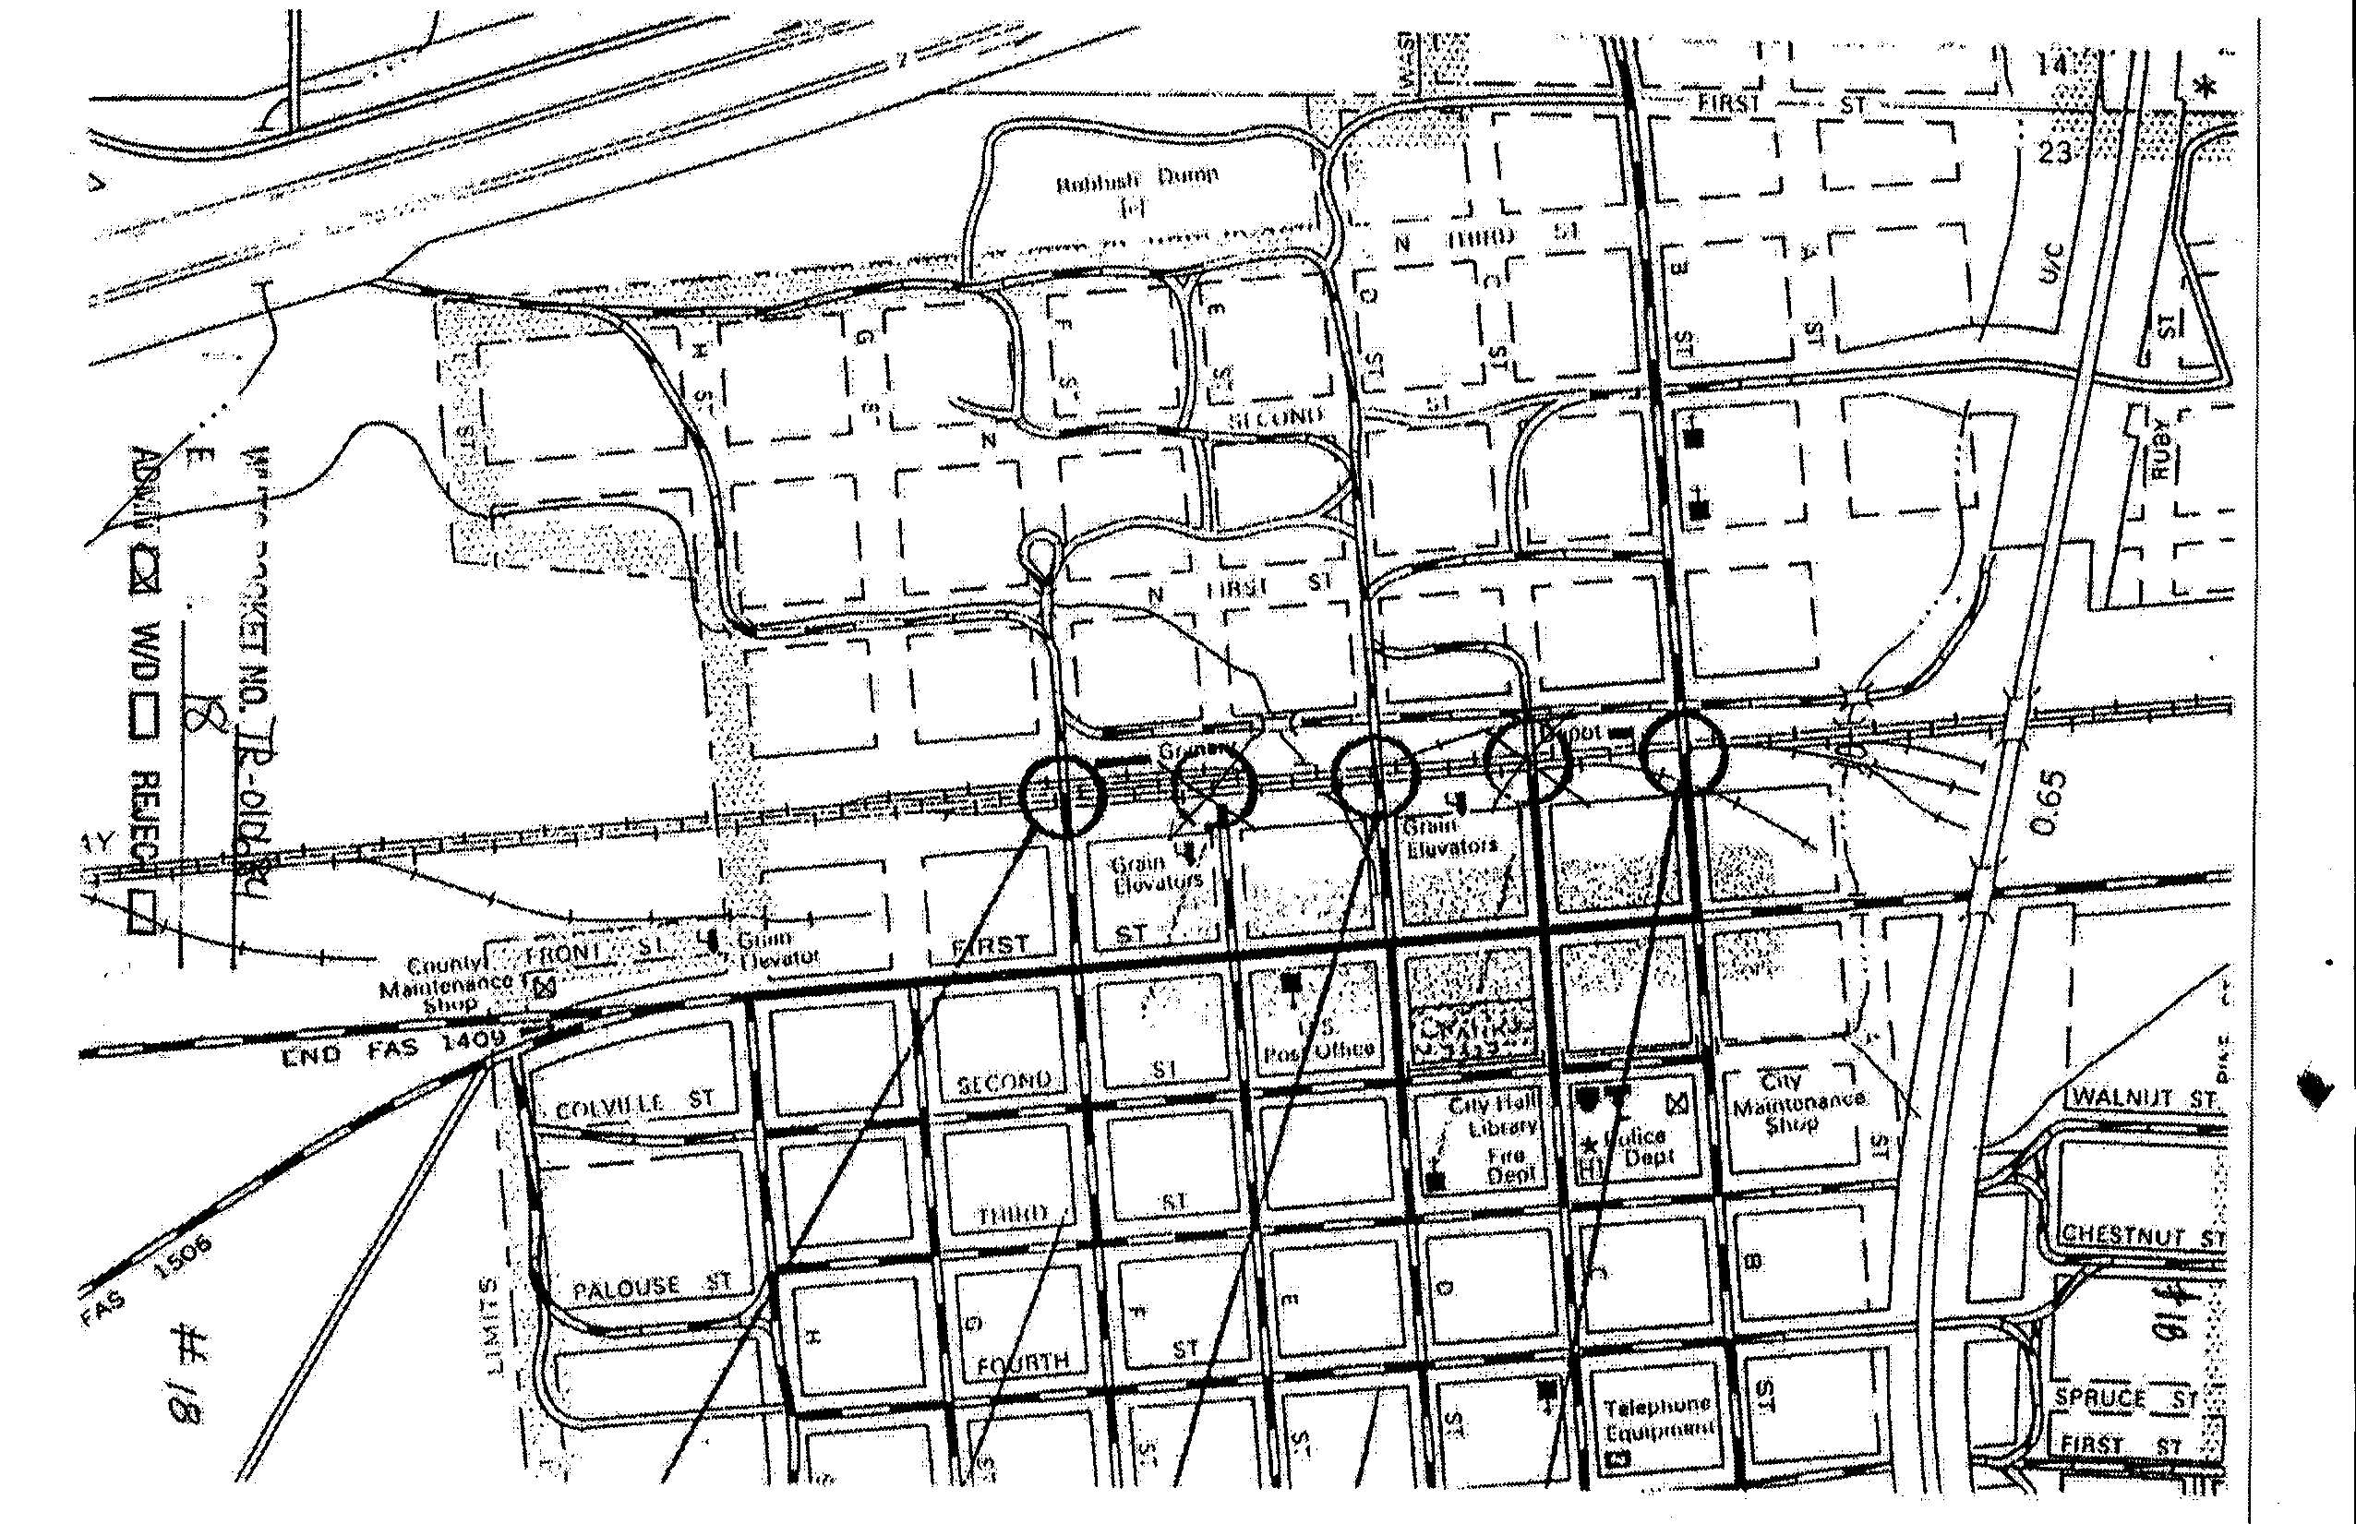
- Fig. 1. This map shows the orientation of tracks and crossings in Sprague, Washington. The circles show the locations of present and past railroad grade crossings in Sprague. From the left, they are "F" Street (open); "E" Street (closed); "D" Street (open); "C" Street (closed); and "B" Street (open). "F" and "D" Streets are the subjects of this petition to authorize closure.

- A railroad-owned unpaved roadway exists as an east-west frontage road immediately to the north of the tracks. Railroad Street offers public access to properties facing the tracks. Railroad Street crosses a bridge between "E" and "F" streets. The bridge has a six-ton load limit, which prevents use of the road by many trucks and emergency vehicles that exceed the weight limit.

- The BNSF operates one main line track through Sprague. Approximately 27 to 30 trains per day travel through the city, including two Amtrak passenger trains, at 45 miles per hour. The length of freight trains is determined in part by the number of cars they contain, and the trains that pass through Sprague average 5,000 to 7,000 feet in length. In addition to the main line, there are two siding tracks to the south of the main line. The track farthest south serves the grain elevators, and grain cars are left ("spotted") on the tracks during the harvest season, before and after they are filled. Railroad maintenance equipment is also placed on those tracks. The middle track of the three is a siding that is used by a way freight (a train that makes frequent stops).

- Most of the developed part of Sprague lies to the south of the railway. A new school is also south of the railway line, in the southwest corner of the city, most easily reached from the north by crossing the tracks at "F" Street. Some residences, a church and a baseball field are north of the railway. The town anticipates further development to the north because that is where vacant land is available, and also because that land is on higher ground. Further development south of the railway is hampered by a flood plain in that part of the city.

- The city has designated "D" Street as an emergency route. The fire department and other emergency response facilities are located on "C" Street south of the railway line and use both the "D" Street crossing and the "F" Street crossing to reach the north part of the town.

- The Grange, one of Sprague’s main businesses, is located north of the railway tracks at the northeast corner of the intersection of "D" Street and Railroad Avenue, although testimony indicates that all or a majority of the Grange activities will move to a location south of the tracks.

- Forty-two percent of vehicle-train collisions in the United States from 1997 to 2000 occurred at railroad crossings with active warning devices, such as those at the "D" and "F" Street crossings. This is consistent with other statistics in the U.S. Department of Transportation, Federal Railroad Administration Annual Report 2000.

- Gary Larsen, a Burlington Northern locomotive engineer and volunteer with the company’s Operation Lifesaver education program, testified. If a train is going 55 mph, it takes a mile for it to come to a stop. Approximately 30 trains per day run through Sprague, traveling at 45 mph. In 2001, 3,502 train-vehicle collisions occurred at protected crossings in the United States. Of those, 38 occurred in Washington State. Testimony at 110-112.

- In response to the concern about the high incidence of collisions at gated crossings, the Federal Railroad Administration ("FRA") and Burlington Northern have implemented a program to close unnecessary at-grade gated crossings.

- The Sprague Grange Supply store located north of the tracks on "D" St. could experience some inconvenience associated with closing the "D" Street crossing, but plans exist to move most or all of the store activities to the southeast part of town. Even if the Grange remained at the corner of "D" Street and Railroad Street and the "D" Street crossing were closed, Burlington Northern agrees to remove a signal bungalow to the south of the Grange in order to enhance the access of truck traffic to the Grange.

- While there have been no incidents or accidents at any of the Sprague crossings that BNSF witness John Michael Cowles is aware of, the probability of accidents at protected crossings continues to represent a sufficient public safety concern to warrant closure of such a crossing when reasonable alternatives are readily available.

- Ahmer Nizam appeared as a witness on behalf of Commission Staff. Closing the "F" Street crossing could create problems because the load limit on the bridge on Railroad Street could be a barrier to some traffic, and pedestrians depend on crossing the railroad tracks at "F" Street on the way to the school. "B" and "D" Streets, each within 600 feet of the other, are redundant. Mr. Nizam acknowledged, however, that "D" Street is currently designated as a primary route for emergency vehicles to reach the north side of town.

- While recommending closure of the "D" Street crossing, Mr. Nizam expressed concern about the impact on the Grange Supply business located at "D" Street and Railroad Street north of the tracks. The Grange is a significant source of income in the city and, if customers and suppliers experience inconvenience in approaching or leaving the business, they might take their business to competitors of the Grange. However, trucks leaving the Grange would be able to exit by turning right, or north, on "D" Street and then turning right on Alder, a street running east and west just north of the Grange Supply store, based on his personal observation of the width of the streets at that intersection. There will be approximately 110 feet of turning space in front of the Grange if the signal bungalow for the "D" Street crossing is removed. Witnesses agreed that much, if not all, of the Grange’s business is proposed to relocate to the southeast part of town. In addition, the "D" Street crossing experiences significant pedestrian traffic, based on Mr. Nizam’s testimony and on public testimony at the hearing.

- Mr. Nizam recommended closure of the "D" Street crossing rather than the "F" Street crossing. He conditioned his recommendation on either mitigation of the traffic situation at the Grange by removal of the signal box and amelioration of the turning area in front of the Grange or, in the alternative, the Grange’s relocation of all of its business activities to the Chevron station. He also recommended that if the "D" Street crossing were closed, Burlington Northern be required to install a signalized pedestrian crossing at "D" Street. Testimony at 221-222; 376-380. Truck traffic presently negotiates access to the alley behind the Grange building in circumstances that appear to be at least as tightly-confined as the space available on Railroad and "D" streets.

- The City of Sprague presented testimony from townspeople responsible for fire and emergency operations, from the manager of the Grange Supply store, and from the Mayor of the town, who is also a business owner. All were opposed to any further grade crossing closures in the city, on grounds that the railway had already closed two of the original five crossings; that there had been no accidents at Sprague crossings within memory; and that closure of the crossings would further divide the town and reduce emergency and other access to the northern part of the town, where expansion and development are taking place.

- Kon Lamparter, Fire Chief for Lincoln County fire District #1, testified. The city has an ambulance and eight Emergency Medical Technicians, or EMTs. The city operates large fire trucks and a water truck, but also operates smaller emergency vehicles. The two smallest of the emergency vehicles could cross the bridge on Railroad Street safely, but because of the weight limitations on the bridge, Mr. Lamparter said that if a crossing had to be closed the better course would be to close the "D" Street crossing. He expressed concerns that in winter, if the "D" Street crossing were closed, emergency vehicles coming from the "C" Street fire station to emergencies north of the tracks might not have enough momentum to negotiate the hill on "D" Street north of the tracks unless they came straight at it from south of the tracks on "D" Street. In the year prior to the hearing, only one fire emergency had occurred in the north part of town, and emergency vehicles used "F" Street as their point of access.

- Don Ringwood, Chairman of the Board of Fire Commissioners of Lincoln County Fire District #1 voiced his concern that while closure of "D" Street might not impede the normal emergency run on a "normal" day, problems could result from extremes of weather, or blockages of roads and highways due to accidents, or blockage of the railroad crossings by standing cars.

- Ms. Beth Ann Engels, general manager of the Sprague Grange Supply store, testified. The Grange Supply store employs 22 people. It sells petroleum, fuel, hardware, feed, chemicals, fertilizer, seed, twine, auto parts, and garden supplies.

- The store is visited by at least three semi-trucks daily. In addition, two large trucks per week drop off merchandise. Ms. Engels has personally observed the traffic of such trucks in and out of the Grange facility. She believes that trucks delivering diesel fuel would not be able to make a turn in front of the Grange to exit east on Railroad Street if the "D" Street crossing were closed, because 30 feet or more of the distance from the tracks is unusable due to the rocky sloping surface there and because vehicles are frequently parked in front of the Grange and block egress on Railroad Street. Although the witness contends that trucks with trailers could not go north on "D" Street from the Grange and turn right onto Alder to exit east to the highway because they would have insufficient space to make the right turn onto Alder, she acknowledged that similar trucks turn right off "D" Street into the alley behind the Grange, involving similar clearances.

- Ms. Engels stated that even if the Grange moved its hardware and fuel operations to the Chevron station, it would not move its chemical supply business for which convenient truck access is crucial. About 90% of Grange customers currently use the "D" Street crossing when leaving the business. Ms. Engels believes that closing the crossing would hurt her business because inconvenience would drive customers to competitors. She confirmed that the move to the location south of the railroad tracks is planned because in eighteen months, the fuel tanks at the Grange’s current location will be out of compliance with federal fuel containment regulations.

- Finally, Mayor Sylvia Fox testified about problems that she believed would be caused in the City of Sprague if either the "D" or the "F" Street crossings were closed.

- The Initial Order.

- The initial order reviewed evidence relating to both of the crossings for which closure was sought. It concluded that the public concerns presented dangers and inconveniences that require both of the proposed crossings to remain open.

IV. Petition for Administrative Review.

- The BNSF petitioned for administrative review of the initial order. It reviewed the evidence, and contends that to be consistent with Federal policy, with state policy as expressed in statutes, rules, and prior Commission decisions, and with good sense, the Commission should reverse the initial order and direct the closure of the "D" Street crossing.

- The petition argues (1) that the facts of record support closure of the crossing and fail to support the initial order; (2) that the statute and case law pertinent to the facts of record require closure; and (3) that the initial order improperly considered argument and legal precedent in deciding the issues.

- No party of record opposed the petition. The Commission reviewed the entire record and the post-hearing submission. The Commission finds that the evidence and the law pertinent to the matter before the Commission require closure of the crossing, and grants the petition, in part. The Commission finds no fault with consideration of argument and legal precedent in the initial order, and rejects that portion of the BNSF petition for administrative review.

- On the last of the three points, we find no requirement in state law or in the Commission’s rules that legal precedent must be received in evidence to be considered. On the contrary, the Commission is required to follow the results of judicial appellate decisions that define the Commission’s scope of legal authority. The Commission considers the results of its own prior orders in testing or distinguishing its reasoning in current orders, to ensure that its decisions are not arbitrary or capricious. The Commission may cite to published legal research sources – statutes, reported decisions, law reviews, and other legal publications – to the same degree as may a court.

V. Discussion and Commission Decision

- Although no party opposed the petition for administrative review, we review the provisions of the initial order, the contentions of the petition, and the evidence of record in reaching a decision. We conclude that while inconvenience would result from closure of the "D" Street crossing, the potential consequences of leaving it open substantially outweigh the potential consequences of closing it. One result will be two alternative crossings within the city of Sprague, rather than three, and a slight increase in travel time between some (but not all) pairs of points north and south of the tracks. The primary consequence, however, will be improved crossing safety.

- The legislature has decreed that railway-highway crossings must be accomplished by means of grade separations (over or underpasses) whenever practical. RCW 81.53.020. The principle underlying this provision is that grade crossings are inherently dangerous. Reins v. C.M.St.P.&P. Ry, 195 Wash. 146, 80 P.2d 406 (1938); Dept. of Transportation v. Snohomish County, 35 Wn. 2d 247, 212 P.2d 829 (1949).

- The initial order points out, and we concur, that the statistics in this record demonstrating the probability of train-vehicle collisions at protected grade crossings are dramatic. Moreover, the numbers show that over the period of time the railroads have been acting aggressively to close unnecessary crossings, such accidents have decreased. The initial order, however, appears to use evidence that there have been no accidents at the crossings in Sprague as evidence that the crossings in question are more safe or less dangerous than other such crossings. The Commission disagrees with that analysis.

- The lack of past accidents at a dangerous location is not a necessary predictor of future safety. It is merely an indication that statistics for similarly-protected crossings demonstrate the existence of danger but do not predict where or when, among similar locations or different times, the danger will result in an accident. People become impatient or take risks as a result of inexperience, as a result of faulty judgment from ingesting chemicals or lack of sleep or emotional state or other cause. Vehicles suffer mechanical problems, with discouraging statistical regularity, even at gated crossings such as those in Sprague. The lack of prior disastrous consequences from such events at these locations in the past does not predict that accidents will not occur there in the future.

- The evidence demonstrates that of the two crossings mentioned in the petition for closure, "D" Street and "F" Street, the "F" Street crossing is of more use to the community, would be a better continuing alternative in conjunction with the remaining "B" Street crossing, and should not be considered for closure. All witnesses who make a recommendation for closure support retaining the "F" Street crossing. Mr. Lamparter testified that if one crossing must be closed, it should be the "D" Street crossing and not the one at "F" Street because of the weight restrictions on the Railroad Street bridge. Because no party recommends its closure, and because we agree that according to the evidence of record it appears to be required by the public convenience and necessity, we will not consider further the closure of the "F" Street crossing and will focus on issues relating to the "D" Street crossing.

- The FRA criteria for evaluating need for crossings include the following: 1) redundancy of crossings (more than four crossings per mile in urban areas; more than one per mile in rural areas); 2) ability of vehicular traffic to be re-routed safely and efficiently to an adjacent crossing; 3) a high number of collisions at a crossing; 4) poor visibility.

- Of these four, at least three indicators point toward closure of the "D" Street crossing. 1) There are currently three crossings within about 1200 feet within Sprague. Closure of the "D" Street crossing would leave two crossings within 1200 feet of each other and provide cross-track access for citizens on both sides of town. The "D" Street and "B" Street crossings are redundant. 2) Testimony indicates that closure would result in additional transit times of zero to 20 seconds in good weather. While time is important in emergency situations, the testimony of Mr. Lamparter, who is responsible for fire and ambulance service, indicates that this small delay is unlikely to be critical. The time may be longer in snow situations, but there is no evidence of record that quantifies any additional delay. Some measures can mitigate that delay and the possible need to climb a slight grade on "D" Street north of the tracks, such as installing chains on all emergency vehicles when snow begins falling. 3) No witness remembers an accident at any of the Sprague crossings. 4) Poor visibility exists at the approaches to the "D" Street crossing, particularly from the south. See Figures 2-5 below. Large shade trees and buildings obstruct the view of oncoming train traffic until the vehicle is very near the crossing. See Exhibits 2A, 2B, 2F, and 2J through 2L. During the grain season, grain cars spotted at the elevators also obstruct the view of the main line tracks from the south.

- Burlington Northern utilizes somewhat similar criteria: 1) redundancy; 2) whether the crossing is a designated emergency route; and 3) whether it has low traffic volumes. In addition, the railway looks at 4) inconvenience due to closing, 5) necessity for the crossing, and 6) the accident history at the crossing. Of those, at least four are consistent with closure of the "D" Street crossing.

- 1) The use and location of the crossing supports a finding that it is redundant to the "B" Street crossing and that much of its traffic can also use the "F" Street crossing with minimal inconvenience. 2) The crossing is designated an emergency route, but evidence indicates that emergency vehicles do use at least one of the other crossings, and there is no evidence that the other crossings would be ineligible or inappropriate for designation as an emergency route. 3) The crossing has very low traffic volume, at only 130 vehicles per day. 4) Inconvenience due to closure would be slight, as the additional time required in most circumstances would be zero to 20 seconds depending on the starting point and the destination. The other crossings also have low traffic counts, so congestion at those crossings is very unlikely and will not impede traffic. 5) Necessity for the crossing appears to be slight because of the available alternatives. 6) Finally, there have been no accidents at the crossing, although that does not prove its safety.

- The Railroad-Highway Grade Crossing Handbook recommends factors to be considered with regard to closure of a grade crossing. These factors include: 1) existence of alternate routes within a reasonable travel time and distance from the closed crossing; 2) sufficient capacity in the alternate routes to accommodate diverted traffic safely and efficiently; 3) sufficient access across the railroad tracks by emergency vehicles; 4) frequent use of the crossing by emergency vehicles; and 5) economic assessment of the positive and negative impacts of crossing closures. The Handbook suggests that criteria for closing mainline crossings include main line sections with more than five crossings within a one-mile segment.

- All of the elements in the Handbook support closure here. 1) Alternative routes are very close and are readily accessible. 2) Alternate routes have ample capacity to handle the traffic. 3) The alternate routes provide sufficient access for emergency vehicles. 4) Testimony did not indicate that the crossing is used frequently for emergency vehicles, and it did indicate that other crossings are also suitable for emergency access. 5) Elementary economic evidence is of record as to potential effects of closure on the Grange. While the current Grange building would lose some of the visibility it has, and access would be slightly less convenient (for heavy trucks, because of the 6-ton weight limit on the Railroad Street bridge), adequate signage, a very slight change in access routes, and the removal of the signal bungalow and ballast will mitigate access issues for any parts of the business that remain at the "D" Street location after the underground fuel tanks become noncompliant.

- We acknowledge that there was extensive testimony from members of the public about the perceived need for the "D" Street crossing and the inconvenience should it be closed. The Commission respects the concerns of the witnesses and understands how removal of a longstanding crossing may pose inconveniences. On balance, however, the evidence demonstrates that the "D" Street crossing is redundant to the "B" Street crossing. The Commission does not find the facts in this record to show that the public convenience and necessity require that the crossing remain open. This is not an instance in which no nearby alternatives exist or where such alternatives are impractical. Instead, alternatives are readily available and impose minimal additional burden on the community although they may mean minor inconvenience for some motorists.

- The initial order responded to the City of Sprague’s suggestion to consider potential future development to the north of the tracks in defining public need for retaining the "D" Street crossing. The legislature has not given us the discretion to consider future needs in grade crossing matters as it did in other transportation matters. See, BNSF v. Ferndale, cited above, at page 8. This record contains no evidence of record to define any applications for such development, no descriptions of projects underway or slated to begin. The remedy available to the City and its citizens to meet future need that actually does develop is a petition to open or re-open a crossing under Chapter 81.53 RCW.

- While the "D" Street crossing is designated as an emergency route, the choice was made when at least three crossings nearby were available to choose from. The evidence shows that emergency responders use the "F" Street crossing, that there was no use of the "D" Street crossing during the year prior to the hearing, and that there is no indication that designation of another crossing would be impractical or inappropriate. We do not find the effect of crossing closure on emergency access to require that the "D" Street crossing remain open.

- Witnesses addressed concerns about the adequacy of truck access to the current location of the Grange, which all acknowledge to be a substantial resource to the community and surrounding farms and worthy of serious consideration. There was also evidence of record that the bulk of Grange operations seem likely to relocate to a site south of the tracks, evidence that removal of railroad facilities on the north side of the tracks near the "D" Street crossing would improve access, evidence that trucks now negotiate limited-space access to the Grange via the alley, and evidence that the result will still allow relatively convenient access to the existing location. As a part of this decision, we will order that the signal bungalow and ballast be removed, consistent with recommendations Staff made during oral argument, to mitigate effects of crossing closure on services that are expected to remain at the current Grange location.

- This record does contain evidence of a character that in other matters has been sufficient to demonstrate that a crossing is exceptionally hazardous. The existence of three tracks at the crossing, for example, offers the problem that a train on the track nearest the motorist will obstruct the view of oncoming traffic on the other two. Persons waiting at a gated crossing may see only the train that is stopped or perhaps moving slowly – and impatiently skirt the gates to be struck by an oncoming train on one of the other tracks. While a motorists stopped directly at the crossing gate may have an unimpeded view of train traffic on the nearest track, railway cars on the sidings impair their views of oncoming train traffic.

- In addition, features near the crossing that obstruct the view of the rails render a crossing particularly dangerous. Those conditions exist at the "D" street crossing. Trees on the west side of "D" Street, and buildings at the tracks near "D" street, all block motorists’ view of oncoming train traffic. Vehicles approaching the crossing have an impeded view of all tracks until they are relatively close to the crossing. Figures 2, 3, 4, and 5 show the obstructions to visibility at the "D" Street crossing.

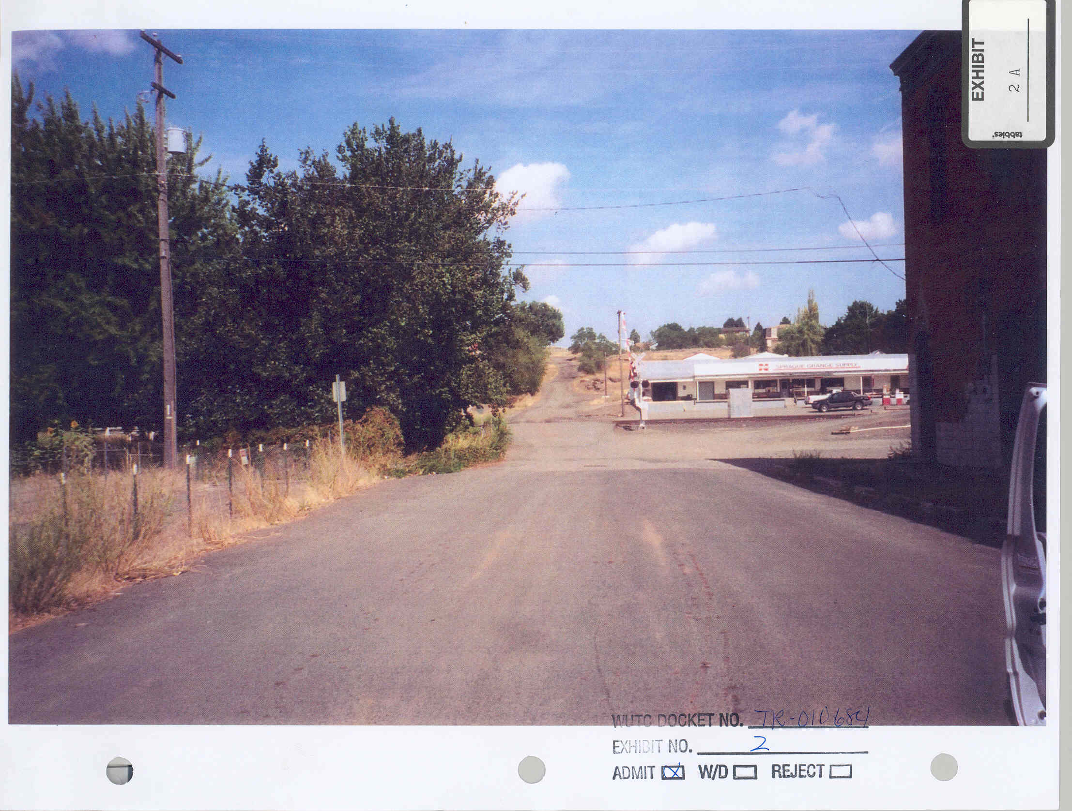
- Fig. 2. This photo, Exhibit 2A in the record, shows the "D" Street approach to the crossing from about a block away. Foliage to the west and buildings to the right are obstructions to a view of the tracks.
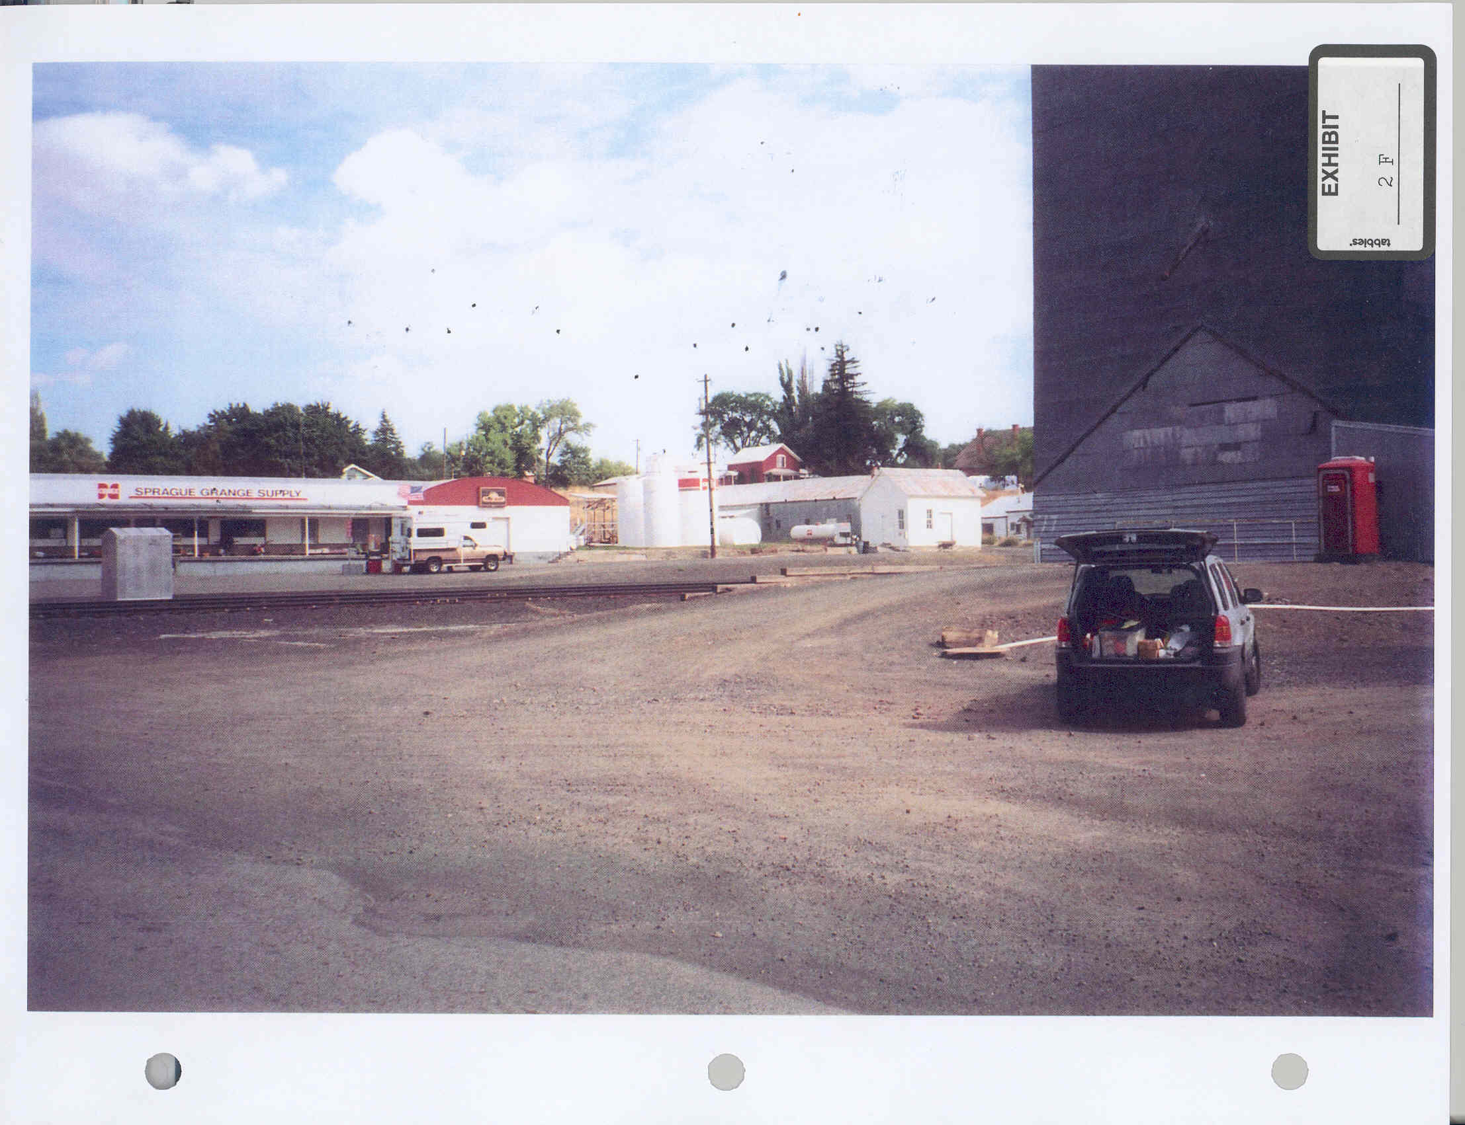
- Fig. 3. Exhibit 2F in the record shows the view to the east from "D" Street about a half-block south of the tracks. The grain elevator obstructs the view of the tracks to the east.

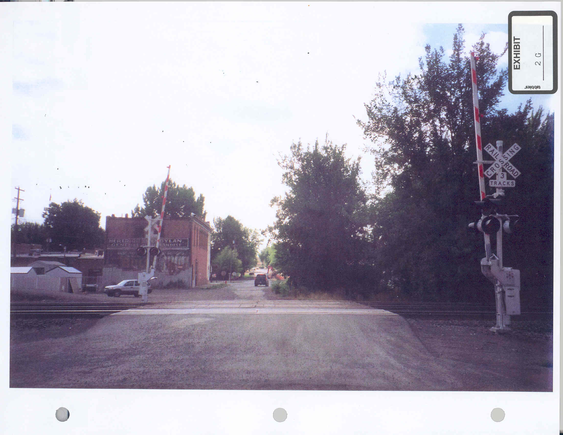
- Fig. 4. Exhibit 2G in the record is a view to the south on "D" Street from north of the tracks. The nearest of the three tracks is the main line track.
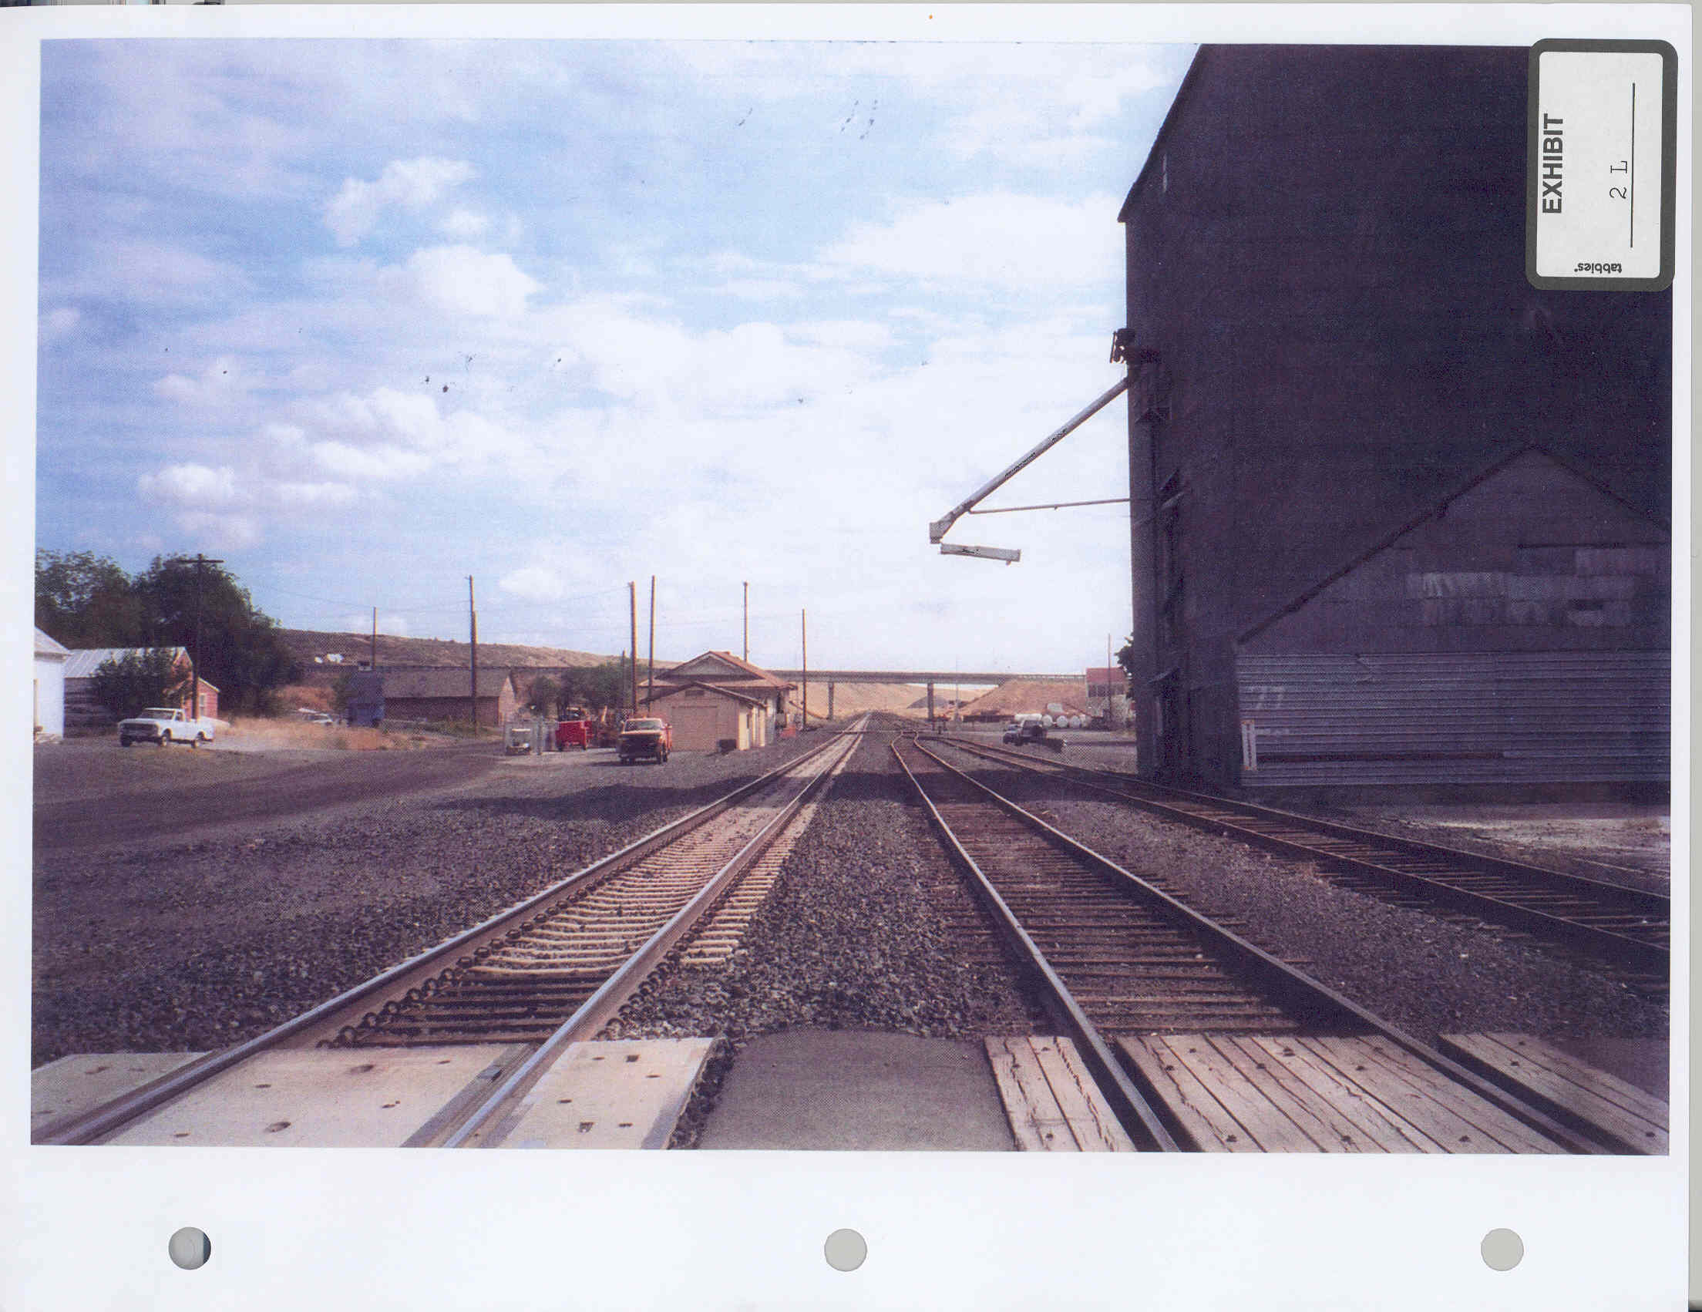
- Fig. 5. Exhibit 2L in the record is a photo that is taken from the "D" Street crossing and shows the view to the east. The main line track is to the left and the two sidings are to the right. The grain elevator is set close to the southernmost tracks to facilitate loading.

- Conclusion. Irrespective of the markers of particular hazard, this vehicle crossing is dangerous both by legislative finding and by statistical proof, as noted above. The countervailing concern – need for the crossing – is simply not persuasive. Traffic count on all Sprague crossings is low. Alternative crossings exist within 600 feet in either direction, so a motorist seeking to cross the tracks need go no farther than two blocks out of his or her way, at a cost of some twenty seconds. Conditions on closure can address the needs of the Grange and pedestrian traffic. We understand that the closure will result in some inconvenience to some persons – but as public officials whose agency shares responsibility for investigations of crossing injuries and fatalities, we are acutely aware of the hazards presented by crossings and believe that the increase in safety resulting from closure will significantly outweigh any resulting inconvenience. Closure should be mitigated by measures identified below to minimize negative effects on the community.

- The Commission finds that the evidence of record demonstrates that the "D" Street vehicle crossing is dangerous, that there are adequate alternative routes should the crossing be closed, and that the public convenience and necessity do not require that the "D" Street vehicle crossing remain open if the mitigating measures described herein are taken. The Commission will order closure of the crossing, subject to condition.

- The evidence does not support closing the "F" Street crossing. Mr. Cowles, Mr. Nizam and Mr. Lamparter each testified that closure of the "D" Street crossing should be considered before closure of the "F" Street crossing. In the instance of the "F" Street crossing, there is ample evidence of the convenience of the crossing and the need to preserve it for cross-track access. For this reason, the portion of Burlington Northern’s amended petition seeking to close the "F" Street at-grade crossing should be denied.

- Based upon the evidence of record, the Commission makes and enters the following ultimate findings of fact. The Commission has made specific findings of fact in the discussion above, and incorporates those findings in the ultimate findings set out below by means of this reference.

FINDINGS OF FACT

- (1) The Washington Utilities and Transportation Commission is an agency of the State of Washington vested by statute with the authority to regulate the placement and conditions of operation of crossings at grade of railroad tracks with public roadways within the State of Washington.

- (2) The Burlington Northern and Santa Fe Railway Company (BNSF) petitioned on May 1, 2001, for authority to close the highway-railway crossing at grade at "D" Street in the city of Sprague, Washington. It amended its petition on September 12, 2002, to seek authority to close either the "D" Street crossing or the crossing at "F" Street, also within the City of Sprague.

- (3) Sprague is a community of about 500 people in a rural, agricultural-based area of eastern Washington. One main line and two sidings traverse the town in an east-west direction. The tracks are crossed by three city streets – "B," "D," and "F" Streets – which are oriented north-south. The crossings transport 150, 130, and 120 vehicles per day, respectively. Visibility of the tracks for traffic approaching the "D" street crossing from the south is obstructed by trees and buildings. Rail cars are spotted on the southerly siding during grain loading season and obstruct motorists’ view of the tracks. The middle set of tracks is used regularly for way-freight (local) service.

- (4) Twenty-seven to 30 trains use the crossing daily, including two passenger trains. Freight trains average 5,000 to 7,000 feet long. Trains travel thorough Sprague at the rail speed limit, which is 45 miles per hour.

- (5) The Grange, an economically important business in Sprague, is located immediately to the north of the tracks at "D" Street, across an east-west street on railroad right-of-way called Railroad Street. Railroad Street crosses a bridge between "D" and "F" Streets that has a 6-ton load limit, so low that heavy trucks and emergency vehicles cannot use it. Truck access to the Grange would be enhanced by removal of a signal bungalow serving the "D" Street crossing and ballast that is placed to the north of the tracks. "D" Street is designated as an emergency route, but emergency vehicles use other crossings and no emergency vehicles were shown to have used the "D" Street crossing during the year prior to the hearing.

- (6) The "F" Street crossing serves a significant public need.
- (7) The "D" Street crossing is served by gates and signals. Statistically, a substantial minority of train-vehicle crossing accidents in the United States occur at crossings with such signal devices

- (8) Vehicle traffic over the "D" Street crossing is infrequent, with only about 130 vehicles per day using the crossing. The "D" Street crossing is within 600 feet of crossings to the east ("B" Street) and west ("F" Street). One or both of those crossings provide suitable alternative access across the tracks with a minimum of inconvenience.

- (9) A substantial number of pedestrians use the "D" Street crossing. A gated pedestrian crossing will eliminate an additional walk of up to 1200 feet after closure of the crossing, reduce trespassing, and facilitate the volume of pedestrian traffic at the crossing, especially traffic for the Grange.

- (10) Truck traffic at the Grange suffers obstruction from placement of a signal bungalow and of ballast near the tracks immediately at the south of the Grange facility. Closure of the "D" Street crossing will cause these obstructions to hamper such traffic significantly. Removal of the obstructions will reduce the negative effects of crossing closure on traffic to the Grange.

CONCLUSIONS OF LAW

- (1) The Washington Utilities and Transportation Commission has jurisdiction over the subject matter of and the parties to this proceeding.

- (2) The "F" Street crossing is required by the public convenience and necessity and should not be closed.

- (3) The "D" Street vehicle crossing in Sprague is dangerous. The "D" Street crossing is redundant to the "B" Street crossing, approximately 600 feet to the east, and some traffic can more conveniently use the "F" Street crossing, approximately 600 feet to the west of "D" Street.

- (4) Closure of the "D" Street crossing will result in inconvenience to some persons who now use the crossing. Mitigating measures can ameliorate concerns about closure of the "D" Street crossing. Removal of the signal bungalow and ballast on Railroad Street near "D" Street will improve truck access to the Grange. Retention of a gated pedestrian crossing at the site will eliminate the need to walk up to 1200 feet additional to an authorized crossing after closure of "D" Street, thereby reducing trespassing and providing necessary and convenient pedestrian access across the tracks.

- (5) The public convenience and necessity do not require that the "D" Street crossing remain open. The Commission should grant the petition of the BNSF and should order that the "D" Street crossing in Sprague be closed, upon conditions that will mitigate the inconvenience of closure.

ORDER

- The Commission grants with conditions the petition and amended petition of Burlington Northern to close the "D" Street at-grade crossing and denies the amended petition insofar as it asks authority to close the "F" Street at-grade crossing in the City of Sprague, Washington.

- Authority to close the "D" Street crossing is granted upon the following conditions, which must be met prior to closure:

- First, the signal bungalow at the "D" Street crossing must be removed.

- Second, the ballast on the north side of the tracks at "D" Street facing the Grange must be removed and the surface of Railroad Street made usable for truck maneuvering to the maximum extent consistent with clearance and right-of-way requirements of the tracks fronting on the Grange property.

- Third, the railroad must install a gated pedestrian crossing at the site of the "D" Street crossing.

Dated at Olympia, Washington, and effective this _____ of January, 2003.

WASHINGTON UTILITIES AND TRANSPORTATION COMMISSION

MARILYN SHOWALTER, Chairwoman

RICHARD HEMSTAD, Commissioner

PATRICK D. OSHIE, Commissioner

NOTICE TO THE PARTIES: This is a final order of the Commission. In addition to judicial review, administrative relief may be available through a petition for reconsideration, filed within 10 days of the service of this order pursuant to RCW 34.05.470 and WAC 480-09-810, or a petition for rehearing pursuant to RCW 80.04.200 or RCW 81.04.200 and WAC 480-09-820(1).

Exhibit Nos. 1-4 and 18 consist of maps and photographs and provide assistance in visualizing the layout of the City of Sprague’s streets and railway crossings.
Highway 23, the main access to the city from Interstate 90, runs north and south further east of "B" Street and crosses over the railway line on an overpass.
Exhibit No. 19.
Exhibit No. 20.
The railway line runs just south of, and parallel to, Railroad Street, which is an east-west road owned and maintained by Burlington Northern. Another similar road is Boxcar Avenue, located just south of, and parallel to, the tracks. Boxcar Avenue runs only between "B" Street and "D" Street.
Exhibit No. 7
Exhibit No. 10
Operation Lifesaver is an education program designed to alert the public about the dangers of railroad crossings. It is undertaken cooperatively among railroads and state and federal governments.
At 45 miles per hour, a train travels 3960 feet per minute. A 7,000-foot train takes 1.76 minutes (a minute and 46 seconds) to pass through a crossing at 45 miles per hour.
Testimony at 87-89.
Testimony at 165-166. This was bolstered by the testimony of Mr. Lamparter, a 60-year resident of Sprague, who could remember no accidents at any of the crossings during his 30 years with the fire department. Testimony at 259. Company witness Froscheiser also testified that there have been no accidents at crossings in Sprague in the last 50 years. Testimony at 103.
The numbers on Table 1-12 of Exhibit No. 10 indicate that since the implementation of the grade crossing closure program, total highway-rail crossing incidents have decreased from a total of 4,153 nationally and 50 in the State of Washington in 1995, to 3,032 nationally and 24 in the state in 2000.
Exhibit No. 8, p. 5
Testimony of Mr. Cowles.
Exhibit No. 17.
See, Burlington Northern Railroad Co. v. Skagit County, Docket No. TR-940282 (Dec. 13, 1996); Burlington Northern Railway Company v. City of Ferndale, Docket No. TR-940330 (March 31, 1995); Spokane County v. Burlington Northern, Inc., Cause No. TR-1148 (September 1985) .
See, Burlington Northern Railroad Co. v. Skagit County, Docket No. TR-940282 (Dec. 13, 1996); Whatcom County v. Burlington Northern Railroad Co., Docket Nos. TR-1725 and TR-1726 (Jan., 1985).

