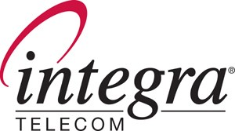

1201 NE Lloyd Boulevard - Suite 500 - Portland – Oregon - 97232
phone: 503.453.8000
fax: 503.453.8221
February 4, 2008

Via Email and Overnight Delivery
records@wutc.wa.gov

Carole J. Washburn
Washington Utilities and Transportation Commission
1300 South Evergreen Park Drive SW
P. O. Box 47520
Olympia, WA 98504

RE: In the Matter of the Petition of Qwest Corporation for Arbitration with
Eschelon Telecom, Inc. Pursuant to 47 U.S.C. §252 of the Federal
Telecommunications Act of 1996 – Docket No. UT-063061
Supplemental Authority

Dear Ms. Washburn:

Enclosed as supplemental authority are an original and eight copies of the recent Order of the Minnesota Commission addressing the remaining open issues related to the Qwest-Eschelon interconnection agreement compliance filing in the Minnesota arbitration.

Sincerely,

Tobe L. Goldberg
Legal & Regulatory Administrator
Eschelon Telecom, Inc., an Integra
Telecom Company
612.436.6084 (Direct)
612.436.6816 (Dept. Fax)
tlgoldberg@eschelon.com

Enclosures
cc w/enclosure to: jason.topp@qwest.com
lisa.anderl@qwest.com
maura.peterson@qwest.com
mark.reynolds@qwest.com
mary.neill@qwest.com
dianne.barthel@qwest.com
JDevaney@perkinscoie.com
gregory.merz@gmplaw.com

