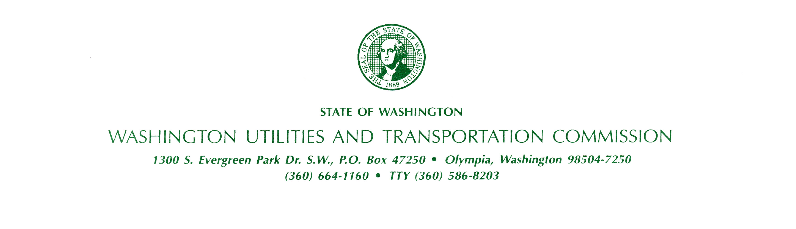
bkName
bkAddress
bkCityStateZip

July 30, 2026

Docket Number: bkDocket

Dear Interested Person (IP):

Thank you for contacting the Washington Utilities and Transportation Commission (commission) regarding the proposal filed by Deer Meadows Water Company, Inc. (Deer Meadows) to increase rates. This letter updates you on the status of the filing.

On April 20, 2010, Deer Meadows requested an increase in annual revenue totaling $114,234 or 80 percent. The filing was suspended on May 13, 2010, because the company had not demonstrated that the requested rates were fair, just, reasonable and sufficient.

By notice dated July 15, 2010, the commission scheduled a prehearing conference for August 2, 2010, and appointed an administrative law judge to hear the matter. The commission set a hearing schedule. Considering the amount of the original request, staff requested the commission hold a public comment hearing for customers to present their comments before the administrative law judge. The judge granted this request.

Staff reviewed the company’s records and worked with the company to reach a settlement. On September 14, 2010, staff and the company filed a settlement agreement which, if approved, will result in an increase in annual revenue of $11,227 or 7.8 percent, and the average residential customer will see an increase of $3.73 per month, or 11.2 percent. Staff and the company also requested, and the judge granted, that the scheduled hearings be put on hold while the judge considers the proposed settlement. Due to the much smaller amount of increase in the proposed settlement, staff requested that the public comment hearing scheduled for October 14 be cancelled. The judge has also granted this request.

The commission is still interested in your comments. Comments will be accepted through October 15, 2010. If you would like to comment on this filing please use the contact information below. You may also comment through the “Public Comment” feature at the commission’s website, at utc.wa.gov.

Washington Utilities and Transportation Commission
1300 S. Evergreen Park Drive SW
P.O. Box 47250, Olympia, WA 98504-7250
E-mail: comments@utc.wa.gov
Telephone: 1-888-333-WUTC (9882)

Further information on this filing is available at www.utc.wa.gov/water. Under “Active Cases” you will find a link labeled “Deer Meadows Water Co., Inc. UW-100462.” This link will lead you to information staff used in its analysis of this filing.

Sincerely,

bkStaff
Public Involvement Coordinator

