November 25, 2009

Via Electronic Mail & U.S. Mail

David W. Danner
Executive Director and Secretary
Washington Utilities and Transportation Commission
Post Office Box 47250
1300 S. Evergreen Park Dr. SW
Olympia, Washington 98504-7250
Dear Mr. Danner:
Enclosed, for filing, are the original and 15 copies of each of the following:
1. Exhibit A (Attorney Agreement) to the Protective Order, signed by David L. Rice on behalf of Broadband Communications Association of Washington.
2. Exhibit B (Expert Agreement) and Exhibit C (Highly Confidential Information Agreement) to the Protective Order, signed by Ronald N. Main, on behalf of Broadband Communications Association of Washington.
If you have any questions, please do not hesitate to contact me.
Very truly yours,
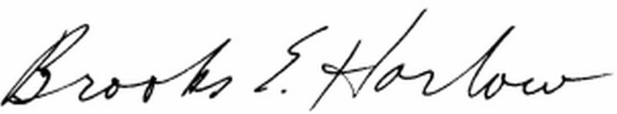
Brooks E. Harlow, P.C.

cc w/enc: Service List (attached)
Mr. Ronald N. Main (via e-mail)

