BEFORE THE WASHINGTON UTILITIES AND TRANSPORTATION COMMISSION

DOCKET NO. UE-10________
DOCKET NO. UG-10________

DIRECT TESTIMONY OF
DAVE B. DEFELICE
REPRESENTING AVISTA CORPORATION

I. INTRODUCTION
Q. Please state your name, employer and business address.
A. My name is Dave DeFelice. I am employed by Avista Corporation as a Senior Business Analyst. My business address is 1411 East Mission, Spokane, Washington.
Q. Please briefly describe your education background and professional experience.
A. I graduated from Eastern Washington University in June of 1983 with a Bachelor of Arts Degree in Business Administration, majoring in Accounting. I have served in various positions within the Company, including Analyst positions in the Finance Department (Rates Section and Plant Accounting) and in the Marketing/Operations Departments, as well. In 1999, I accepted the Senior Business Analyst position that focuses on economic analysis of various project proposals as well as evaluations and recommendations pertaining to business policies and practices.
Q. As a Senior Business Analyst, what are your responsibilities?
A. As a Senior Business Analyst, I am involved in financial analysis of numerous projects within various departments such as Engineering, Operations, Marketing/Sales and Finance.
Q. What is the scope of your testimony?
A. My testimony and exhibits in this proceeding will cover the Company’s proposed pro forma adjustments for capital investments in utility plant for the 2009 test period.
Q. Are you sponsoring any exhibits?
A. Yes. I am sponsoring Exhibit No. __(DBD-2) through Exhibit No. __(DBD-7), which were prepared under my direction, and have been included to provide supporting information for pro forma adjustments as proposed in this testimony.

II. CAPITAL INVESTMENT RECOVERY
Q. What does the Company's request for rate relief include regarding investment in utility plant to serve customers?
A. As in prior rate cases, Avista started with rate base for the historical test year, which for this case is the average of monthly averages (AMA) for the twelve months ended December 31, 2009. Adjustments were made to reflect certain 2010 capital additions, as described below, together with the associated accumulated depreciation and deferred federal income taxes at a 2011 AMA basis. These adjustments included associated expenses (depreciation expense and property taxes) and offsets to expenses for the pro forma additions.
Adjustments were also made to include the 2010 Noxon Unit #3 generation plant upgrade (approved in the 2009 rate case), and the 2011 Noxon Unit #2 generation plant upgrade at a 2011 AMA basis.
The utility plant investment that we have included in this filing represents utility plant that will be "used and useful" in providing service to customers during the period that new retail rates from this filing will be in effect. The costs associated with the investment will be "known and measurable" prior to the time that rates go into effect. In addition, the plant investment that was pro formed into this case was matched with offsetting factors. Including the costs associated with this investment in retail rates provides a proper "matching" of revenues from customers, with the costs associated with providing service to customers (including the cost of utility plant to serve those customers).
Q. Is the Company's application of these ratemaking principles in this filing consistent with prior general rate cases?
A. Yes. In prior cases, the objective has been the same -- to include in retail rates the investment, or rate base, that is providing service to customers, and ensure that there is a proper matching of revenues and expenses during the period that rates are in effect.
Q. Has the Company followed the guidance that was provided by the Commission in its order from the most recent general rate case?
A. Yes. The Company has been responsive to the guidelines relating to pro forma adjustments and capital investment that was presented in Commission Order 10 in Docket Nos. UE-090134 and UG-090135.
In that order, the Commission stated, at paragraph 45, that “First, the adjustment must be known and measurable.” That is, the event is known to have taken place by the rate year and it must be measurable. All of the capital investment pro formed in this case will be in service prior to the 2011 rate year. In addition, the Company has provided support for these pro forma adjustments and will continue to provide updated information to assist with the audit of these adjustments.
The Commission also stated, at paragraph 46, that “Second, for rate base, and for expense or revenue items, pro forma adjustments must be matched with offsetting factors.” As described below, the Company has quantified all offsetting factors related to new capital investment and has pro formed those offsets to provide the necessary matching of revenues and costs.
Finally, the Commission stated, at paragraph 48, that “Third, if the pro forma adjustment is to add new plant, pursuant to statute it must be shown that the new plant will be used and useful to serve Washington customers.” All of the plant that has been pro formed in this case will be in service by the rate year to serve Washington customers.
Q. How does new investment in utility plant change rate base over time for ratemaking purposes?
A. Historically, the annual dollars spent by the Company on new utility plant were generally relatively close to the level of depreciation expense, with the exception of years where the Company invested in major new utility projects. In those years, net rate base stayed at a relatively constant level and the use of the rate base amount from a prior year, i.e., a historical test year, would be adequate for setting rates for the upcoming year (pro forma rate year), because there was little change in the net plant investment used to serve customers.
In more recent years, Avista’s investment in utility plant has significantly exceeded depreciation expense. Because of this, rate base in the rate year is significantly greater than the historical test period AMA rate base. The only way to ensure that retail rates are fair, just, reasonable, and sufficient is for the utility plant investment that is being used to serve customers be properly reflected in retail rates. This makes it necessary for the Company to pro form plant investment that is in service after the historical test year and will be in service during the rate year so that rate base for the pro forma rate year is representative of the level of investment used to serve customers. The Company’s pro forma adjustments in this case properly reflect any offsets, and include adjustments to ensure a proper matching with test period loads.
Q. What 2010 and 2011 capital additions were pro formed into rate base?
A. The Company included all electric generation, transmission and non-revenue producing distribution plant that were required by laws, regulations, or directives from regulatory bodies, or related to reliability that will be in service by December 31, 2010. With regard to reliability, in some cases this includes replacing infrastructure that has reached the end of its useful life, and it is prudent to replace it prior to failure.
In addition, the Company included three major investments in general plant that will be in service by December 31, 2010. The Company also included the 2011 Noxon Unit #2 generation plant upgrade, and the additional generation from this upgrade was factored into the Company’s power supply model. All of the plant investment pro formed in this filing was stated at the 2011 AMA basis.
Although there is a strong case to be made that all of the new capital investment in 2010 and 2011 will be used to serve customers during the 2011 rate year, and should be reflected in this case, the Company has only included certain 2010 new investment and only the 2011 Noxon Unit #2 Upgrade in this filing. By excluding some of the 2010 new investment and almost all of the 2011 new investment, the rate base used to serve customers in 2011 will not be recovered in rates, i.e., we have understated our costs to serve customers in 2011.
Q. What is driving the significant investment in new utility plant?
A. As Company witnesses Mr. Kinney and Mr. Storro explain in their testimony, the Company is being required to add significant new generation, transmission and distribution facilities, including strengthening the “backbone” of our system, due in part to customer growth in our service area, reliability requirements, and needed capacity upgrades. Other issues driving the need for capital investment include an aging infrastructure, physical degradation, and municipal compliance issues (e.g., street/highway relocations), etc.
While the rate of increases experienced in recent years for the cost of materials (concrete, copper, steel, etc.) has diminished, they are still orders of magnitude higher than what they were even a few years ago, causing the cost of these new facilities to be significantly higher than in the past. Because the cost of adding new facilities is significantly higher than the original cost of our older, existing facilities, the investment in new facilities will be significantly higher than the annual depreciation expense on the Company’s older, existing facilities.
Q. What is causing the substantial increase in raw materials for Avista, and the utility industry in general?
A. The Edison Foundation commissioned a study from The Brattle Group, dated September 2007, titled, “Rising Utility Construction Costs: Sources and Impacts,” which identified cost trends specifically related to the utility industry pertaining to critical materials and equipment, as well as labor support services used for building capital infrastructure (a copy is included in my workpapers.) Although the study is over two years old, we believe the changes in costs described in the study are still indicative of the increase in costs the utility industry has experienced in recent years, and continues to experience. The study identifies the reasons for dramatic cost increases in critical raw materials, including global competition for materials and an aging domestic utility infrastructure, as well as the need for additional infrastructure to accommodate growth in the near future.
Q. What are some of the key cost drivers that are cited in the study?
A. The study, at page 16, cites four major cost drivers: “(1) material input costs, including the cost of raw physical inputs, such as steel and cement as well as increased costs of components manufactured from these inputs (e.g., transformers, turbines, pumps); (2) shop and fabrication capacity for manufactured components (relative to current demand); (3) the cost of construction field labor, both unskilled and craft labor; and (4) the market for large construction project management, i.e., the queuing and bidding for projects.” The study goes on to compare cost trends for various raw materials, critical equipment and labor services relative to the general inflation rate (GDP deflator). In addition, a cost trend is summarized by three key utility functional plant categories, including generation, transmission, and distribution plant. The study concludes that these inflation impacts have been outside the utility industry’s control and there are no immediate indications of cost relief in the near future.
Illustration 1 below, excerpted from the Brattle Group study, depicts what has occurred to infrastructure costs nationally. From the chart, it is apparent that starting in 2003, costs of distribution, transmission and generation infrastructure increased at a far more significant rate than the overall economy, as measured by the GDP deflator.

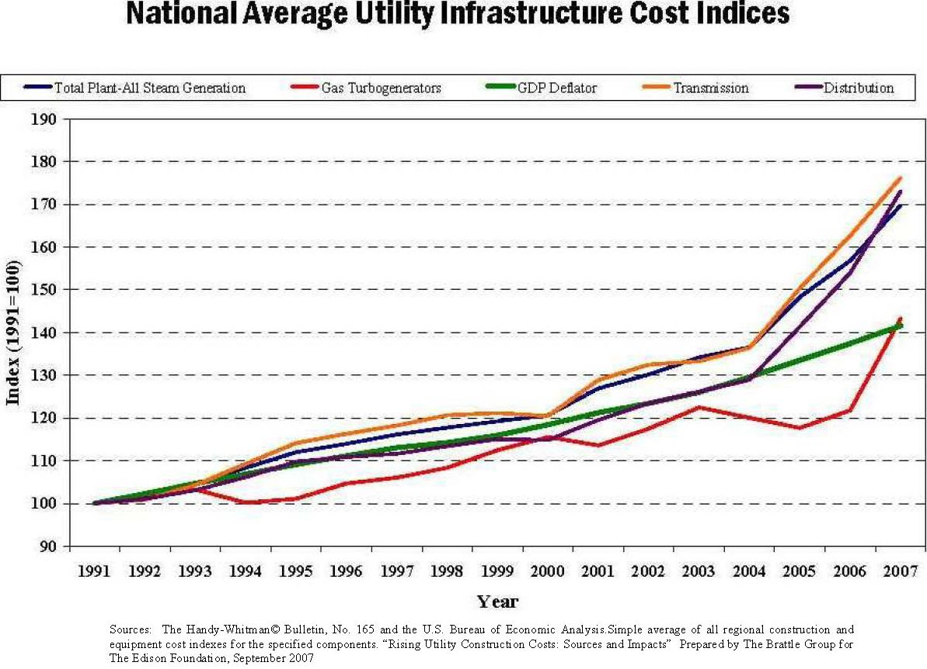
Illustration 1

Q. Is there specific evidence that Avista is experiencing cost escalations similar to that indicated in the study?
A. Yes. As we explained in the past general rate cases, Avista tracks the cost of materials and equipment that Avista routinely uses in order to support various infrastructure construction efforts that are part of the Company’s annual capital requirements.
In the recent analysis performed by the Company of all cost of materials that are accounted for through the Company’s inventory system that pertain to the electric transmission, electric distribution and natural gas distribution functions, there continues to be an increase in the average cost per unit of all materials, as shown in Illustration 2 below.
Illustration 2
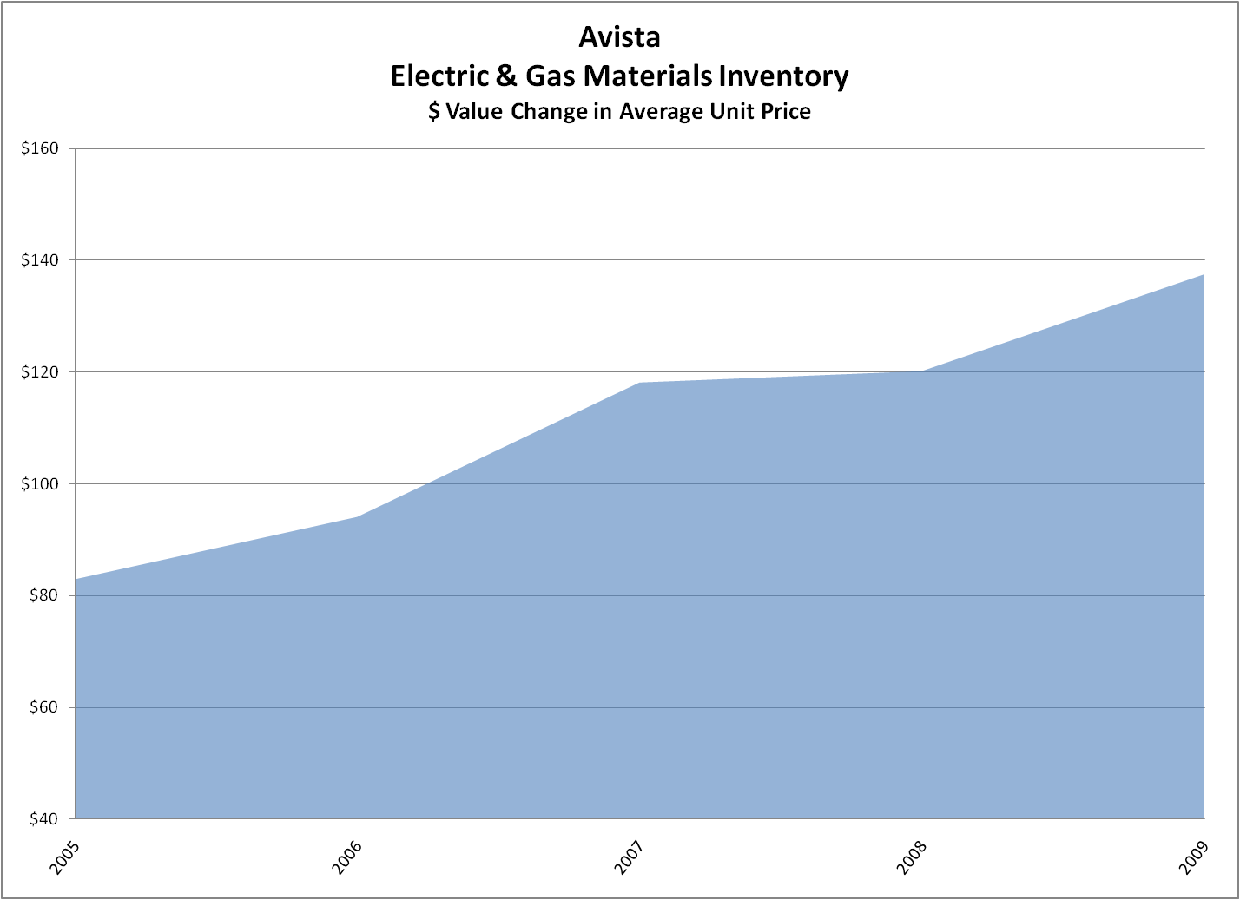
In 2005, the average cost per unit was $82.95, in 2006 it was $94.11, 2007 was $118.16, 2008 was $120.10 and for 2009 the cost was $137.51 per unit. The average annual increase over this four-year period is over 13%, which is well above the general inflation that our overall economy has experienced during the same timeframe. This illustrates that costs continue a significant trend upward as it relates to capital expenditures incurred that are necessary to operate the system.
Another analysis that was performed on specific materials is provided in Exhibit No. ___(DBD-2). On page 1, it can be seen that distribution transformers have experienced price increases from 2005 to 2009 anywhere from 49% to 74%. While the study also showed that there was a decrease in costs between 2008 and 2009, the one-year decline in costs did not offset the large increases experienced over the past five years. On page 2 of the Exhibit, it can be seen that poles and crossarms have also experienced substantial price increases from 2005 to 2009 in the range of 50% to 123%, depending on size. As noted in the Exhibit, some of the increase in costs is due to changes in specifications from wood to steel for certain poles and changes from wooded crossarms to fiberglass crossarms, that Avista is now installing. On page 3 of the Exhibit, a sampling of other distribution materials shows that prices have steadily risen from 2005 to 2009 for all but one category, conductor 600V 2/0 triplex; however the 2009 price of that conductor is still 24% higher than the 2005 price.
Q. What is the historical and projected level of annual capital spending for Avista?
A. Avista’s annual capital requirements have steadily increased from approximately $130 million in 2005 to approximately $210 million in 2010. Exhibit No. ___(DBD-3) reflects this trend that Avista has experienced and what is planned for in the near future.
This chart not only shows the total magnitude of capital expenditures, but also shows that the amount of capital projects is well in excess of revenue-supported capital expenditures to connect new customers, and beyond the level of revenues that is being collected from customers related to existing plant. The difference between the total capital requirements, less the new revenue-related capital and depreciation and amortization, represent a significant discrepancy that is negatively impacting the Company.

III. DESCRIPTION OF CAPITAL PROJECTS
Q. Please provide a description of the 2010 capital projects pro formed in this filing.
A. Exhibit No. ___(DBD-4) details the capital projects that will be transferred to plant in service in 2010 and included in this filing. A short description of these projects and their system costs follows:
Generation ($33.4 million):
The electric generation projects that will transfer to plant in service are described in detail in Mr. Storro’s direct testimony. A listing of these projects follows:

Thermal – Kettle Falls Capital Projects - $1,817,000
Thermal - Colstrip Capital Additions- $2,275,000
Thermal – Other Small Projects - $78,000
Hydro – Nine Mile Upgrade - $3,954,000
Hydro – Noxon Capital Project - $7,551,000
Hydro – 2010 Noxon Unit #3 Upgrade - $9,265,371
Hydro – Clark Fork/Spokane Implement PME Agreements - $4,053,000
Hydro – Other Small Projects - $2,296,000
Other - Coyote Springs 2 (CS2) Capital Projects - $1,197,000
Other – Boulder Park - $410,000
Other Small Projects - $493,000

Electric Transmission ($18.9 million):
The electric transmission projects that will transfer to plant in service are described in detail in Mr. Kinney’s direct testimony. A listing of these projects follows:

Lolo 230 kV Substation - $1,450,000
Spokane-CDA 115 kV Line Relay Upgrades - $1,250,000
Nez Perce 115 kV Substation Rebuild and Capacitor Bank - $3,575,000
SCADA Replacement - $800,000
System-Replace/Install Capacitor Banks - $750,000
Airway Heights – Silver Lake 115 kV Transmission Line - $975,000
Moscow 230 – Pullman 115 Reconductor - $1,300,000
Beacon Storage Yard Oil Containment - $750,000
Colstrip Transmission Minor Rebuild - $503,000
Tribal Permits - $519,000
Reliability Improvements – Boulder-Rathdrum 115 kV Transmission Line - $1,500,000
Transmission Minor Rebuild - $1,250,000
Power Circuit Breakers - $485,000
Pine Creek – Replace 115 kV Circuit Switcher - $570,000
Otis Orchards – 115 kV Breaker and Line Relay Replacements - $650,000
Replacement Programs - $2,044,000
Other small transmission projects - $517,000

Electric Distribution ($33.6 million):
The electric distribution projects that will transfer to plant in service are described in detail in Mr. Kinney’s direct testimony. A listing of these projects follows:

Power Transformer Distribution - $4,740,000
Othello & Chewelah Transformer Replacements - $950,000
Northeast Substation - $900,000
Distribution – Spokane North and West - $1,890,000
System-Dist Reliability-Improve Feeders - $1,150,000
Electric Distribution Minor Blanket - $7,000,000
Wood Pole Replacement Program & Capital Distribution Feeder Repair - $6,884,000
Electric Underground Replacement - $4,000,000
T&D Line Relocation - $2,348,000
Failed Electric Plant - $2,000,000
Spokane Electric Network Capacity - $1,356,000
Other small distribution projects - $1,083,000

Q. Are you providing additional testimony discussing additional general plant capital projects not otherwise addressed by other Company witnesses?
A. Yes. Exhibit Nos.__(DBD-5) through Exhibit Nos.__(DBD-7) contain supporting documentation for each of the projects described below.

General ($4.0 million):
HVAC Renovation Project - $3,499,000 (Exhibit No. ___(DBD-5))
The heating, ventilating, and air conditioning systems throughout the Spokane Central Operating Facilities are approximately fifty years old and are in need of replacement. In 2007, the Company initiated a multi-year HVAC renovation project that involves replacing central air handling units and distribution systems in three buildings - the Spokane Service Center, the general office building, and the cafeteria auditorium building. The building envelope of the general office building was also renovated with high efficiency glass and insulation. The project will also achieve asbestos abatement and life safety (fire sprinkler) additions. New controls will also be installed which will enable energy conservation. Present estimates indicate cost savings of approximately $430,000 per year in energy use, a 36% reduction in energy costs once all phases have been completed, currently planned to be completed in 2013. The 2010 project pro formed into this case will produce approximately $31,000 per year (system) in reduced energy costs, which have been pro formed as a reduction to O&M costs.

WSDOT Highway Preservation/Maintenance of Right of Ways - $500,000
(Exhibit No. ___(DBD-6))
In order to operate our electric system within State highway rights of way, the Company needs to preserve/maintain right of ways. Existing right of ways have expired and Avista must seek new agreements with the State or risk penalties or non-approval by the State. There are no offsets to costs with the renewal of these preservations/maintenance of right of ways.

Transportation ($10.0 million):
Transportation Equipment - $9,971,000 (Exhibit No. ___(DBD-7))
Expenditures are for the scheduled replacement of trucks, off-road construction equipment and trailers that meet the company's guidelines for replacement including age, mileage, hours of use and overall condition. This also includes additions to the fleet for new positions or crews working to support the maintenance and construction of our electric and gas operations. Some of the vehicles being purchased in 2010 will be equipped with diesel engines rather than gasoline engines. This is intended to increase life expectancy and generate fuel savings. The Company has pro formed annual fuel cost offsets of approximately $129,000 (system) in reduced O&M costs.

IV. ADJUSTMENT METHODOLOGY
Q. What was the general approach to computing the pro forma adjustments for investment in capital projects?
A. The Company included pro forma adjustments for new investment through December 31, 2010, in accordance with Order 10 (Docket Nos. UE-090134 and UG-090135), paragraph 48:
Third, if the pro forma adjustment is to add new plant, pursuant to statute it must be shown that the new plant will be used and useful to serve Washington customers. With very limited exceptions the plant must be in service by no later than the end of the rate proceeding if it is to be allowed in rate base. Typically, this means the plant will be in service before the suspension date, which generally marks the beginning of the “rate year.”

The Company’s adjustment included all generation, transmission and distribution investments that are required by laws, regulations, or directives from regulatory bodies or related to reliability for all plant that will transfer to in-service by December 31, 2010. In addition, the adjustment includes three major general plant projects that will transfer to in-service by December 31, 2010. No natural gas plant investment was included in the pro forma adjustment.
The end of the suspension period for this rate proceeding will be in early 2011, therefore, all of the plant investment pro formed in this adjustment meets this requirement.
In addition, an adjustment was made to include the 2010 Noxon Unit #3 generation plant upgrade (approved in the 2009 rate case) and the 2011 Noxon Unit #2 generation plant upgrade at a 2011 AMA basis.
Table 1 below provides a summary of the pro forma rate base adjustments, the revenue and expense offsets, and the resulting net revenue requirement.
Table 1: |  | Electric
Category | System Cost | WA Net Rate Base – 2011 AMA | Revenue/Expense Offsets | Revenue Requirement (2)
Generation (1) | $ 24,124,000 | $15,072,000 | $ 283,000 | $ 2,350,000
Noxon (1) | $ 18,510,000 | $ 8,656,000 | $ 91,000 | $ 1,377,000
Transmission | $ 18,888,000 | $11,769,000 | $ 140,000 | $ 1,893,000
Distribution | $ 83,556,000 | $23,136,500 | $ 417,000 | $ 3,768,000
General Plant | $ 36,814,000 | $ 6,006,500 | $ 81,000 | $ 951,000
Natural Gas | $ 14,915,000 | $ - | $ - | $ -
TOTAL | $196,807,000 | $64,640,000 | $1,012,000 | $10,339,000
(1) These assets are included in the power cost model (Aurora) and any Aurora-related offsets from these investments are already included in the power costs adjustment, therefore, those offsets are not summarized and included in this table.
(2) Revenue Requirement is shown before impact of the restate debt adjustment.

Q. What are the offsets included in the case related to the pro formed capital investment shown in Table 1?
A. The offsets include the following:
Revenue Requirement before Offsets |  | $11,351,000
Offsets:
Reduction to O&M Costs | $ 657,000
Production Property Adjustment | $ 355,000
TOTAL OFFSETS |  | $ 1,012,000
Net Revenue Requirement |  | $10,339,000

Each component of the offsets is described below.
Q. How were the offsets determined for the generation category of plant investment?
A. The output from generation assets is included in the Aurora power cost model. Therefore, to the extent that the additional investments serve to either preserve or increase generation from the generation projects, the benefits are reflected in the Aurora model. In addition, these assets are included in the production property adjustment, which is designed to preserve test year relationships between investment costs and revenues. It does so by adjusting rate year costs (revenues, expenses and rate base) to match test year loads. The offsets through application of the production property factor to these pro formed capital additions are included in the table above.
In addition to the above offsets, each generation capital addition was analyzed to determine whether there were any additional offsets (e.g. reduced O&M costs). Maintenance records were reviewed to determine whether any specific maintenance costs were incurred in the test period that would be reduced or eliminated by the investment at the facility. Those costs were quantified and included as a reduction to O&M costs in the pro forma adjustment. These offsets identified are discussed by Mr. Storro.
Q. How were the offsets determined for the transmission category of plant investment?
A. Like the generation assets, these assets are included in the production property adjustment, which preserves test year relationships between investment costs and revenues by adjusting rate year costs (revenues, expenses, and rate base) to match test year loads. The offsets through application of the production property factor to these pro formed capital additions are included in the table above.
In addition to the above offsets, each transmission capital addition was analyzed to determine whether there were any additional offsets (e.g., reduced load losses, reduced O&M costs, etc.). Analyses were conducted to determine the amount of potential load loss savings that would be achieved. In addition, maintenance records were reviewed to determine whether any specific maintenance costs were incurred in the test period that would be reduced or eliminated by performing the investment at the facility. Those costs were quantified and included as a reduction to O&M costs in the pro forma adjustment. These offsets identified are discussed by Mr. Kinney.
Q. How were the offsets determined for the distribution category of plant investment?
A. First, the Company excluded all distribution capital that was for customer growth or new revenue from the pro forma adjustment. In addition, an offset was calculated that reduced O&M costs. This offset was computed by applying a load adjustment factor of 5.85% to the revenue requirement associated with this pro formed capital. The load adjustment factor is based on the percentage increase of the 2011 pro forma period Washington retail loads above the 2009 Washington test year retail loads, to adjust these rate year costs to match test year loads. Calculations are provided in Company witness Ms. Andrew’s workpapers.
Each distribution capital addition was also analyzed to determine whether there were any additional offsets (e.g. reduced O&M costs). Maintenance records were reviewed to determine whether any specific maintenance costs were incurred in the test period that would be reduced or eliminated by performing the investment at the facility. Those costs were quantified and included as a reduction to O&M costs in the pro forma adjustment. These offsets identified are discussed by Mr. Kinney.
Q. How were the offsets determined for the general plant investments?
A. Consistent with the process used for the other categories of capital investment, each general plant capital addition was analyzed to determine whether there were any offsets. Analyses were conducted to determine the amount of cost savings that would be achieved. Those costs were quantified and included as a reduction to O&M costs in the pro forma adjustment. These offsets identified are discussed above with the description of the project.
Q. What documentation has the Company provided to support these pro formed capital costs?
A. Exhibits (Exhibit Nos. ___(RLS-4) and (RLS-5), Exhibit Nos. __(SJK-3) through (SJK-6), and Exhibit Nos. ___(DBD-5) through (DBD-7)) have been included with the following information on each investment:
- Detailed project description
- Detail of actual costs incurred to date
- Listing of total project costs
- Copies of contracts, invoices or purchase orders for major components
- Timeline
- Analysis of offsetting factors
This information has been provided to facilitate the audit if this information. Based on the nature of construction projects, new information will be generated throughout 2010 as the work is performed and the projects are completed and moved into service. As this information becomes available, the Company will provide updated information to document the progress.
Q. Please summarize the pro forma adjustment related to the upgrades to the Noxon units.
A. A pro forma adjustment was made to include the 2010 Noxon Unit #3 generation plant upgrade (approved in the 2009 rate case) and the 2011 Noxon Unit #2 generation plant upgrade at a 2011 AMA basis.
As explained by Mr. Storro, the Company has been upgrading one turbine each year at its Noxon generating facility. The upgrade for Unit #3 will be completed in April 2010 and was approved in rates in the most recent general rate case on a 2010 AMA basis. This adjustment pro forms this same upgrade on a 2011 AMA basis.
The upgrade for Unit #2, which will be completed in April 2011 is also pro formed into this case and is the only 2011 capital addition that the Company has included in its electric case. Seventy-five percent of the additional generation and costs have been included in the power cost model to provide a proper matching of revenues and costs. The Company included seventy-five percent of the additional generation and costs for the nine months that it will be in service during 2011.
Q. Has the Company included pro forma adjustments for new capital investment in the natural gas system?
A. No. Due to the nature of natural gas projects, the Company did not pro form any natural gas projects in this case. However, the Company has pro formed the allocated costs and net rate base of the three general plant capital investments described above.

VI. CONCLUSION
Q. What is the impact of the pro forma capital investment adjustments?
A. The proposed adjustments will result in a closer matching of revenues to cost of service to customers at the time new rates go into effect at the conclusion of this general rate proceeding. Without the proposed adjustments, the Company will not have the opportunity to earn its allowed rate of return on investment during the rate year. Avista only proposed to reflect certain new investment in utility plant through December 31, 2010, even though rates from this case will remain in place throughout 2011. Although there is a strong case to be made that all of the new capital investment in 2010 and 2011 will be used to serve customers during the 2011 rate year, and should be reflected in this case, the Company has only included certain 2010 new investment and only the 2011 Noxon Unit #2 upgrade in this filing. By excluding some of the 2010 new investment and almost all of the 2011 new investment, the rate base used to serve customers in 2011 will not be fully recovered in rates. Therefore, if the Commission were to approve Avista’s proposed pro forma capital adjustments as filed, the revenues received from customers would not recover costs associated with total capital investment in place to serve customers.
Q. Does this conclude your pre-filed direct testimony?
A. Yes, it does.

Recognizing that a portion of the costs associated with certain capital additions are offset by additional revenues.

