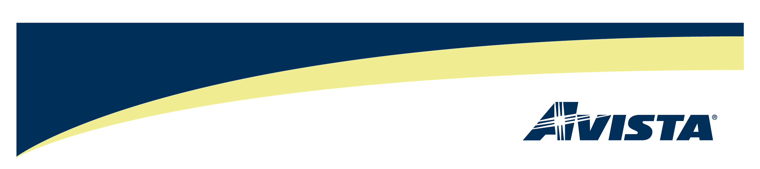

October 14, 2010

David Danner
Executive Director and Secretary
Washington Utilities & Transportation Commission
1300 S. Evergreen Park Drive S. W.
P.O. Box 47250
Olympia, Washington 98504-7250

RE: Avista Utilities 2010 Third Quarterly DSM Report

Dear Mr. Danner:

In compliance with the requirements set forth in Docket Nos. UE-100176, Avista Utilities submits an electronic version of its Third Quarter DSM Balance Report. If you have any questions, please contact Bruce Folsom at 509-495-8706 or feel free to contact me at 509-495-4975.

Sincerely,

//Linda Gervais//

Linda Gervais
Manager, Regulatory Policy
509-495-4975
linda.gervais@avistacorp.com

