AVISTA CORP.

RESPONSE TO REQUEST FOR INFORMATION

JURISDICTION: WASHINGTON DATE PREPARED: 07/15/2015

CASE NO.: UE-150204 & UG-150205 WITNESS: Don Kopczynski/Tara Knox

REQUESTER: ICNU RESPONDER: Larry La Bolle

TYPE: Data Request DEPT: State & Federal Regulation

REQUEST NO.: ICNU – 076 Supplemental TELEPHONE: (509) 495-4710
EMAIL: larry.labolle@avistacorp.com

REQUEST:
Please refer to Exhibit No.__(DFK-5), page 23. Please provide Avista’s proposed: a) digital meter installation schedule, according to rate schedule; and b) allocation of digital meter installation costs, per year, according to rate schedule.

RESPONSE:

The Company’s preliminary estimate of the expected capital costs associated with the Washington advanced metering project, by year, is provided in Exhibit No._(DFK-1T), Illustration No. 5, page 14. The costs for the metering project will be allocated to each rate schedule based on the metering that is ultimately installed for customers served under that rate schedule. The Company anticipates at this time that the costs for the metering project will be principally applied to rate schedules other than schedule 025. This is the case because we expect that many of the industrial customers we serve will continue to be metered under the Company’s existing MV-90 program. The basis for the allocation of metering costs among rate schedules is provided in Exhibit No._(TLK-2), page 5, lines 6-8, and in the related work papers TLK-E-135-137.

SUPPLEMENTAL RESPONSE:

In the Company’s previous response, we referred to the initial preliminary capital estimate developed and approved for the advanced metering project in late 2014, as presented in Exhibits No._(DFK-1T and DFK-5). Avista has noted that its initial preliminary estimate would be revised through the course of implementation as new information is developed in support of the project, most notably, when we have firm costs from vendors for various solutions. Though the Company has no firm pricing at this point, and will not have firm prices for most of the required solutions until the end of 2015, and into early 2016, we have made revisions to the initial preliminary capital and O&M estimates based on the best information available to the Company at this time.

Capital Revisions

The table, below, presents the initial preliminary project capital cost categories, as described in Exhibit No._(DFK-5), pages 20-23. The costs in the table show the initial preliminary budget as presented in Exhibit No._(DFK-5), and the costs reflecting the most-recent revisions, referenced above.

Description | July 2015 Revision | Initial Budget
Electric Meters | $ 35,829,062.40 | $ 33,830,016.00
Electric Meter Labor - in house | $ 9,054,202.59 | $ 3,389,938.72
Electric Meter Labor - contract | $ 7,464,774.25 | $ 6,815,950.03
Gas Modules | $ 8,942,246.42 | $ 8,443,322.80
Gas Module Labor - contract | $ 5,555,646.75 | $ 4,261,977.50
Head End Hardware | $ 4,922,650.48 | $ 4,922,650.48
Head End Software | $ 5,140,000.00 | $ 859,650.00
Head End Labor - Internal | $ 21,592,959.72 | $ 9,075,925.85
Network Communications - Hardware | $ 30,105,294.83 | $ 26,152,769.50
Network Communications - Software | $ 3,522,185.00 | $ 3,015,100.00
Network Communications - Labor | $ 19,938,151.52 | $ 29,268,731.80
Customer Communications | $ 4,500,000.00 | $ 5,500,000.00
AFUDC | $ 7,361,195.68 | $ 6,591,694.62
Additional Project Costs (Spread Across All Units) | $ 1,624,231.37
Totals | $ 165,552,601.00 | $ 142,127,727.31

An additional change to the revised estimated capital costs, which is embedded in the revised cost categories shown above, and in the project total of $165.6 million, is an increase in the financial contingency for the project, in the amount of $5.8 million. A brief explanation of the reasons for the changes in each capital cost category, is provided below.

Electric Meters – Increase in the equipment loading charges applied to the meters.

Electric Meter Labor / Avista – Upward revision of the estimate of the internal labor resources required to install the advanced meters.
Electric Meter Labor / Contract – Increase in the initial estimate of the contract labor resources required for meter installation.
Gas Modules – Increase in the equipment costs associated with the natural gas modules.
Gas Module Labor / Contract – Increase in the initial estimate of the contract labor resources required to install the natural gas modules.
Head-End Software – Increase in the initial estimate for the meter data management system based on more refined technical specifications, and recent discussions with potential vendors.
Head-End Labor / Avista – Increase in the initial estimate of labor resources, and a transfer of labor from other areas, needed to install and integrate the meter data management system.
Network Communication Hardware – Increase in the initial estimate of the contract labor resources required for network installation.
Network Communication Software – Increase in the initial estimate of the network software costs.
Network Communication Labor – Reduction, representing a shift in the initial estimate of labor resources to other elements of the project, such as Head-End Labor, above.
Customer Communications – Reduction in the initial estimate of the costs for customer communications required to support the project.
AFUDC – Increase reflecting the greater capital costs associated with the project.

Additional Project Costs – Recognition of additional costs associated with implementation of the advanced metering system.

In addition to changes in project costs by category, Avista also revised the initial preliminary forecast of annual capital spending during each year of implementation. The illustration, below, shows the initial forecast of annual capital expenditures for the Washington advanced metering project, as provided in Exhibit_No. (DFK-1T), page 14, and the most-recent revisions of the forecast, as described above.

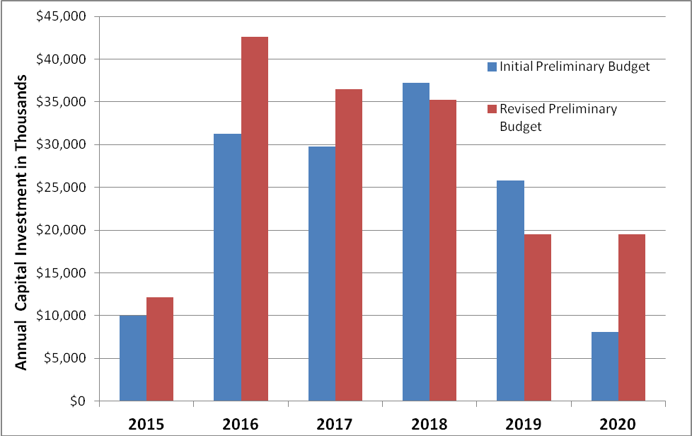

To determine the overall cost impact associated with these capital additions, Avista revised its initial project financial model, provided in the workpapers of Company witness Mr. Kopczynski, under the tab labeled “AMI Financials.” The revised model is provided as ICNU_DR_076 Supplemental Attachment A. As shown in the model in column “T,” lines 28 through 48, the overall cost impact related to the increase in estimated capital costs, measured as the change in the net present value of the overall project revenue requirement, is $24.9 million, or approximately 10.9 percent.

Operations & Maintenance Costs

The Company’s initial preliminary estimate of the annual O&M costs required to support the fully-deployed project was $5,191,063, which was escalated at two percent annually over the life of the project. Avista has made two revisions to this initial preliminary forecast. The estimate of the required O&M costs has been increased from $5.19 million, above, to $5,400,023, which is also subject to the two percent annual adjustment. The second adjustment involves “phasing in” the full O&M costs over the period of the deployment of the advanced metering system. In its initial financial model, noted above, the Company inadvertently applied the O&M costs, associated with the fully deployed advanced metering system, to each year of the implementation of the project, resulting in an overestimate of the lifecycle operating costs for the system. The net effect of these two O&M adjustments is a $20.8 million reduction (or approximately 9.1 percent) in the overall net present value of the revenue requirement associated with the advanced metering system. These two changes to the Company’s initial financial model are shown in ICNU_DR_076 Supplemental Attachment B, in the “AMI Financials” tab, under column “N,” lines 28 through 48.
Net Effect of Capital and O&M Revisions

The overall cost impact of these revisions in estimated capital and O&M costs, as described above, is an increase of $4.1 million in the overall net present value of the revenue requirement for the project, or 1.8 percent. Revisions to the Company’s initial financial model, reflecting the changes described above in the estimated capital and O&M costs, are provided in ICNU_DR_076 Supplemental Attachment C, under the “AMI Financials” tab. The Company is also continuing to refine its preliminary estimate of offsetting quantifiable benefits. It is anticipated that those estimated benefits will increase.

In addition to the advanced metering project costs noted above, Avista is also in the process of developing a business case for a network communications system that would support a variety of utility functions. Some of these functions include distribution grid modernization and operation, SCADA telemetry to all substations, physical and infrastructure security, field mobility workforce solutions, replace leased fiber and telecommunications facilities, and support of advanced metering in Washington, and subsequently in Idaho. The Company believes the value associated with this network communications system will support its development, likely irrespective of the benefits provided to advanced metering. However, because the network communications project will have an association with the advanced metering system now being deployed by the Company, we will evaluate the costs and benefits of each project in parallel to ensure the costs and benefits of the communications network are properly allocated. Avista is presently engaged in the process of identifying use cases to be evaluated as part of the communications network project, and subsequently, will be preparing a Capital Project Business Case for the program.

