
David S. Valdez
Vice President
Public Policy & External Affairs
WA0101RA
1800 41st Street
P.O. Box 1003
Everett, WA 98201
Phone 425 261-5691
Fax 425 261-5262
June 28, 2005

Ms. Carole Washburn, Executive Secretary
Washington Utilities and
Transportation Commission
1300 S. Evergreen Park Drive S.W.
Olympia, Washington 98504-7250

Dear Ms. Washburn:

Subject: Verizon Communications Inc. and MCI, Inc. Direct Testimony – Docket No. UT-050814

Pursuant to Paragraph 14 of Order No. 01 dated June 23, 2005 in the above referenced docket, please find enclosed for filing an original and nine (9) copies of the direct testimony of 1) Dr. William E. Taylor; 2) Dr. Carl R. Danner and 3) Michael A. Beach.

Verizon Communications Inc. (“Verizon”) and MCI, Inc. (“MCI”) request that the documents contained in the envelopes marked “Confidential Per WAC 480-07-160” and “Highly Confidential Per WAC 480-07-160” be treated as confidential under the provisions of WAC 480-07-160(3). The information is “confidential” because it constitutes valuable commercial information, including trade secrets or other information defined in WAC 480-07-160 (2)(c). Verizon and MCI will also seek protection under the terms of a protective order to be entered in this adjudicative proceeding and this information would also qualify as confidential under WAC 480-07-160(2)(b) at that time. Verizon and MCI cannot identify any person, other than Verizon and MCI, that might be directly affected by disclosure of the confidential information. In accordance with WAC 480-07-160(3)(b), the documents are marked “Confidential Per WAC 480-07-160” and “Highly Confidential Per WAC 480-07-160.” In accordance with WAC 480-07-160(3)(c) Verizon and MCI have enclosed redacted versions of the documents containing confidential information with the nonconfidential documents, and have placed unredacted versions of the documents containing confidential information in separate envelopes marked appropriately. All unredacted documents have been printed on yellow or blue paper.

If you have any questions please call me at (425) 261-5691.

Very truly yours,

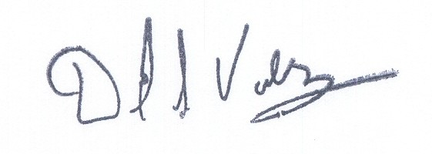

David S. Valdez

DSV:kad
Enclosures

c: Service List

