MASTER SERVICES AGREEMENT

BETWEEN

QWEST CORPORATION

AND

QWEST COMMUNICATIONS CORPORATION

TABLE OF CONTENTS

ARTICLE 1 SERVICES 3
ARTICLE 2 TERM 3
ARTICLE 3 BILLING 4
ARTICLE 4 INDEPENDENT CONTRACTORS 4
ARTICLE 5 PROPRIETARY INFORMATION 4
ARTICLE 6 INDEMNIFICATION 5
ARTICLE 7 LIMITATION OF LIABILITY 5

ARTICLE 8 REGULATORY SUPPORT 5
ARTICLE 9 COMPLIANCE WITH LAWS 6
ARTICLE 10 NOTICES 6
ARTICLE 11 DISPUTE RESOLUTION 7
ARTICLE 12 SEVERABILITY 8

EXHIBIT

Exhibit A SUMMARY OF AFFILIATE TRANSACTIONS 9

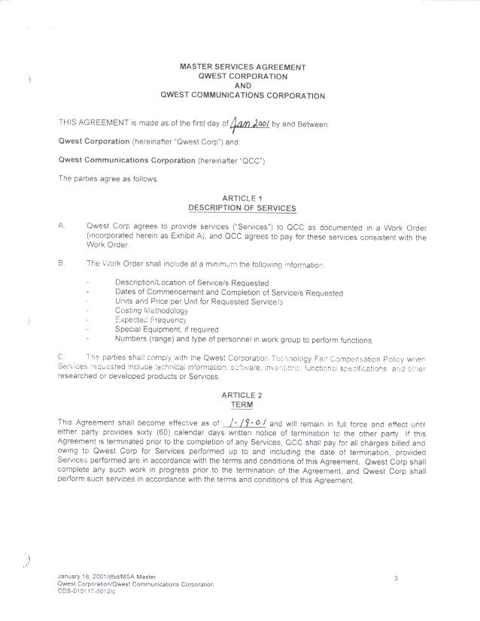

ARTICLE 3

BILLING

A. Qwest Corp shall submit invoices to QCC for Services provided in accordance with the terms and conditions of this Agreement on a monthly basis unless otherwise specified in the Work Order. QCC shall notify Qwest Corp of the address to which invoices are to be sent.

B. Invoices shall include the following billing information as a minimum:

- Invoice number
- Payment due date
- Date of Service
- Description of charges
- Applicable taxes
- Total charge

ARTICLE 4

INDEPENDENT CONTRACTOR

Qwest Corp hereby declares and agrees that it is engaged in an independent business and will perform its obligations under this Agreement as an independent contractor and not as the agent or employee of QCC; that Qwest Corp does not have the authority to act for QCC or to bind QCC in any respect whatsoever, or to incur any debts or liabilities in the name of or on behalf of QCC; that any persons provided by Qwest Corp shall be solely the employees or agents of Qwest Corp under its sole and exclusive direction and control. Qwest Corp and its employees or agents are not entitled to QCC's unemployment insurance benefits as a result of performing under this Agreement. Qwest Corp shall be solely responsible for all matters relating to payment of its employees and agents, including compliance with worker's compensation, unemployment, disability insurance, social security withholding, and all other federal, state and local, rules and regulations. Qwest Corp shall indemnify and hold QCC harmless from any causes of action arising out of Qwest Corp's liability to its employees or agents.

ARTICLE 5

PROPRIETARY INFORMATION

Solely for the purposes of providing Services under this Agreement, each party grants to the other a nonexclusive, nontransferable license to use information provided by the other. Neither party shall publish, circulate, or otherwise distribute or disclose any such information that is marked proprietary or confidential to any third party other than its affiliates and its consultants who have executed a confidentiality agreement unless and until (1) the original disclosing party has consented to such disclosure and such third party executes a confidentiality agreement containing terms substantially similar to the ones contained in this Agreement, (2) such information has come into the public domain through no fault of QCC or Qwest Corp, (3) such information is otherwise in the possession of QCC or Qwest Corp free of any obligation of confidentiality, or (4) such party is required to do so by regulatory mandate.

Any third party information provided by QCC or Qwest Corp to the other party shall be deemed QCC or Qwest Corp information according to its source and shall be treated accordingly. If such information is subject to a separate agreement with a third party, the party receiving information agrees to hold and use the information in strict accordance with the separate agreement, provided it has knowledge of the separate agreement, unless otherwise instructed in writing by the party providing the information.

ARTICLE 6

INDEMNIFICATION

A. Qwest Corp shall indemnify and hold harmless QCC, its owners, parents, subsidiaries, affiliates, agents, directors and employees against all Liabilities to the extent they arise from or in connection with: (1) the fault or negligence of Qwest Corp, its officers, employees, agents, subcontractors and/or representatives; and/or (2) the furnishing, performance or use of any Services under this Agreement or any product liability claims relating to any Services; and/or (3) failure by Qwest Corp, its officers, employees, agents, subcontractors and/or representatives to comply with the Article entitled "Compliance with Laws;" and/or (4) assertions under workers' compensation or similar employee benefit acts by Qwest Corp or its employees, agents, subcontractors, or subcontractors' employees or agents.

B. QCC shall indemnify and hold harmless Qwest Corp, its owners, parents, subsidiaries, affiliates, agents, directors and employees against all Liabilities to the extent they arise from or in connection with: (1) the fault or negligence of QCC its officers, employees, agents, subcontractors and/or representatives; and/or (2) the furnishing, performance or use of any Services under this Agreement or any product liability claims relating to any Services; and/or (3) failure by QCC, its officers, employees, agents, subcontractors and/or representatives to comply with the Article entitled "Compliance with Laws," and/or (4) assertions under workers' compensation or similar employee benefit acts by QCC or its employees, agents, subcontractors, or subcontractors' employees or agents.

ARTICLE 7

LIMITATION OF LIABILITY

Neither party is liable to the other for consequential, incidental, indirect, punitive or special damages, including commercial loss and loss profits, however caused and regardless of legal theory or foreseeability, directly or indirectly arising under this Agreement. Notwithstanding the foregoing, the parties are liable in accordance with the provisions of this Agreement and this limitation of liability shall not apply to the indemnification obligations under this Agreement.

ARTICLE 8

REGULATORY SUPPORT

This agreement shall comply with all state statutes and regulations, and Qwest Corp shall bear the financial risk if it does not. The parties agree that to the extent Qwest Corp is under the regulation of federal or state agencies, QCC will provide cooperation and support for Qwest Corp's response to regulatory inquiries or discovery requests concerning this Agreement or relationships derived from this Agreement.

ARTICLE 9

COMPLIANCE WITH LAWS

A. The parties shall obtain and maintain at its own expense all permits and licenses and pay all fees required by law with respect to any Services and/or performance of this Agreement. The parties shall, in connection with performance of and Services under this Agreement, comply with all applicable federal, state, and local laws, ordinances, rules, regulations, court orders, and governmental or regulatory agency orders ("Laws"), including, without limitation:

- The Communications Act of 1934, as amended and all rules, regulations and orders issued in connection with that Act and this Agreement shall, to the greatest extent possible, be construed to be consistent with the same.

- Laws relating to non-discrimination in employment, fair employment practices, equal employment opportunity, employment opportunities for veterans, non-segregated facilities, and/or employment of the disabled, except to the extent a party is exempt therefrom; and the Laws and contract clauses required by those Laws to be made a part of this Agreement are incorporated herein by this reference.

- The Laws referred to in the Article entitled "Independent Contractor”.

B. Qwest Corp acknowledges that Purchase(s) and/or Confidential Information ("Exports") may be subject to U.S. and applicable foreign export laws or regulations. Qwest Corp shall perform its obligations under this Agreement in a manner consistent with the requirements of all applicable U.S. and all applicable foreign laws and regulations, including the U.S. export laws and regulations, the Foreign Corrupt Practices Act, and anti-boycott laws, and U.S. export laws and regulations prohibiting the unauthorized export or re-export of certain items to residents of countries listed in U.S. Export Administration Regulations.

C. The requirements of this Article shall survive the expiration, termination or cancellation of this Agreement. All provisions of this Article shall also apply to all subcontractors, and similar terms shall be included in all Qwest Corp's contracts with subcontractors.

ARTICLE 10

NOTICES

Where written notices, demands, or other communications are required under this Agreement, they shall be deemed duly given when made in writing and delivered to the other party's address listed below. Addresses may be changed by written notice to the other party. Notices shall be delivered by hand, overnight courier service or certified mail, return receipt requested. Notification will be deemed to have taken place upon delivery, if delivery is by hand, overnight courier service or five (5) calendar days after posting if sent by certified mail.

Qwest Communications Corporation Qwest Corporation
Attention: Contract Manager Attention: Contract Specialist
Contract Development & Services Contract Development & Services
7800 East Orchard Road, Suite 250 7800 East Orchard Road, Suite 250
Englewood, CO 80111-2526 Englewood, CO 80111-2526

ARTICLE 11

DISPUTE RESOLUTION

A. Any claim, controversy or dispute which arises between the parties, their agents, employees, officers, directors or affiliates ("Dispute") which the parties are unable to settle through consultation and negotiation may be mediated under the Commercial Mediation Rules of the American Arbitration Association ("AAA") by a mutually acceptable mediator. Any Dispute which cannot be resolved through negotiation or mediation shall be resolved by binding arbitration as provided in this Article. The arbitrability of claims shall be determined under the Federal Arbitration Act, 9 USC Secs. 1-16. Notwithstanding the foregoing, the parties may cancel or terminate this Agreement in accordance with its terms and conditions without being required to follow the procedures set forth in this Article.

B. A single arbitrator engaged in the practice of law, who is knowledgeable about the subject matter of this Agreement and the matter in Dispute, shall conduct the arbitration under the rules of the AAA then in effect, except as otherwise provided herein. The arbitrator shall be selected in accordance with AAA procedures from a list of qualified people maintained by the AAA. The arbitration shall be conducted in Denver, Colorado, and all expedited procedures prescribed by the AAA rules shall apply. The laws of Colorado shall govern the construction and interpretation of this Agreement. The arbitrator's decision and award shall be final, conclusive and binding, and judgment may be entered upon it in accordance with applicable law in any court having jurisdiction thereof.

C. Either party may request from the arbitrator injunctive relief to maintain the status quo until such time as the arbitration award is rendered or the Dispute is otherwise resolved. The arbitrator shall not have authority to award punitive damages. Each party shall bear its own costs and attorneys' fees, and the parties shall share equally the fees and expenses of the mediator and arbitrator.

D. If any party files a judicial or administrative action asserting claims subject to arbitration, as prescribed herein, and another party successfully stays such action and/or compels arbitration of said claims, the party filing said action shall pay the other party's costs and expenses incurred in seeking such stay and/or compelling arbitration, including reasonable attorneys' fees.

E. Qwest Corp agrees that in the event of any Dispute between the parties, it will continue to provide Services without interruption.

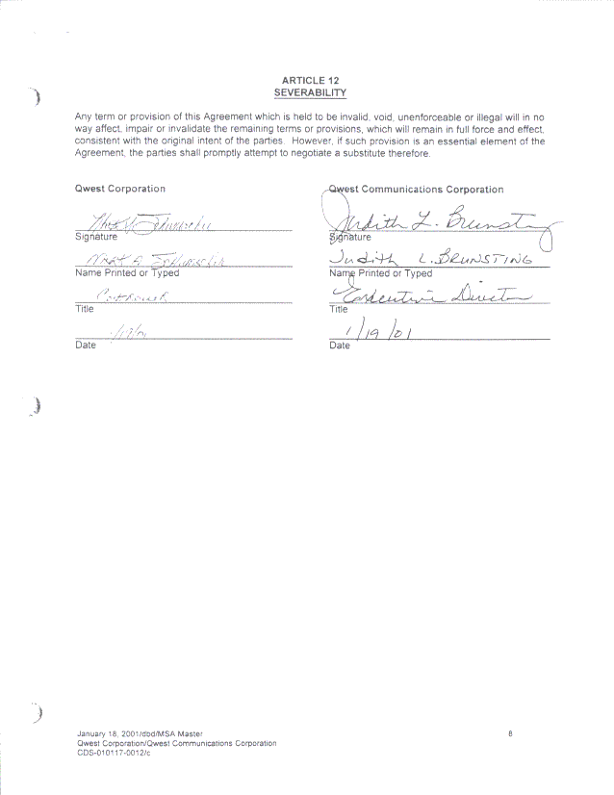

SUMMARY OF AFFILIATE TRANSACTIONS

Original Summary of Services Amendment ( # ) Terminated Services Asset Transfer

For services provided or assets transferred: ___to___ Qwest Corporation __from__ , a Qwest affiliate.
Is the Qwest affiliate a Section 272 subsidiary: ___

Description of Services Provided or Assets Transferred:

Effective Date: Termination Date (if applicable):

Estimated Annual Revenues/Expenses to Qwest Corporation or Gross Book Value, listed by Primary USOA Account:
Amount: Account:
$

Methodology of Assigning Qwest Revenues/Expenses to the States:
Standard company prorates
Other (Please explain below and specify the percentage assigned to each state.)

Assets transferred at higher__ or lower ___of net book value or fair market value.
Net book value by state: $
Fair market value by state: $

Expected Pricing Methodology for Services:
___Tariff
___Rates in publicly filed agreements submitted to a state commission pursuant to Section 252(e)
___Prevailing Company Price
___Higher of Fully Distributed Cost or Fair Market Value
___Lower of Fully Distributed Cost or Fair Market Value

For Transactions with Section 272 Subsidiaries, Please Provide the Following Information:

Special Equipment:
Number of Personnel Required:
Title(s) of Personnel and Level of Expertise:
Expected Frequency:
Pricing: See addendum for the actual prices charged.
Approved By:
Qwest Corporation Name of Qwest Affiliate:
Signed: ___________________________________ Signed: ________________________________________________
Printed Name: _____________________________ Printed Name: __________________________________________
Title: ____________________________________ Title: __________________________________________________
Date: ___________________________________ Date: __________________________________________________

Comments:

