BEFORE THE WASHINGTON UTILITIES AND TRANSPORTATION COMMISSION
In re Application of  SHUTTLE EXPRESS, INC.,  For Extension of Certificate No. C-975,  Shuttle Express, Inc. d/b/a Shuttle Express | Docket No. TC-091931  Permit No. C-975  WITNESS LIST AND HEARING EXHIBITS OF SHUTTLE EXPRESS

  - Applicant Shuttle Express hereby provides the following list of witnesses and exhibits pursuant to Order No. 3: Prehearing Conference Order:
John Rowley, President of Shuttle Express. Mr. Rowley will testify regarding background of Shuttle Expres, public need for operations in larger vehicles and Shuttle’s fitness to operate larger vehicles.
Stacy Mattson, Port of Seattle: Ms. Mattson will testify that it is in the public interest for Shuttle Express to operate larger vehicles than seven passenger vans at SeaTac Airport.
Courtney Touw, passenger: Mr. Touw will testify as to his experience as a passenger on Shuttle Express vans and the need for vans larger than seven passengers.
  - The Exhibits being produced by Shuttle Express are as follows:
Exhibit 1: Extension of Existing Auto Transportation.
Exhibit 2: Shuttle Express Schedule.
Exhibit 3: Press Release.
Exhibit 4: Photo of drive cam.
Exhibit 5: Photo of propane facility.
Exhibit 6: Photo of driver and van.
Exhibit 7: Photo of driver in uniform.
Exhibit 8: Photo of dispatch screen.
DATED this 12th day of November, 2010.
Miller Nash LLP
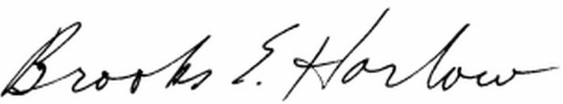
Brooks E. Harlow, P.C.
WSB No. 11843
brooks.harlow@millernash.com
(206) 622-8484

CERTIFICATE OF SERVICE
Docket No. Docket No. TC-091931
I hereby certify that a true and correct copy of the foregoing was forwarded via electronic mail and first class mail, postage fully prepaid, in a sealed envelope, to the following:

John Solin
Mike Lauver
SeaTac Shuttle, LLC
d/b/a Whidbey Seatac Shuttle
P.O. Box 2895
Oak Harbor, WA 98277
E-mail: mike@seatacshuttle.com

John Rowley
President
Shuttle Express, Inc.
800 SW 16th Street
Renton, WA 98055
jrowley@shuttleexpress.net

Dated at Seattle, Washington, this 12th day of November, 2010.
/s/________________________________
Carol Munnerlyn, Secretary

