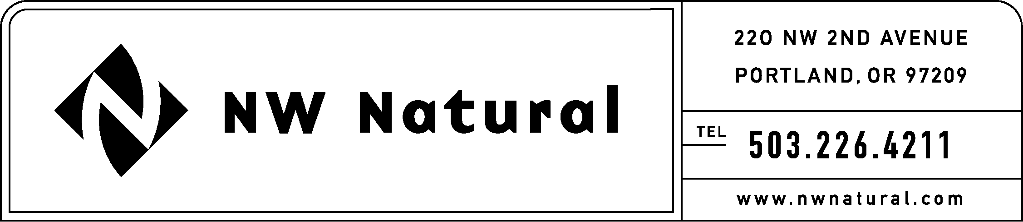
ONITA R. KING, MANAGER
TARIFFS AND REGULATORY COMPLIANCE
RATES AND REGULATORY AFFAIRS
Telephone: (503) 721-2452
Facsimile: (503) 721-2532
Email: ork@nwnatural.com

March 11, 2003

Secretary
Washington Utilities & TraTransportation Commission
P.O. Box 47250
Olympia, Washington 98504-7250

Re: Docket Number A-021178
Draft Financial Reporting Rules

NW Natural respectfully submits the following comments on changes proposed in the above-referenced matter. These comments are not necessarily final or all inclusive, and we reserve the right to add to, delete from, or revise our comments as the rules review process in this docket continues.

WAC 480-90-208 (4)
Subsection (b) of Section (4) as currently proposed is overly broad and unclear. This proposed new section requires further clarification in several areas, including but not necessarily limited to:

- The proposed rule does not limit the reporting to contracts that apply only to services offered in the state of Washington. Is it the intent that all essential gas services contracts, without regard to the state in which the contract is applicable, be subject to this subsection?

- If the costs associated with any particular essential gas services contract call for an allocation of costs across one or more states, and the Washington allocation is less than the $10,000,000 threshold, does this section apply to that contract?

- It is not clear what is meant by “anticipated associated charges.”

- The timing for making such filings is not specified.

- Gas purchase contracts are typically provided at the time of the company’s annual purchased gas cost adjustment filing. Would the continuation of that practice meet the requirements of this section?

WAC 480-146-330
We are concerned that the deletion of this section would have an undesirable impact on us. Please explain the rationale for the proposed deletion of this section.

We look forward to discussing these and other changes with you and other utilities at the April 10th workshop.

Thank you again for the opportunity to comment in this proceeding.

Sincerely,

NW NATURAL

Onita R. King, Manager
Tariffs and Regulatory Compliance

