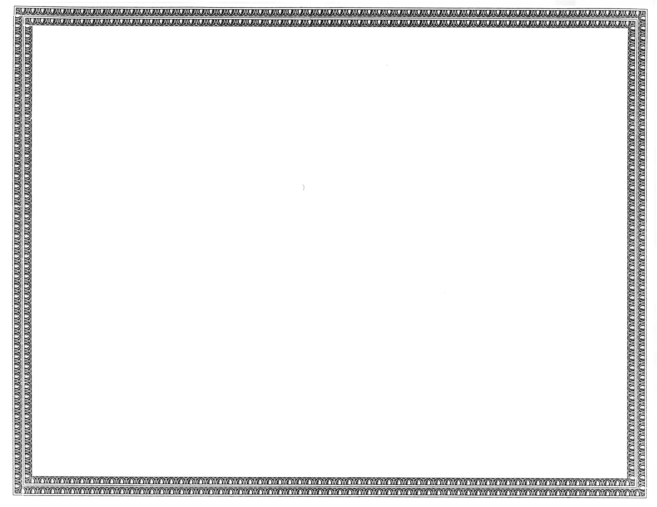



REGISTRATION
OF

Sidera Networks, LLC

AS A COMPETITIVE
TELECOMMUNICATIONS COMPANY

Docket Number UT-121463 October 7, 2012
Effective Date

DAVID W. DANNER

Executive Director and Secretary

CERTIFICATE IS NOT TRANSFERABLE

