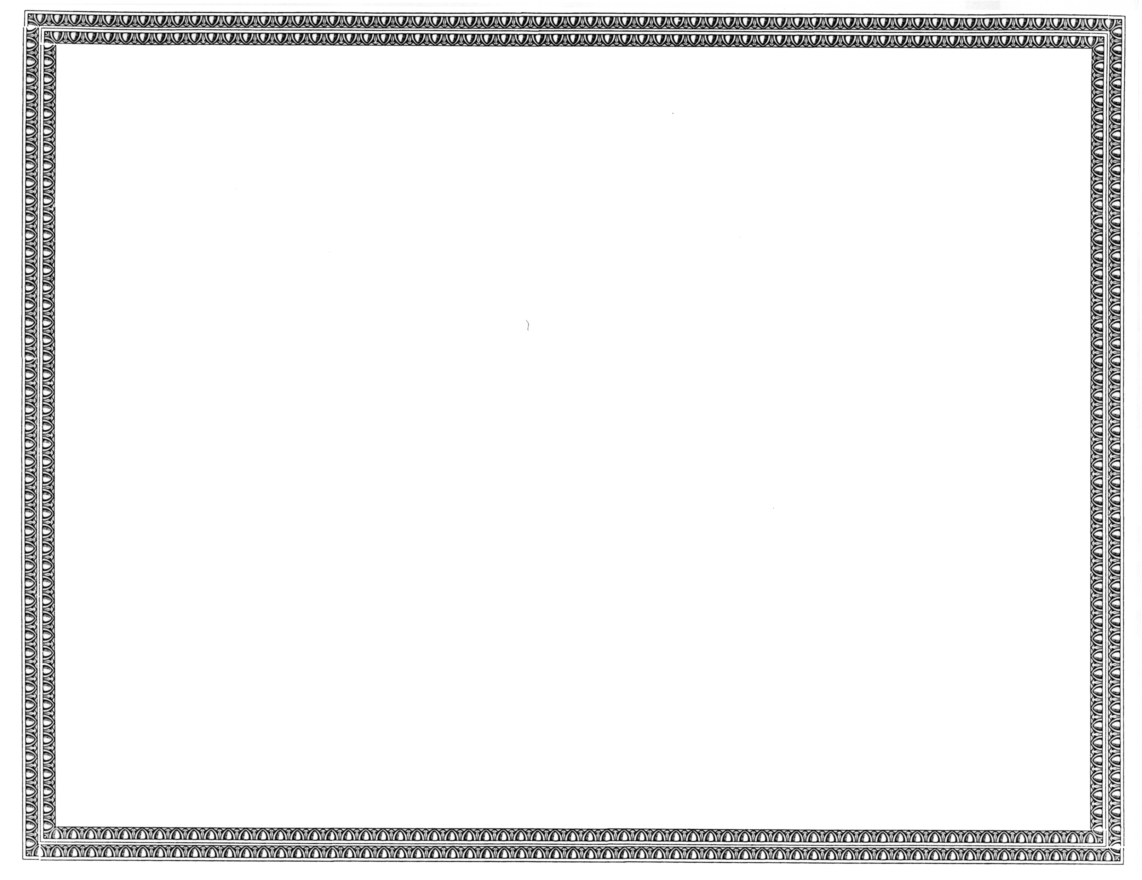



REGISTRATION
OF

DIECA Communications, Inc., d/b/a Covad Communications Company - CA

AS A COMPETITIVE
TELECOMMUNICATIONS COMPANY

Docket Number UT-111565 September 29, 2011
Effective Date

DAVID W. DANNER

Executive Director and Secretary

CERTIFICATE IS NOT TRANSFERABLE

