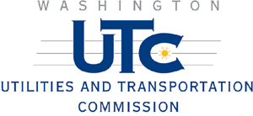

NOTICE

2nd Street HIGHWAY-RAIL GRADE CROSSING

BNSF Railway has filed a petition with the Utilities and Transportation Commission to close this railroad crossing. If you would like to comment on this petition, e-mail your comments to comments@utc.wa.gov or send your written comments to:

David W. Danner, Executive Director and Secretary
Washington Utilities and Transportation Commission
P.O. Box 47250
Olympia, WA 98504-7250

Please include our reference number, TR-080957. You must submit your comments by July 31, 2008. If you have questions about the proposed petition, call Lynda Johnson toll free at 1-800-562-6150 or send her an e-mail at comments@utc.wa.gov.

