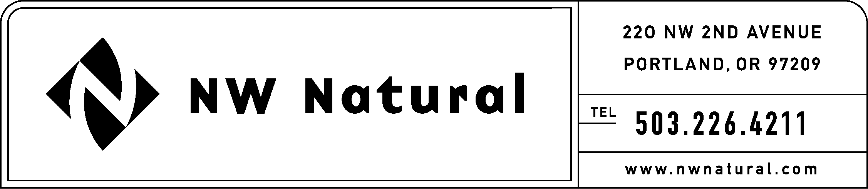
Rates and Regulatory Affairs
Fax: 503.721.2532

October 7, 2008

Washington Utilities & Transportation Commission
1300 S. Evergreen Park Drive, S.W.
P. O. Box 47250
Olympia, Washington 98504-7250

ATTN: Filing Center

RE: UG-080912, NW Natural’s 2009 IRP Revised Work Plan

On May 16, 2008, NW Natural filed its 2009 IRP Work Plan with WUTC Staff in compliance with Washington’s requirements for Least Cost Planning, WAC 480-90-238 (4), which states, “The work plan must outline the content of the integrated resource plan to be developed by the utility and the method for assessing potential resources.”

The Company now files a revised IRP Work Plan for informal review. This Work Plan provides greater specificity so as to comply with WAC 480-90 238(5) which states, “The work plan must outline the timing and extent of public participation.” Dates are now cited for the Technical Working Group meetings, the Public Participation Meeting and the Draft IRP filing date.

If you have any questions regarding this Plan, please contact me at
1-503-226-4211, extension 3590.

Sincerely,

/s/ Jennifer Gross

Jennifer Gross
Tariff and Regulatory Compliance Consultant

Enclosures

cc: Deborah Reynolds, WUTC Staff

