 |  |  |  |  |  |  | Commission Docket No. |  |  |  |  |  |  |  | UT-071634
 |  |  |  |  |  |  | Agenda Date Assigned
BEFORE THE WASHINGTON UTILITIES AND TRANSPORTATION COMMISSION

LESS THAN REQUIRED NOTICE REQUESTED BY:

Verizon Northwest Inc. 313-013-420
(Utility Name) |  |  |  |  |  |  |  |  |  |  |  |  | (Utility UBI Number)
Utility proposes |  | Renewal of Agreement for Analog and Digital CentraNet Service, CMAC and SMDR Service |  |  |  |  |  |  |  |  |  |  | Number |  | Contract No. 1345ICB
(Contract Title)
Indicate below, or attach, an explanation of the reason the company requests permission to file the proposed provisions with less than required notice.

Verizon Northwest respectfully requests this ICB contract become effective August 31, 2007. The customer’s current Agreement expired on 7/31/07 and with no effective contract in place, the Company reverted the Customer’s CNET Service to higher tariff rates effective 8/1/07 for the 30 day minimum period required under the tariff. The Customer would like their Service to move back under an effective contract as soon as possible because the rates are lower and the CMAC can only be provided under the contract. The Customer’s SMDR service can’t be provided under tariff due to their line size and has been disconnected. Once the new contract is made effective, SMDR can be put back into service.

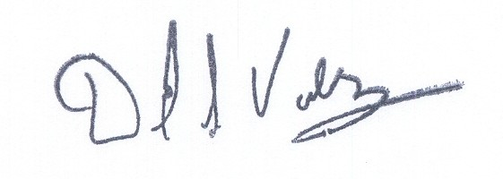  David S. Valdez-Sr. VP West, Public Affairs, Policy and Communications |  |  | is authorized to make filings on behalf of |  |  |  |  |  |  |  |  |  |  | Verizon Northwest Inc.
Signature and Title of Company Officer
I request these provisions become effective on |  |  |  | August 31, 2007
 |  |  |  |  |  |  |  |  | (Date)
 |  |  |  |  |  |  |  |  | Senior Vice President-West, Public Affairs, Policy and Communications
(Signature of Authorized Agent) |  |  |  |  |  |  |  |  | (Title)
David S. Valdez
(Print Name)
( 425 ) 261-5691 |  |  |  |  | (425 ) 261-5262 |  |  |  |  |  |  | David.s.valdez@verizon.com
(Telephone Number) |  |  |  |  | (Fax Number) |  |  |  |  |  |  | (E-Mail Address)
1800 41st St. MC: WA0105RA |  |  |  |  | Everett |  |  |  |  |  |  | WA |  |  |  | 98201
(Mailing Address) |  |  |  |  | (City) |  |  |  |  |  |  | (State) |  |  |  | (Zip Code)
WASHINGTON UTILITIES AND TRANSPORTATION COMMISSION

O R D E R
The Commissioners, having determined this order is consistent with the public interest, directed the Secretary to enter this order granting the provisions requested above.
DATED and signed at Olympia, Washington, this |  |  |  |  |  |  |  | Day of
 |  |  |  |  |  |  |  |  | (Month and Year)
 |  |  |  |  |  |  |  |  | Secretary
Util LRN Form 05/16/05

