 | 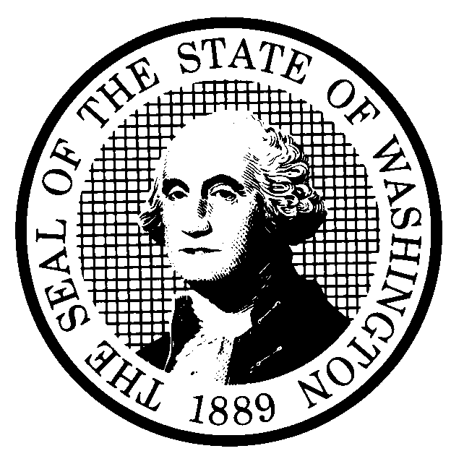 | EXPEDITED RULE MAKING |  |  |  |  | CR-105 (June 2004)  (Implements RCW 34.05.353)  EXPEDITED RULE MAKING ONLY
 | Agency: Washington Utilities and Transportation Commission
Title of rule and other identifying information: (Describe Subject)
Expedited rulemaking under RCW 34.05.353(1) (c) and (e) to include recently adopted Regulatory fee provisions, specifically Subsection (5) in WAC 480-120-303, 480-120-304,480-90-208, 480-100-208, and 480-110-275 at WSR #04-05-031 (Docket A-031232) that were mistakenly omitted in the repeal and reorganization of those sections to WAC 480-120- 382, 480-120-385, 480-90-252, 480-100-252, and 480-110-505^{t}in the Financial reporting rules rulemaking at WSR #05-06-051 (Docket A-021178). See Attachment A which illustrates the reorganization.
Docket No. A-060085
NOTICE
THIS RULE IS BEING PROPOSED UNDER AN EXPEDITED RULE-MAKING PROCESS THAT WILL ELIMINATE THE NEED FOR THE AGENCY TO HOLD PUBLIC HEARINGS, PREPARE A SMALL BUSINESS ECONOMIC IMPACT STATEMENT, OR PROVIDE RESPONSES TO THE CRITERIA FOR A SIGNIFICANT LEGISLATIVE RULE. IF YOU OBJECT TO THIS USE OF THE EXPEDITED RULE-MAKING PROCESS, YOU MUST EXPRESS YOUR OBJECTIONS IN WRITING AND THEY MUST BE SENT TO
Name: Carole J. Washburn, Executive Secretary, Docket No. A-060085
Agency: Washington Utilities and Transportation Commission
Address: P.O. Box 47250, Olympia, WA 98504-7250

AND RECEIVED BY (Date) March 20, 2006

Purpose of the proposal and its anticipated effects, including any changes in existing rules:

The purpose of this rulemaking is to correct a production error in a prior rule adoption in 2005. The effect of the error was to eliminate a provision that exempted telecommunications, gas, electric, and water chapters from the requirement to pay regulatory fees on de minimus revenue amounts, which was defined as less than $20.

This rulemaking will correct the error by restoring the de minimus exemption that had been in effect prior to the 2005 adoption error.

Reasons supporting proposal:

See above.
 | Statutory authority for adoption:  RCW 34.05.353, RCW 80.01.040, RCW 80.04.160. |  |  |  |  | Statute being implemented:
Is rule necessary because of a:  Federal Law?  Federal Court Decision?  State Court Decision?  If yes, CITATION: |  |  | Yes  Yes  Yes | No  No  No | CODE REVISER USE ONLY  Filed with the Code Reviser’s Office  January 18, 2006, 10:09 a.m.  WSR 06-03-129
DATE
January 18, 2006
NAME (TYPE OR PRINT)
Carole J. Washburn
SIGNATURE

TITLE
Executive Secretary

(COMPLETE REVERSE SIDE)
Name of proponent: (person or organization)  Washington Utilities and Transportation Commission |  |  |  | Private  Public  Governmental
Name of agency personnel responsible for:
 | Name | Office Location | Phone
Drafting............... Sharyn Bate |  | 1300 S. Evergreen Park Drive S.W. Olympia, WA 98504 | (360) 664-1295
Implementation.... Carole J. Washburn, Secretary |  | 1300 S. Evergreen Park Drive S.W. Olympia, WA 98504 | (360) 664-1174
Enforcement........ Carole J. Washburn, Secretary. |  | 1300 S. Evergreen Park Drive S.W. Olympia, WA 98504 | (360) 664-1174)
Agency comments or recommendations, if any, as to statutory language, implementation, enforcement, and fiscal matters:

None.

