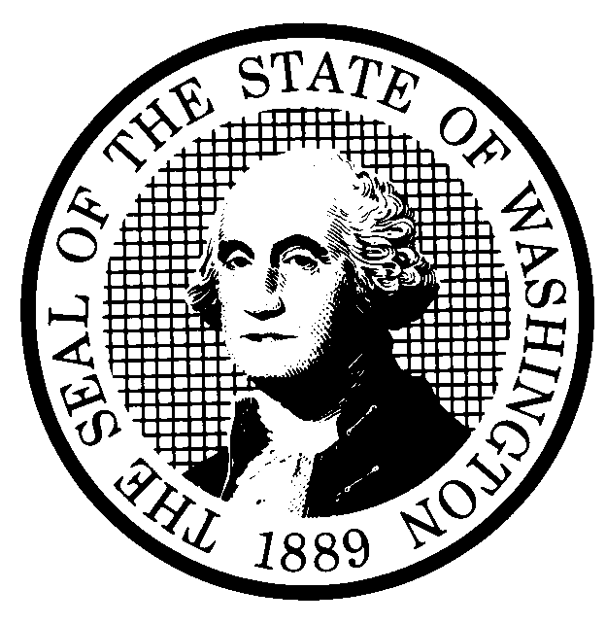 | PREPROPOSAL STATEMENT OF INQUIRY  (RCW 34.05.310) |  |  | CR-101 (7/22/01)  Do NOT use for expedited rule making
Agency: WASHINGTON UTILITIES AND TRANSPORTATION COMMISSION

Subject of possible rule making: This rulemaking would consider establishing a new standard for calculating the interest rate on customer deposits in Chapters 480-70 Solid Waste, 480-90 Gas Operations, 480-100 Electric Operations, and 480-110 Water Companies.
In addition, this rulemaking would consider amendment of WAC 480-100-148, Service responsibility, to clarify current language that may unintentionally prevent electric utilities from suspending services for reasonable periods in order to repair meters.
Docket No. A-020405
- Statutes authorizing the agency to adopt rules on this subject:

RCW 80.01.040, RCW 80.04.160, and RCW 81.04.160
- Reasons why rules on this subject may be needed and what they might accomplish:
In 1994, the Commission began using the 52-week Treasury bill rate to compute the interest rate payable on customer deposits. After February 2001, the 52-week Treasury bill auctions were eliminated. The interest on deposit rules in the four chapters listed above should be reviewed to consider establishing a new standard for calculating the interest rate on customer deposits.

WAC 480-100-148(2)(d) Service responsibility should be reviewed to consider amending current language that may unintentionally prevent electric utilities from suspending services for reasonable periods in order to repair meters.
- Identify other federal and state agencies that regulate this subject and the process coordinating the rule with these agencies:
FERC
(d) Process for developing new rule (check all that apply):
Negotiated rule making
Pilot rule making
X Agency study
X Other (describe)

The Commission will ask for initial written comments, and will provide the opportunity for additional comments.
(e) How interested parties can participate in the decision to adopt the new rule and formulation of the proposed rule before publication:
(List names, addresses, telephone, fax numbers of persons to contact; describe meetings, other exchanges of information, etc.)
Interested persons may contact the Secretary, Washington Utilities and Transportation Commission, P.O. Box 47250, 1300 S. Evergreen Park Drive, S.W., Olympia, Washington, 98504-7250; Telephone (360) 664-1174; Facsimile (360) 586-1150.
Interested persons may file written comments on the CR-101 by May 22, 2002. For specific information regarding opportunities for written comment and to ensure receipt of further information concerning this rulemaking, please see the attachment to this form.

 |  |  | CODE REVISER USE ONLY
NAME (TYPE OR PRINT)

CAROLE J. WASHBURN

SIGNATURE
TITLE  SECRETARY |  | DATE  4/25/02

WASHINGTON UTILITIES AND TRANSPORTATION COMMISSION
CR-101 - ATTACHMENT
DOCKET NO. A-020405

(e) Interested persons may contact the Secretary, Washington Utilities and Transportation Commission,
P. O. Box 47250, Olympia, Washington, 98504-7250, 360-664-1174 (Fax: 360-586-1150).

WRITTEN COMMENTS
Written comments may be submitted to the Commission at the address given above and should be filed with the Commission no later than May 22, 2002.

Electronic copies. The Commission also requests, but does not require, that comments be provided in electronic format to facilitate quotations from the comments, to enhance public access, and to reduce the need for additional paper copies. Please help us by sending an electronic copy with your paper filing on a 3-1/2 inch, IBM-formatted, high density disk, in .pdf Adobe Acrobat format, reflecting the pagination of your original. Also send us the text in your choice of .doc (Word 97 or later) or .wpd (Wordperfect 6.0 or later) and include all of the following information on the label of the diskette:
* The docket number of this proceeding (A-020405)
* The commenting party's name
* The title and date of the comment or comments; and
* The type of software used
Please use the three-letter extension noted above for all electronic files. You may also send your comments by electronic mail to the Commission's Records Center at <records@wutc.wa.gov>; if you choose this means of submitting comments, include all of the information requested above for the diskette label. The Commission will post on the Commission's web site all comments that are provided in electronic format. The web site is located at <http://www.wutc.wa.gov/020405>.
Opportunity for further comment is anticipated. Information about the schedule and other aspects of the rulemaking, including comments, will be posted on the Commission’s web site as it becomes available. If you wish to receive further information on this rulemaking you may (1) call the Commission’s Records Center at 360-664-1234, (2) e-mail the Commission at <records@wutc.wa.gov>, or (3) mail written comments to the address above to the attention of Carole J. Washburn, Secretary. When contacting the Commission, please refer to Docket No. A-020405 to ensure that you are placed on the appropriate service list. Questions may be addressed to Sharyn Bate (360) 664-1295 or e-mail at sbate@wutc.wa.gov.

TO CONTINUE RECEIVING NOTICES AND INFORMATION ABOUT THIS RULEMAKING -- The Commission wants to ensure its mailings are sent to persons who are interested in the topic and want to receive that information. ANY PERSON WHO COMMENTS will continue to receive notices and information. If you do not submit comments but wish to remain on the mailing list for this rulemaking, please advise the Records Center by any one of the following methods: (1) send a note with your name, address (or a copy of your mailing label), and telephone and fax numbers referencing Docket No. A-020405, and the words "Please keep me on the mailing list"; or (2) E-mail your name, address, telephone and fax numbers, referencing Docket No. A-020405, and the words "Please keep me on the mailing list" to records@wutc.wa.gov. Please note that all information in the mailings will be accessible through the Commission's Internet web site at <http://www.wutc.wa.gov/>. THOSE PARTIES WHO DO NOT RESPOND MAY NOT RECEIVE FURTHER MAILINGS OR INFORMATION ON THE RULEMAKING.

NOTICE

