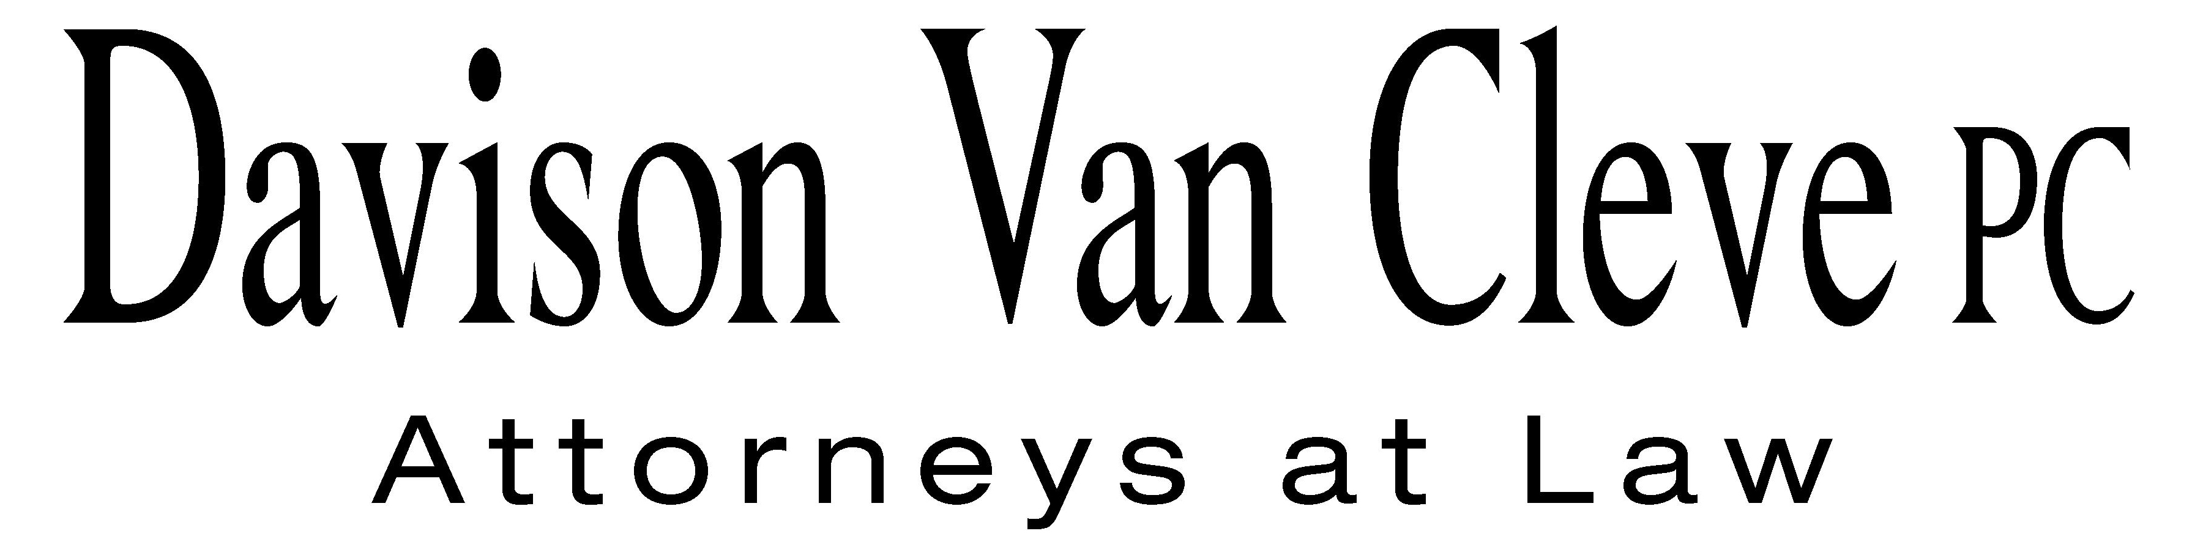
TEL (503) 241-7242 ● FAX (503) 241-8160 ● mail@dvclaw.com
Suite 400
333 SW Taylor
Portland, OR 97204

July 8, 2011

Via Email and Federal Express

Mr. David E. Danner
Secretary
Washington Utilities and Transportation Commission
PO Box 47250
1300 S Evergreen Park Drive SW
Olympia, WA 98504-7250

Re: In the matter of WUTC v. PacifiCorp.
Docket No. UE-111190

Dear Mr. Danner:

Enclosed please find an original and twelve (12) copies of the Petition to Intervene of the Industrial Customers of Northwest Utilities.

Additionally, please find an original and twelve (12) copies of the Notice of Appearance of Melinda J. Davison and Irion A. Sanger on behalf of the Industrial Customers of Northwest Utilities.

Thank you for your assistance.

Sincerely yours,

/s/ Sarah A. Kohler
Sarah A. Kohler
Enclosures

cc: Service List

CERTIFICATE OF SERVICE

I hereby certify that I have this day served the foregoing documents upon all parties of record in this proceeding by mailing a copy thereof in a sealed, first-class postage prepaid envelope to each individual’s last-known address, as listed below.
DATED this 8th day of July, 2011.
Davison Van Cleve, P.C.

/s/ Sarah A. Kohler
Sarah A. Kohler

ANDREA KELLY  VICE PRESIDENT, REGULATION  PACIFICORP  825 NE MULTNOMAH, SUITE 800  PORTLAND OR 97232  andrea.kelly@pacificorp.com | JORDAN WHITE  SENIOR COUNSEL  PACIFICORP  1407 W NORTH TEMPLE, SUITE 320  SALT LAKE CITY UT 84116  jordan.white@pacificorp.com
KATHERINE MCDOWELL  MCDOWELL & RACKNER P.C.  419 SW 11TH AVENUE STE 400  PORTLAND OR 97204  katherine@mcd-law.com | SIMON FFITCH  OFFICE OF THE ATTORNEY GENERAL  PUBLIC COUNSEL  800 FIFTH AVENUE STE 2000  SEATTLE WA 98104-3188  simonf@atg.wa.gov
GREG J TRAUTMAN
ASSISTANT ATTORNEY GENERAL
WUTC
ATTORNEY GENERAL SECTION
STATE MAIL STOP 40128
gtrautma@utc.wa.gov

