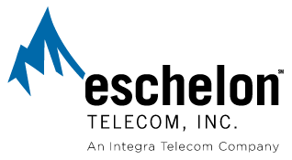

May 13, 2008

Ms. Carole J. Washburn
Executive Secretary
WA Utilities & Transportation Commission
1400 S. Evergreen Park Drive S.W.
P.O. Box 40128 Via Email to: records@utc.wa.gov
Olympia, WA 98504-0128 and Overnight Delivery

Re: DOCKET NO. UT-061443, IN THE MATTER OF THE PETITION OF ESCHELON TELECOM OF WASHINGTON, INC. FOR APPROVAL OF AN ALTERNATIVE MEASUREMENT OF SERVICE QUALITY REPORTING PURSUANT TO WAC 480-120-439(12) – March 2008 Report

Dear Ms. Washburn:

Enclosed for filing with the Washington Utilities and Transportation Commission is the monthly service quality report of Eschelon Telecom, Inc.’s Washington affiliates in accordance with WAC 480-120-439 and Order 01 in Docket UT-061443 for the month of March 2008.

Should Commission Staff have any questions or concerns, please contact me directly.

Sincerely,

Cathy Murray
Eschelon Telecom, Inc.
An Integra Telecom Company
730 2nd Avenue South, Suite 900
Minneapolis, MN 55402-2456
(612) 436-1632 (direct)
(612) 436-6816 (department fax)
camurray@integratelecom.com

Enclosure (Email Attachment)
cc: Kristen Russell, WUTC, via email

