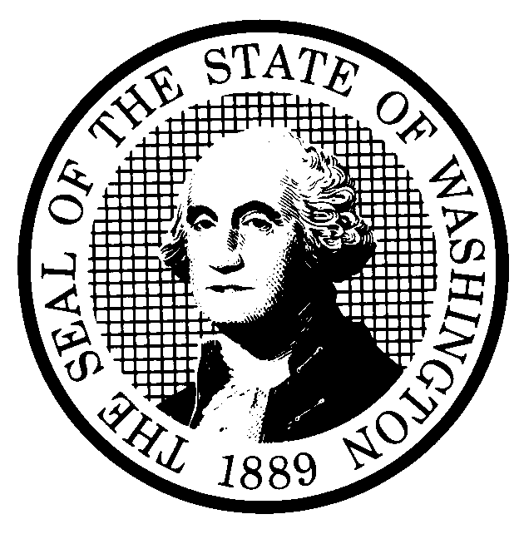 | PREPROPOSAL STATEMENT OF INQUIRY  (RCW 34.05.310) |  |  | CR-101 (710/97)  Do NOT use for expedited repeal or adoption
Agency: Washington Utilities and Transportation Commission

Subject of possible rule making:
Examine the need to adopt rules relating to cessation of telecommunications services including but not limited to notice requirements, services covered, and responsibilities of remaining companies. WAC 480-120-083. Docket No. UT-010558
- Statutes authorizing the agency to adopt rules on this subject:

RCW 80.01.040(4) and RCW 80.04.160

- Reasons why rules on this subject may be needed and what they might accomplish:

Rules may be needed because changing conditions in the telecommunications industry may, without warning, cause business failures and decisions to exit the market. Rules may assist in the orderly transition of service to protect public health, safety, and economic vitality.

- Identify other federal and state agencies that regulate this subject and the process coordinating the rule with these agencies:

N/A
(d) Process for developing new rule (check all that apply):
Negotiated rule making
Pilot rule making
X Agency study
X Other (describe)

The Commission will ask for initial written comments, and will provide the opportunity for additional comments. The Commission hasl scheduled a workshop for representative of affected constituencies in a manner designed to develop consensus among affected interests regarding any rule proposal. The time and place of the workshop is set out on the attachment to this statement.
(e) How interested parties can participate in the decision to adopt the new rule and formulation of the proposed rule before publication:
Interested persons may contact the Secretary, Washington Utilities and Transportation Commission, P.O. Box 47250, 1300 S. Evergreen Park Drive, S.W., Olympia, Washington, 98504-7250; Telephone (360) 664-1174; Facsimile (360) 586-1150.

For specific information regarding opportunities for written comment, opportunities for participation in workshops, and to ensure receipt of further information concerning this rulemaking, please see the attachment to this form.

 |  |  | CODE REVISER USE ONLY
NAME (TYPE OR PRINT)
Carole J. Washburn

SIGNATURE
TITLE  Secretary |  | DATE  June 6, 2001

