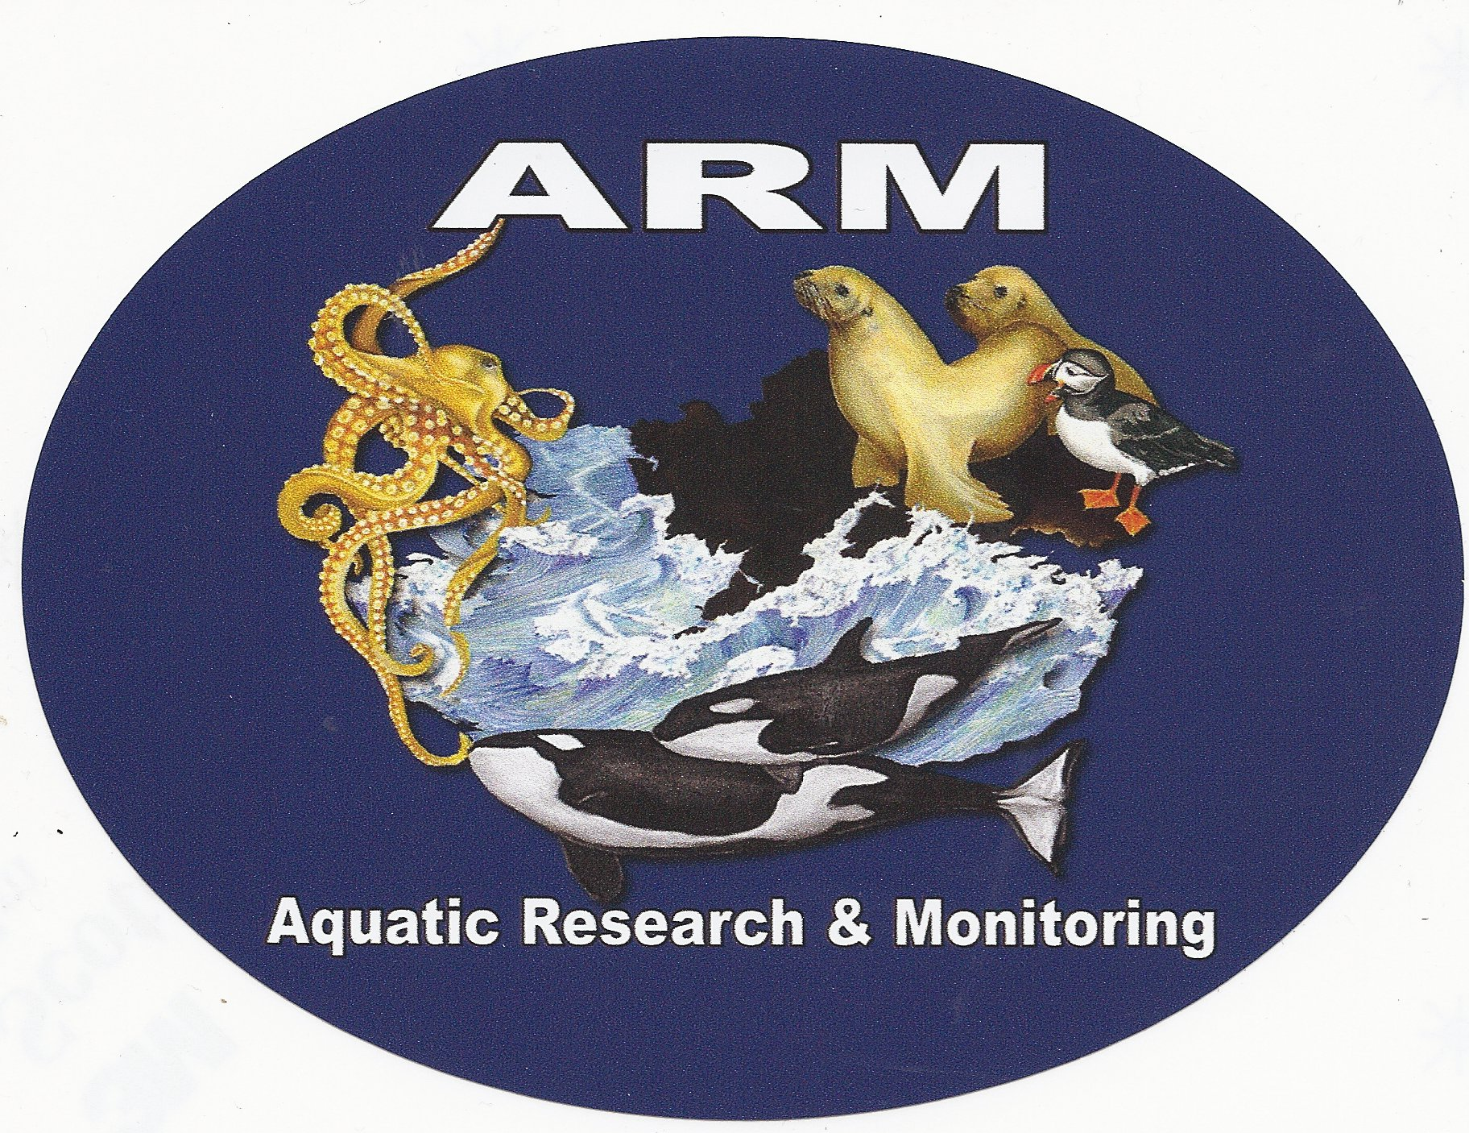

Aquatic Research & Monitoring

WITNESS LIST

At this time I Terry Buzzard anticipate being the only witness representing Island Mariner Cruises.

Terry Buzzard

