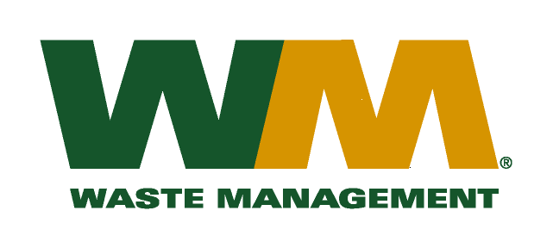
July 30, 2026
David W. Danner
Executive Director and Secretary
Washington Utilities and Transportation Commission
Chandler Plaza Building
1300 S. Evergreen Park Drive SW
P.O. Box 47250
Olympia, WA 98504-7250

Re: Waste Management – Northwest – TG-101220;
Waste Management – Sno-King – TG-101221; and
Waste Management – South Sound and Waste Management of Seattle – TG-101222
Dear Secretary Danner:
In accordance with Order 06 to the “Initial Order Approving and Adopting Partial Settlement Agreement”, enclosed are substitute revised tariff pages to the above-referenced dockets. Please do not re-docket.
If you have any questions or need additional information, please contact me at (425) 814-7840.
Very truly yours,

Mike Weinstein
Senior Pricing Manager, Pacific Northwest Market Area

cc: Sego Jackson, Snohomish County Solid Waste Division
Bill Reed, King County Solid Waste Division
Jeff Gaisford, King County Solid Waste Division

