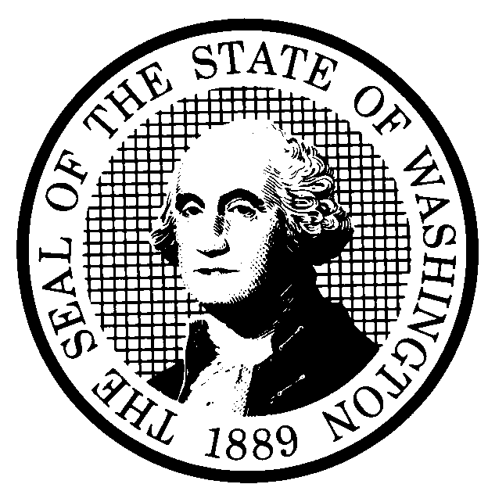 | PROPOSED RULE MAKING  (RCW 34.05.320) |  |  |  |  |  |  |  |  | CR-102 (7/22/01)  Do NOT use for expedited  rule making
Agency: WUTC |  |  |  |  |  |  |  |  |  | Original Notice
Preproposal Statement of Inquiry was filed as WSR ; or  Expedited Rule Making -- Proposed notice was filed as WSR ; or  X Original Proposal is exempt under RCW 34.05.330(1)(b). |  |  |  |  |  |  |  |  |  | X Supplemental Notice  to WSR 03-16-063  Continuance of WSR
(a) Title of rule: (Describe Subject) WAC 480-120-146, Changing service providers from one local exchange company (LEC) company to another. On June 17, 2003, Qwest Corporation filed a petition to amend this section to clarify the process to be followed when a customer migrates from one LEC to another, and the customer retains his/her telephone number via Local Number Portability (LNP).

This supplemental proposal differs from the original Qwest proposal by adopting detailed national standards in Federal Communications Commission (FCC) rules for LNP. Qwest participated in drafting the revised rule language, and Qwest supports the rule revisions.
Purpose: This supplemental proposal would provide the companies with more options for compliance when customers change LEC service providers compared to the original Qwest proposal by adopting national LNP guidelines. In addition, the supplemental proposal would achieve compliance with Commission-approved interconnection agreements.

Other identifying information: Docket No. UT-030964
(b) Statutory authority for adoption: RCW 80.01.040, RCW 80.04.160, and RCW 34.05.330 |  |  |  |  |  |  |  |  | Statute being implemented:
(c) Summary: See (j) below

Reasons supporting proposal:

(d) Name of Agency Personnel Responsible for: |  |  |  |  |  | Office Location |  |  |  |  | Telephone
1. Drafting............... Tom Wilson, Regulatory Analyst |  |  |  |  |  | 1300 S. Evergreen Park Drive S.W., Olympia, WA. |  |  |  |  | 360-664-1282
2. Implementation....Carole J. Washburn, Secretary |  |  |  |  |  | 1300 S. Evergreen Park Drive S.W., Olympia, WA |  |  |  |  | 360-664-1174
3. Enforcement........Carole J. Washburn, Secretary |  |  |  |  |  | 1300 S. Evergreen Park Drive S.W., Olympia, WA |  |  |  |  | 360-664-1174
(e) Name of proponent (person or organization):  Qwest Corporation |  |  |  |  |  |  |  |  |  |  | X Private  Public  Governmental
(f) Agency comments or recommendations, if any, as to statutory language, implementation, enforcement and fiscal matters:

(g) Is rule necessary because of:  Federal Law?  Federal Court Decision?  State Court Decision? |  | Yes  Yes  Yes |  |  | X No  X No  X No |  | If yes, ATTACH COPY OF TEXT  Citation:
(h) HEARING LOCATION: |  |  |  |  |  |  |  | Submit written comments to:
Commission Hearing Room  Second Floor, Chandler Plaza Building  1300 S. Evergreen Park Drive SW  Olympia, WA 98504 |  |  |  |  |  |  |  | Carole J. Washburn, Secretary, P.O. Box 47250  Olympia, WA 98504 or  E-mail to records@wutc.wa.gov Please include  Docket No. UT-030964 in your communication.  FAX (360) 586-1150 By February 25, 2004
Date: March 24, 2004 Time: 9:30 a.m. |  |  |  |  |  |  |  | DATE OF INTENDED ADOPTION: March 24, 2004
Assistance for persons with disabilities: Contact  Mary De Young by March 19, 2004 |  |  |  |  |  |  |  | CODE REVISER USE ONLY
TDD (360) 586-8203 or (360) 664-1133
NAME (TYPE OR PRINT)  CAROLE J. WASHBURN |  |  |  |  |  |  |  | Filed with the Code Reviser's Office  January 21, 2004
SIGNATURE |  |  |  |  |  |  |  | 11:20 a.m.  WSR# 04-03-117
TITLE  EXECUTIVE SECRETARY |  |  | DATE  JANUARY 21, 2004
(COMPLETE REVERSE SIDE)
(j) Short explanation of rule, its purpose, and anticipated effects:
This supplemental proposal continues to address issues raised by Qwest in its petition for rulemaking filed at WSR#03-16-063. Namely, the proposed language would permit Qwest to meet the intent as well as the letter of the rule plus comply with Commission-approved interconnection agreements. The supplemental proposal differs from the original Qwest proposal by providing greater flexibility to address all of the types of situations that arise when customers change LECs. The proposed language addresses the issue of flexibility by referencing detailed national standards in FCC rules for LNP. Compliance with national LNP guidelines also permits continued compliance with Commission-approved interconnection agreements. Moreover, adoption of the national guidelines will ease the task of compliance for those companies that operate in multiple jurisdictions.

The proposed revised language will allow companies to utilize resources more efficiently and continue to service customers effectively.

Does proposal change existing rules? | X YES NO | If yes, describe changes:
Existing WAC 480-120-146, Changing service providers from one LEC to another, does not address the situation where the migrating customer wishes to retain his/her telephone number through LNP.

In its petition for rulemaking, Qwest proposed that WAC 480-120-146 be amended to include a process for those customers who wish to retain the same telephone number via LNP. Qwest’s original proposal recommended adoption of the LNP practices ordered in Docket No. UT-003022/UT-003040.

This supplemental proposal would offer companies more options for compliance with the rule by adoption of national guidelines, in contrast to the original Qwest proposal that would prescribe a single method of compliance.

(k) Has a small business economic impact statement been prepared under chapter 19.85 RCW?
Yes. Attach copy of small business economic impact statement.
A copy of the statement may be obtained by writing to:

telephoning: ( )
faxing: ( )
X No. Explain why no statement was prepared
The proposed rule streamlines the process for confirming migrations from LEC to LEC using LNP, and utilizes resources more efficiently. Because there will not be any increase in cost resulting from the proposed rule, an SBEIS is not required.

(l) Does RCW 34.05.328 apply to this rule adoption? Yes X No
Please explain:
The commission is not an agency to which RCW 34.05.328 applies. The proposed rule is not a significant legislative rule of the sort referenced in RCW 34.05.328(5).

