March 19, 2013

BY OVERNIGHT DELIVERY

Steven V. King
Acting Executive Director and Secretary
Washington Utilities & Transportation Commission
1300 S. Evergreen Park Drive SW
P.O. Box 47250
Olympia, WA 98504-7250

Re: Docket No. UG-121434 – Northwest Natural Gas Company

Dear Mr. King:

This letter is filed on behalf of Northwest Natural Gas Company (“NW Natural” or “Company”) and responds to issues raised by Staff of the Washington Utilities and Transportation Commission (“Commission”) and Public Counsel in their March 1 and March 8, 2013, filings in Docket UG-121434, NW Natural’s Annual Purchased Gas Adjustment (“PGA”) proceeding.
Background
On August 31, 2012, NW Natural filed its Annual Purchased Gas Cost Adjustment with the Commission. The purpose of NW Natural’s filing was to revise rates to incorporate (a) changes in purchased gas costs, and (b) the application and removal of temporary rate adjustments to amortize balances in deferred accounts.

On October 25, 2012, Staff recommended that the Commission issue a complaint and order suspending NW Natural’s tariff revisions and allow the tariff revisions to become effective on November 1, 2012, on a temporary basis, subject to revision. Staff made similar requests in the PGA dockets for the other three jurisdictional Local Distribution Companies (“LDCs”), voicing its concern as to whether the LDCs’ policies of financially hedging significant portions of their gas commodity requirements was increasing the gas costs paid by customers. Accordingly, Staff requested the suspension to allow time to investigate the financial hedging activities and policies of all LDCs regulated by the Commission.

On October 31, 2012, the Commission issued a Complaint and Order Suspending Tariff Revisions\*; Allowing Rates on a Temporary Basis, Subject to Revision. The Commission agreed with Staff that “an investigation is warranted into the hedging and procurement practices of Northwest Natural and the other natural gas companies the Commission regulates.” The Commission required Staff to report on the status of its investigation no later than March 1, 2013. Staff subsequently issued data requests to the LDCs, and retained a subject matter expert to assist in the analysis.

On March 1, 2013, Staff filed its report regarding the natural gas hedging policies and practices of NW Natural and the other regulated gas utilities. In that report, Staff observed that the issues raised by the LDCs’ hedging practices were “significant” and “highly complex” and that they had “proven difficult to examine fully and resolve in the time frame allowed for tariff revisions.” Therefore, Staff recommended that the Commission dismiss the Complaint and Order Suspending Tariff Revisions\* and allow the temporary rates to become effective on a permanent basis without disallowance. Staff also recommended that the Commission issue a CR 101 and commence workshops to examine whether a rulemaking, policy statement or other procedure should be pursued with respect to the natural gas hedging practices and policies of Commission-regulated natural gas utilities.

Also on March 1, 2013, Public Counsel filed comments. Contrary to Staff’s recommendation, Public Counsel “recommends that the PGA dockets for Puget Sound Energy, NW Natural, Avista, and Cascade remain open, that the tariffs remain suspended, and if necessary, that the matters be set for hearing.” Thereafter, on March 8, 2013, Public Counsel filed a report
supporting its recommendations. In that report, Public Counsel argued that the Company’s hedging program has resulted in large losses, higher gas costs for customers, and has not reduced price volatility. Public Counsel also argued that the Commission should consider a disallowance from recovery of gas costs and requested that the Commission order NW Natural to suspend its hedging program pending the receipt of recommendations from the Commission and interested parties.
The Commission should Close this Docket and Consider Potential Policy Changes in a Generic Proceeding for Prospective Company Action.
The Company agrees with Staff’s recommendation that the Commission should make the temporary rates permanent, close the PGA dockets, and open a generic proceeding to develop hedging policies and directives. To date the Commission has not issued any policy guidance to gas utilities regarding hedging practices, and both Staff and Public Counsel have expressed concerns on this subject. Therefore, NW Natural believes it would be prudent for the Commission to fully examine the hedging issue and make findings and recommendations to guide LDC’s hedging practices in the future. Moreover, consistent with Staff’s recommendation, this investigation should be made in the context of a general policy docket or rulemaking proceeding. Washington law encourages the Commission to adopt general principles through rulemaking or through the pronouncement of policy statements—not through individual adjudicatory proceedings. Moreover, the use of a generic proceeding is also consistent with recent Commission precedent, which has used generic proceedings to develop generally applicable regulatory polies.
The use of a generic proceeding also ensures that whatever policy is adopted by the Commission is applied prospectively only, as the retroactive application of new agency policy can be highly problematic. A retroactive disallowance, as proposed by Public Counsel in this case, is particularly problematic because the disallowance would be based on a newly developed hedging policy that was not in effect when the Company entered into the hedges for the 2013 PGA year. Staff correctly observed that the Commission “has not previously issued a policy statement or order setting forth guidelines regarding the hedging policies and practices of natural gas companies . . . [and] the companies’ historical losses have been recovered through the PGA tariffs without prior dispute by staff or disallowance by the commission.” Indeed, NW Natural has been engaged in financial hedging since 1995 and NW Natural’s hedging activities are conducted pursuant to a prescriptive, written risk management policy that has never been questioned by either parties or the Commission. As Staff noted, NW Natural has consistently recovered the losses and shared the gains from its hedging activities through the PGA mechanism.
Public Counsel’s Criticisms of NW Natural’s Hedging Practices are Flawed.
Public Counsel argues that the Commission should disallow a portion of NW Natural’s gas costs because Public Counsel claims that “the Company’s gas price hedging program has resulted in large losses and higher cost of gas for retail customers.” Public Counsel’s argument is unpersuasive for two reasons.

First, Public Counsel’s own analysis demonstrates that financial hedging has resulted in customer savings in 6 of the 11 years examined. Indeed, over 73 percent of the net loss cited by Public Counsel over the 11 year period was generated in a single outlier year—November 2008 through October 2009. This was the same year that the United States economy experienced the greatest financial stress since the Great Depression and the same year that gas prices unexpectedly plummeted. The Company’s losses in that one year should not be relied upon as evidence that its overall hedging program is deficient.

In addition, Public Counsel’s proposed disallowance is also based on hedges executed in August and September 2011 for April to October 2012. Public Counsel argues that the hedges exceeded the April to October 2012 prices and were therefore imprudent. However, as set forth in the following chart, gas prices from April to October 2012 were also near historic low points and Public Counsel’s reliance on data from only these months fails to demonstrate that their proposed disallowance is reasonable.
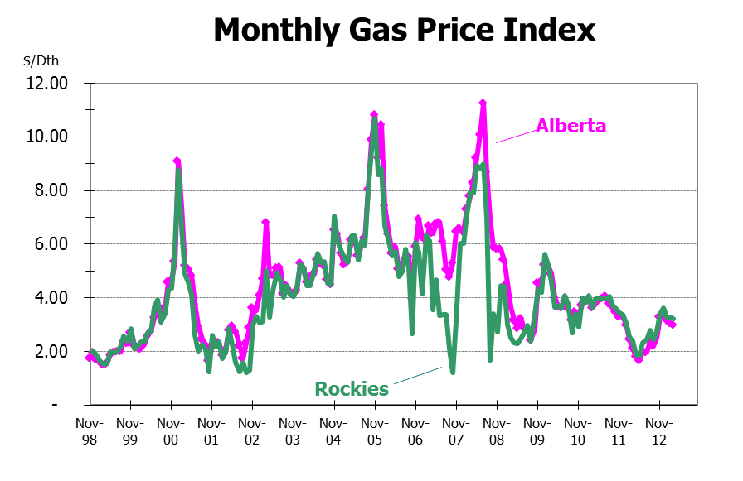
Period examined by Public Counsel
In fact, had the Company failed to hedge the contracts that Public Counsel proposes to disallow, those supplies would have been priced at the PGA spot price and the average embedded WACOG would have been higher, leading to greater price volatility for customers.

Thus, while Public Counsel’s data demonstrates that the magnitude of the market movements over the last 11 years has resulted in a net loss, neither this fact by itself nor Public Counsel’s analysis demonstrates that NW Natural’s hedging program is inherently disadvantageous to customers or otherwise systematically resulting in higher customer gas costs. Quite the contrary, as further discussed below, the Company’s hedging program has provided price stability at a minimal cost to customers.

Second, Public Counsel’s argument relies on improper hindsight review to analyze the prudence of the Company’s hedging policy in violation of the Commission’s prudence
standard. Public Counsel argues that certain hedges were imprudent because the hedge price
ultimately exceeded the actual monthly index prices as they became known. However, Public Counsel’s analysis fails to examine market expectations at the time each hedge was executed. This failure on the part of Public Counsel is critical because NW Natural executes hedges “at the market.” This means that each financial hedge, at the time it is executed, reflects market expectations for those future months to which the transaction is applicable. Thus, the Company is not trying to beat the market or use hedging to speculate on future market prices. Rather, hedging acts like an insurance policy against future price increases or volatility.

The flaw in Public Counsel’s reasoning is evident in its own analysis, which demonstrates that forward market prices were consistently higher than spot market prices during 2011 and early 2012. This means that the market, not NW Natural, expected prices to increase. NW Natural’s reliance on market expectations is wholly reasonable. Indeed, if Public Counsel’s position is adopted, NW Natural could be found prudent only if it deviates from market expectations and is able to beat the market.

Public Counsel also argues that “[i]n the most recent two PGA years, it should have been quite obvious that spot market prices were significantly outperforming the forward market prices.” Again, this argument is flawed because the evaluation of a hedge must examine whether the hedge price is reasonable in light of the market expectations in existence at the time the hedge is executed. Public Counsel argues instead that if a forward market price exceeds the current spot market price, it is unreasonable to execute a hedge. This conclusion is sound only if one assumes that present conditions are perfectly indicative of the future, i.e., that NW Natural could transact in the future at the current spot market price. This assumption is clearly invalid and therefore Public Counsel’s underlying analysis should be rejected.

Public Counsel also claims that NW Natural’s hedging policy has not significantly reduced the Company’s PGA rate volatility. To support this claim, Public Counsel purports to show the Company’s PGA volatility since 2005. However, Public Counsel’s analysis fails to compare the Company’s PGA volatility to the volatility of actual market prices during the same time period. In other words, the question is not whether the PGA prices were volatile, but whether the PGA’s price volatility was greater than it would have been if no hedging had occurred. As shown in the chart below, the Company’s PGA experienced less volatility than the monthly index prices at the buying locations used by the Company. The Company’s hedging policy acted precisely as intended—it reduced the price volatility that would have occurred if the Company had relied on spot market purchases instead of financial hedges.
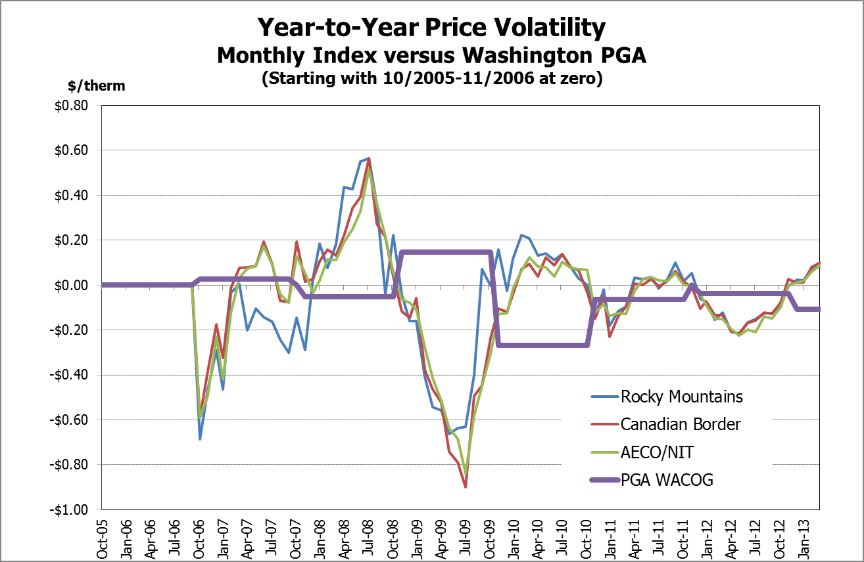

The Commission should Reject Public Counsel’s Request for an Immediate Suspension of the Company’s Hedging Practices.
Public Counsel also recommends that the Commission “order the Company to suspend entering into any new hedging transaction until it has received recommendations from Staff, Public Counsel and other parties on an appropriate hedging program . . .” This recommendation should be rejected. As discussed above, Public Counsel has failed to demonstrate that the Company’s current hedging policy is harmful to customers. Moreover, suspension of the Company’s hedging practices will likely result in greater price volatility, a result that is contrary to customer’s interests. Public Counsel’s request may also cause actual customer harm because it assumes that the market will decrease, or not increase appreciably. Public Counsel has provided no evidence to support the assumption that market prices will behave as their recommendation assumes and if the market prices increase then customers will pay more than they would if the Company utilized a hedge.

While the Company appreciates the concerns expressed by Staff and Public Counsel regarding its hedging practices, the Company disagrees with Public Counsel that the Commission should keep this docket open or disallow a portion of the Company’s gas costs. Rather, the Company supports Staff’s proposal to initiate a generic proceeding, which will allow the Commission to examine in detail NW Natural’s practices and provide guidance for prospective Company action.

The Company looks forward to answering any questions the Commission may have at the March 22, 2013 Public Meeting.

Respectfully submitted,

Lisa Rackner

cc: Judge Adam E. Torem (by electronic mail)
Parties of Record (by electronic mail)

Wash. Util. and Transp. Comm’n v. Northwest Natural Gas Co., Docket UG-121434, Order 01, ¶ 7 (Oct. 31, 2012).
Wash. Util. and Transp. Comm’n v. Northwest Natural Gas Co., Docket UG-121434, Report of Commission Staff Regarding the Natural Gas Hedging Policies and Practices of Avista Corp., Puget Sound Energy, Inc., Cascade Natural Gas Corp., and Northwest Natural Gas Co. (Mar. 1, 2013) (hereinafter “Staff Report”).
Id. at 4.
Id. at 5.
Id. at 5.
Wash. Util. and Transp. Comm’n v. Northwest Natural Gas Co., Docket UG-121434, Comments on behalf of Public Counsel (Mar. 1, 2013).
Wash. Util. and Transp. Comm’n v. Northwest Natural Gas Co., Docket UG-121434, Report on Natural Gas Procurement Practices of Northwest Natural Gas Company Docket UG-121434 on Behalf of Public Counsel (Mar. 8, 2013) (hereinafter “Public Counsel Report”).
Id. at 15.
Id. at 15.
See RCW 34.05.220(4) (“Each agency that is authorized by law to exercise discretion in deciding individual cases is encouraged to formalize the general principles that may evolve from these decisions by adopting the principles as rules that the agency will follow until they are amended or repealed.”); RCW 34.05.230(1) (“An agency is encouraged to advise the public of its current opinions, approaches, and likely courses of action by means of interpretive or policy statements. Current interpretive and policy statements are advisory only. To better inform and involve the public, an agency is encouraged to convert long-standing interpretive and policy statements into rules.”).
See e.g. Report and Policy Statement on Regulatory Mechanisms, Including Decoupling, to Encourage Utilities to Meet or Exceed Their Conservation Targets, Docket UE-100522 (Nov. 4, 2010); Report and Policy Statement Concerning Acquisition of Renewable Resource by Investor-Owned Utilities, Docket UE-100849 (Jan. 2, 2011); Policy Statement Regarding Processes for Determining Whether Projects are “Eligible Renewable Resources” under RCW 19.285 and WAC 480-109, Docket UE-111016 (June 7, 2011).
S.E.C. v. Chenery Corp., 332 U.S. 194, 203 (1947) (retroactive application of new policy “must be balanced against the mischief of producing a result which is contrary to . . . legal and equitable principles”); Montgomery Ward & Co., Inc. v. F.T.C., 691 F.2d 1322, 1333 (9th Cir. 1982) (to determine if it is equitable to apply a decision from an adjudicatory proceeding retroactively requires an examination of “(1) whether the particular case is one of first impression, (2) whether the new rule represents an abrupt departure from well established practice or merely attempts to fill a void in an unsettled area of law, (3) the extent to which the party against whom the new rule is applied relied on the former rule, (4) the degree of the burden which a retroactive order imposes on a party, and (5) the statutory interest in applying a new rule despite the reliance of a party on the old standard.”).
See U.S West Comm. Inc. v. Wash. Utils. & Transp. Comm’n, 134 Wash.2d 48, 52 (1997) (affirming Commission decision to apply methodology change on a prospective basis only); Champagne v. Thurston County, 163 Wash. 2d 69, 79, 178 P.3d 936, 942 (2008) (citing to In re Pers. Restraint of Shepard, 127 Wash.2d 185, 193, 898 P.2d 828 (1995)) (“Generally, we presume prospective application of newly amended administrative regulations, particularly where the amendments change substantive rights.”). See also Letourneau v. Dep't of Licensing, 131 Wash.App. 657, 665–66, 128 P.3d 647 (2006) (considering retroactive application of WAC rule based on whether: (1) the agency intended the amendment to apply retroactively, (2) the effect of the amendment is remedial or curative, or (3) the amendment serves to clarify the purpose of the existing rule.); Magula v. Benton Franklin Title Co., Inc., 131 Wash. 2d 171, 181-82, 930 P.2d 307, 313 (1997) (“Generally, an amendment applies prospectively only. However, an amendment may apply retroactively if it is curative or remedial and intended to clarify rather than change the law. An amendment is curative if it clarifies or technically corrects an ambiguous, older statute, without changing prior case law.”) (citations omitted).
Staff Report at 5.
Public Counsel Report at 15.
Id. at 10, Table 1.
To provide further perspective on the impact of these hedge losses, consider that the net loss cited by Public Counsel represents less than 6 percent of the Company’s total cost of gas for the calendar years 2002-2012; if the outlier period of 2009 is excluded, then the percentage of hedge losses to the entire cost of gas is less than 2 percent. It is important to note this perspective, as it indicates the relatively small impact on cost that enables the larger benefit of dampening price volatility, as discussed in the section that follows.
Public Counsel Report at 12.
Id. at 12.
Wash. Util. and Transp. Comm’n v. Puget Sound Energy, Inc., Dockets UE-111048 and UG-111049, Order 08, ¶ 408 (May 7, 2012) (prudence standard asks “what would a reasonable board of directors and company management have decided given what they knew or reasonably should have known to be true at the time they made a decision.”).
Public Counsel Report at 12-13.
Id. at 11, Table 4.
Id. at 11.
Id. at 15.
Id. at 12, Table 3.
Id. at 15.

