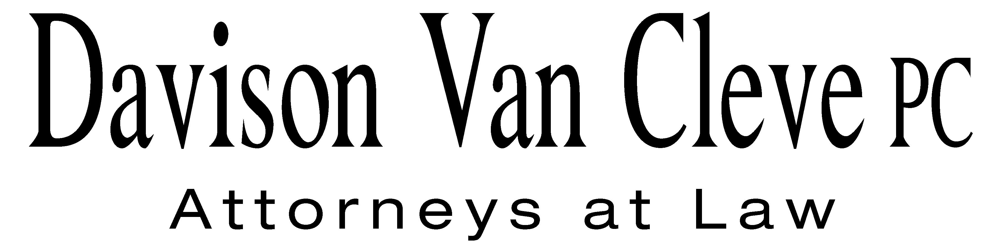
TEL (503) 241-7242 ● FAX (503) 241-8160 ● mail@dvclaw.com
Suite 400
333 S.W. Taylor
Portland, OR 97204

April 21, 2006

Via Federal Express and Electronic Mail

Carole J. Washburn
Secretary
Washington Utilities & Transportation Commission
1300 S. Evergreen Park Drive S.W.
Olympia, WA 98504

Re: In the Matter of Avista Corporation for Continuation of the Company’s Energy Recovery Mechanism, with Certain Modifications

Docket No. UE-060181

Dear Ms. Washburn:

Enclosed please find the following documents on behalf of the Industrial Customers of Northwest Utilities in the above-referenced matter:
- the original and 13 copies of the Direct Testimony of Randall J. Falkenberg; and
- the original and 13 copies of the Direct Testimony of Michael P. Gorman.
Electronic copies were provided to the Records Center today, April 21, 2006. If you have any questions you can reach me at (503) 241-7242. Please return one file-stamped copy of each document in the self-addressed, stamped envelope provided. Thank you for your assistance.
Sincerely yours,

/s/ Ruth A. Miller
Ruth A. Miller

Enclosures
cc: Service List
CERTIFICATE OF SERVICE

I hereby certify that I have this day served a copy of the foregoing Direct Testimonies of Randall J. Falkenberg and Michael P. Gorman on behalf of the Industrial Customers of Northwest Utilities upon the parties, shown below, listed on the official service list in Docket No. UE-060181, by causing the same to be mailed, postage-prepaid, through the U.S. Mail, as well as electronic copies provided via email.
DATED at Portland, Oregon, this 21st day of April, 2006.
Davison Van Cleve, P.C.

/s/ Ruth A. Miller
Ruth A. Miller

Kelly Norwood  David Meyer  Avista Corporation  PO Box 3727  Spokane, WA 99220 | Simon ffitch  Office of the Attorney General  Public Counsel Section  900 4th Avenue, Suite 2000  Seattle, WA 98164
Greg J. Trautman
Washington Utilities & Trans. Comm'n
1400 S. Evergreen Park Drive S.W.
PO Box 40128
Olympia, WA 98504

