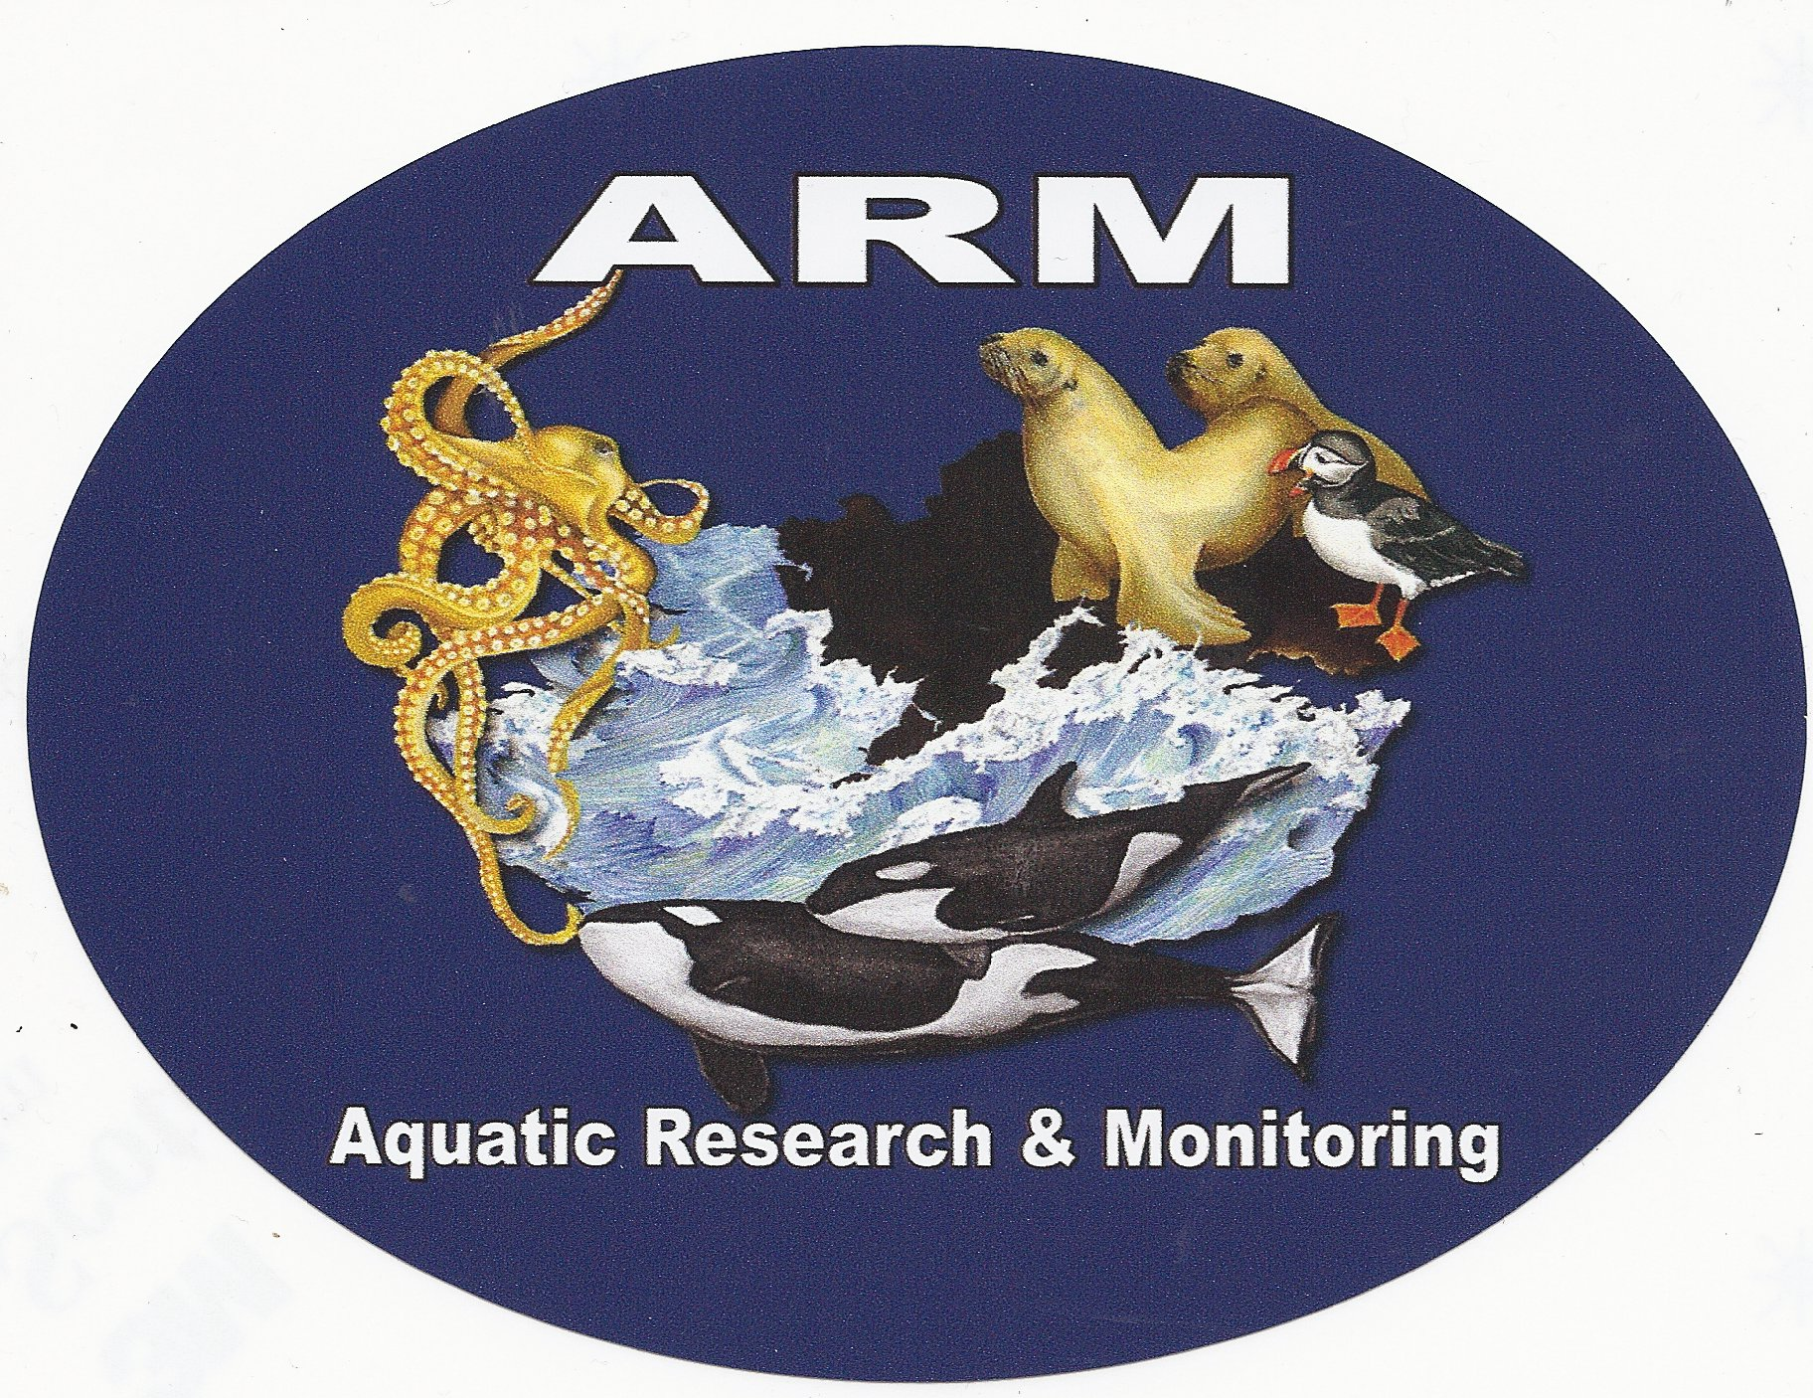

Aquatic Research & Monitoring

December 21, 2012

David Danner, Executive Director and Secretary
Washington Utilities and Transportation Commission
Attention: Judge Adam Torem, License services, Penny Ingram, Michael Fassio
PO Box 47250
1300 S. Evergreen Park Dr. SW
Olympia, WA 98504-7250

Re: Witness list for, Docket TS-121253

Dear Mr. Danner,

Enclosed please find an original and six (6) copies of Island Mariners Cruises witness list. Please feel free to contact me with any questions you may have.

Sincerely,

Terry Buzzard

