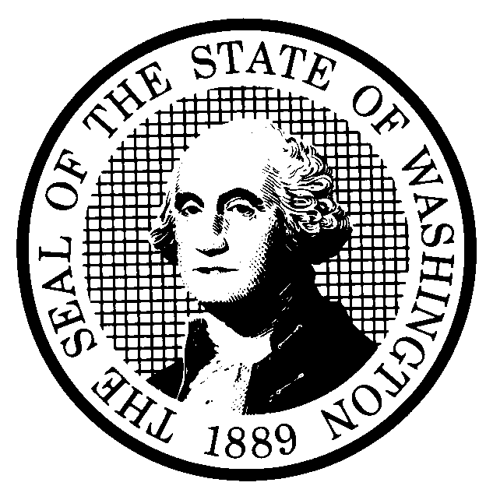 | PROPOSED RULE MAKING  (RCW 34.05.320) |  |  |  |  |  |  |  |  | CR-102 (7/22/01)  Do NOT use for expedited  rule making
Agency: Washington Utilities & Transportation Commission |  |  |  |  |  |  |  |  |  | X Original Notice
X Preproposal Statement of Inquiry was filed as WSR 01-10-047; or  Expedited Rule Making -- Proposed notice was filed as WSR ; or  Proposal is exempt under RCW 34.05.310(4). |  |  |  |  |  |  |  |  |  | Supplemental Notice  to WSR  Continuance of WSR
- Title of rule: Pipeline Safety Fee Methodology, WAC 480-93-240 and WAC 480-75-240.
- Docket No. UG-010522

Purpose: The purpose of this proposal is to implement Section 2, Chapter 238, Laws of 2001, which requires the Washington Utilities and Transportation Commission to establish by rule the methodology for setting the regulatory fee for each jurisdictional pipeline operator to fund the pipeline safety program.

Other identifying information:

- Statutory authority for adoption: RCW 80.01.040, RCW 80.04.160, and Chapter 238, Laws of 2001. |  |  |  |  |  |  |  |  | Statute being implemented: Section 2, Chapter 238, Laws of 2001
(c) Summary: See (j)

Reasons supporting proposal: See (j)

(d) Name of Agency Personnel Responsible for: |  |  |  |  |  | Office Location |  |  |  |  | Telephone
1. Drafting. Sondra Walsh, Senior Policy Strategist |  |  |  |  |  | 1300 S. Evergreen Park Dr. SW, Olympia, WA 98504 |  |  |  |  | 360-664-1286
2. Implementation.... Carole Washburn, Secretary evergreen Pk. Dr. SW; Olympia, WA 985204 |  |  |  |  |  | 1300 S. Evergreen Park Dr. SW, Olympia, WA 98504 |  |  |  |  | 360-664-1174
3. Enforcement.......... Carole Washburn, Secretary; 1300 S. Evergreen Pk. Dr. SW; Olympia, WA 98504 |  |  |  |  |  | 1300 S. Evergreen Park Dr. SW, Olympia, WA 98504 |  |  |  |  | 360-664-1174
(e) Name of proponent (person or organization):  Washington Utilities and Transportation Commission |  |  |  |  |  |  |  |  |  |  | Private  Public  X Governmental
(f) Agency comments or recommendations, if any, as to statutory language, implementation, enforcement and fiscal matters:
None

(g) Is rule necessary because of:  Federal Law?  Federal Court Decision?  State Court Decision? |  | Yes  Yes  Yes |  |  | X No  X No  X No |  | If yes, ATTACH COPY OF TEXT  Citation:
(h) HEARING LOCATION: |  |  |  |  |  |  |  | Submit written comments to:
Commission Hearing Room  2nd Floor; Chandler Plaza Building  1300 S. Evergreen Pk. Dr. SW  Olympia, WA 98504-7250 |  |  |  |  |  |  |  | Carole J. Washburn, Secretary; P.O. Box 47250,  Olympia, WA 98504-7250 or E-mail to  records@wutc.wa.gov. Please include Docket No.  UG-010522 in your communication.  FAX (360) 586-1150 By October 24, 2001
Date: November 16, 2001 Time: 9:30 a.m. |  |  |  |  |  |  |  | DATE OF INTENDED ADOPTION: November 16, 2001
Assistance for persons with disabilities: Contact Mary DeYoung  by Wednesday, November 14, 2001. |  |  |  |  |  |  |  | CODE REVISER USE ONLY
TDD (360) 586-8203 or (360) 664-1133
NAME (TYPE OR PRINT)

Carole J. Washburn
SIGNATURE

TITLE  Secretary |  |  | DATE  September 28, 2001
(COMPLETE REVERSE SIDE)
(j) Short explanation of rule, its purpose, and anticipated effects:

This proposal would implement the legislative requirements of Section 2, Chapter 238, Laws of 2001. Section 2, Chapter 238, Laws of 2001 requires the Commission to establish by rule the methodology for collection of the appropriate fees from each pipeline operator to fund the pipeline safety program. The methodology will provide for an equitable distribution of pipeline safety program costs among all companies subject to the fee.

Does proposal change existing rules? | YES X NO | If yes, describe changes:
(k) Has a small business economic impact statement been prepared under chapter 19.85 RCW?
Yes. Attach copy of small business economic impact statement.
A copy of the statement may be obtained by writing to:

telephoning: ( )
faxing: ( )
X No. Explain why no statement was prepared

Chapter 19.85 RCW does not apply to the adoption of rules that set or adjust fees or rates pursuant to legislative standards. RCW 19.85.025(2), RCW 34.05.310(4)(f).

(l) Does RCW 34.05.328 apply to this rule adoption? Yes X No
Please explain:

The Commission is not an agency to which RCW 34.05.328 applies. The proposed rules are not significant legislative rules as referenced in RCW 34.05.328(5).

