BEFORE THE WASHINGTON UTILITIES AND TRANSPORTATION COMMISSION

In the Matter of the Joint Application of  QWEST COMMUNICATIONS INTERNATIONAL INC. AND CENTURYTEL, INC.  For Approval of Indirect Transfer of Control of Qwest Corporation, Qwest Communications Company LLC, and Qwest LD Corp. |  | DOCKET NO. UT-100820  QWEST’S AND CENTURYLINK’S REQUEST FOR IN CAMERA REVIEW  OF HIGHLY SENSITIVE DOCUMENTS AND REQUEST FOR ORAL ARGUMENT
- Pursuant to WAC 480-07-420 Joint Applicants herby request that the Administrative Law Judge conduct an in camera review of select documents provided by Joint Applicants in response to WUTC Staff Data Request 2-13. The documents consist of highly sensitive material prepared and submitted to the Federal Trade Commission and the U.S. Department of Justice in compliance with requirements set forth in the Hart-Scott-Rodino Antitrust Improvements Act of 1976 (the “HSR Documents”). Joint Applicants are seeking in camera review of some of the most highly sensitive HSR Documents (referred to herein as the “Select HSR Documents”).
- The Select HSR Documents are indentified on Attachment 1 (CenturyLink’s Select HSR Documents) and Attachment 2 (Qwest’s Select HSR Documents) to this pleading. The Select HSR Documents have to date been provided only to WUTC Staff and Public Counsel. The remainder of the HSR documents that are responsive to Staff DR 2-13 have been provided to all parties who have met the requirements of Order No. 1 with respect to access to Highly Confidential material.
- WAC 480-07-420 provides that a presiding officer may establish just terms and conditions for the conduct of discovery “if the commission denies a motion for a protective order in whole or in part.” On August 3, 2010 in Order No. 8, the Commission denied the motion of the Joint Applicants seeking to supplement the protective order to provide more restricted disclosure of highly sensitive materials including the Select HSR Documents. Order No. 8 clearly constituted the Commission’s denial of a protective order “in whole or in part.” Therefore the presiding officer’s authority and discretion to establish just terms and conditions for discovery in the face of denial of a protective order has been triggered.
- Joint Applicants hereby request that the ALJ conduct an in camera review of the Select HSR Documents. Only in this way can the presiding officer properly determine what terms and conditions applicable to discovery of this material are “just” as that term is used in WAC 480-07-420. The Commission’s ruling in Order No. 8, did, in a broader sense, address protective order provisions that would be applicable to highly confidential materials including the Select HSR Documents. However, that ruling was arrived at without the benefit of the ALJ having access to or reviewing the Select HSR Documents themselves.
- Joint Applicants submit that only by actually directly reviewing those documents can the ALJ and the Commission fully grasp the extreme competitive sensitivity of information contained in those documents. Upon such review, Joint Applicants submit that it will become evident that the Select HSR Documents contain information that exceeds the level of sensitivity in documents heretofore exchanged in Commission regulatory proceedings and subject to prior Commission protective orders.
- The CenturyLink Select HR Documents, among other things, include marketing and product information that is more detailed and therefore more competitively sensitive than information disclosed in other dockets. For example Document #23 in CenturyLink’s list of Select HSR Documents (Attachment 1) contains competitively sensitive data regarding the financial assumptions and projected market rollout of IPTV offerings. The information is so detailed that it includes specific roll-out dates at specific locations. IPTV is an extremely competitive service offering and this type of information would be highly valuable to CenturyLink’s competitors. Consequently, even an inadvertent disclosure of such information would be highly damaging to CenturyLink.
- The Qwest Select HSR Documents include, among other things, information concerning evaluation of potential transactions with other third parties unrelated to this transaction. For example, Document #37 in Qwest’s list of Select HSR Documents (Attachment 2) evaluates a transaction opportunity with a specific third party entity (Table of Contents – third item, and second bullet on page two of the document identify that third party entity). The document contains a very detailed analysis of the value of the third party entity to Qwest based on specific financial factors and projections and establishes a potential acquisition price (see e.g. pages 22 – 33, 49 – 51, and 57). This information is extremely sensitive and even an inadvertent disclosure would be very damaging to Qwest and the unidentified third party. Obviously this type of sensitive information concerning the valuation of an outside third party entity has no relevance to any issue that any intervenor could properly raise in this docket.
- Joint Applicants will not attempt in this pleading to present arguments on a document by document basis concerning the degree of sensitivity inherent in these documents, when the documents tend to best speak for themselves (which of course they can only do if they are reviewed by the ALJ).
- Further, review of these documents will show that in addition to their competitively sensitive nature, they are not relevant to any issues that any intervenors in this docket have raised, or even could properly raise. As the Commission noted in Order No. 8, the HSR Documents were filed with the Federal Trade Commission and the Department of Justice for the specific purpose of allowing those agencies to conduct a review of the merger under the Hart-Scott-Rodino Antitrust Improvement Acts of 1976. (Order No. 8 at footnote 1) The FTC and DOJ have completed their review and have effectively signed-off on the merger. Therefore the HSR documents have served their very specific and limited purpose. They have no relevance to issues that intervenors have or could properly raise in this docket. Such lack of relevance makes production of these documents particularly onerous to the Joint Applicants, as the risk of even inadvertent disclosure is increased every time they are produced. The extreme competitive sensitivity of the Select HSR Documents and the damage that would arise from even an inadvertent disclosure completely outweighs any benefit that might be gained by disclosing them outside of the Commission, its Staff and Public Counsel. Because they are not relevant to any issues that can be properly raised by intervenors, there is in fact no benefit to be gained by disclosing them to representatives of Joint Applicants’ competitors.
- Joint Applicants submit that upon in camera review of the documents it will become evident that the only “just” terms and conditions that should apply to discovery of these documents would be to completely restrict any further distribution beyond the WUTC Staff and Public Counsel. Therefore the Joint Applicants respectfully request that the ALJ conduct an in camera review of the Select HSR Documents and establish any other procedural steps that might assist in the identification and application of “just” terms and conditions to the discovery of these materials in the face of denial of a protective order as provided for in WAC 480-07-420.
- Joint Applicants ask the ALJ to schedule an in-person hearing session to review the documents and hear argument on these issues.
- Respectfully submitted September 2, 2010
CENTURYLINK QWEST
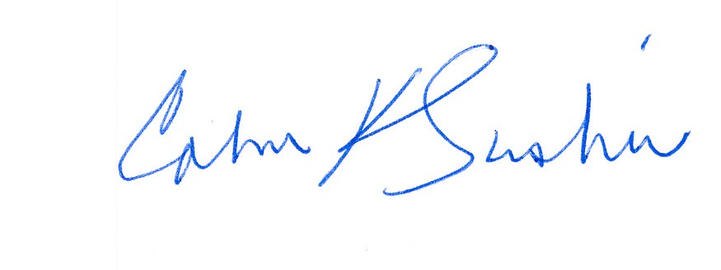
__________________________ ___________________________
Calvin K. Simshaw Lisa A. Anderl (WSBA # 13236)
CenturyLink Qwest Law Department
805 Broadway 1600 – 7th Ave., room 1506
Vancouver, WA 98660 Seattle, WA 98191
calvin.simshaw@centurylink.com lisa.anderl@qwest.com

To date, Joint Applicants have not provided the Select HSR Documents to any party in any of jurisdictions reviewing the merger transaction other than commission staffs and statutorily authorized public counsels.
The final paragraph of WAC 480-07-420 states: “The presiding officer may order that any party or person provide or permit discovery on such terms and conditions as are just, if the commission denies a motion for a protective order in whole or in part.”
Joint Applicants note that following the issuance of Order No. 8 the parties did engage in discussions in an attempt to work out conditions that would specifically apply to the Select HSR Documents. Although the parties exchanged proposals, they were ultimately unable to reach agreement in this area.
In addition to an in camera review Joint Applicants request that the ALJ arrange to take argument or comment on the appropriate treatment of the Select HSR Documents. Joint Applicants acknowledge that some accommodation would have to be made to allow outside counsel for intervening parties to have some form of restricted access to the documents in order to prepare arguments or comments as to their treatment. Joint applicants would be willing to provide such limited inspection, with no notes or copies permitted.

