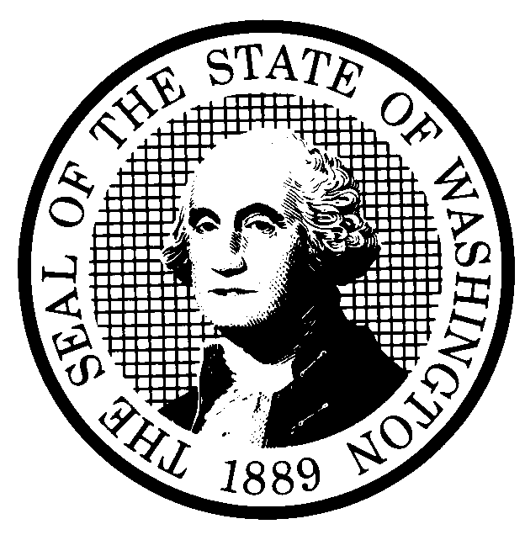 | PROPOSED RULE MAKING |  |  |  |  | CR-102 (June 2004)  (Implements RCW 34.05.320)  Do NOT use for expedited rule making
Agency: Washington Utilities and Transportation Commission
Preproposal Statement of Inquiry was filed as WSR as WSR #07-09-104; or  Expedited Rule Making--Proposed notice was filed as WSR ; or  Proposal is exempt under RCW 34.05.310(4). |  |  |  |  |  |  | Original Notice  Supplemental Notice to WSR  Continuance of WSR
Title of rule and other identifying information: Chapter 480-15 WAC – Household goods carriers, Docket TV-070466.
Hearing location(s):  Commission Hearing Room 206  Second Floor, Richard Hemstad Building  1300 S. Evergreen Park Drive SW  Olympia, WA 98504-7250 |  |  |  | Submit written comments to:  Name: Washington Utilities and Transportation Commission  Address: 1300 S. Evergreen Park Drive S.W.  PO Box 47250  Olympia, WA 98504-7250  e-mail records@utc.wa.gov. Please, include: “Docket  TV-070466” in your comments.  fax (360) 586-1150 by (date) November 19, 2007
Date: December 12, 2007 Time: 1:30 PM |  |  |  | Assistance for persons with disabilities: Contact  Mary De Young by December 10, 2007  TTY (360) 586-8203 or (360) 664-1133
Date of intended adoption: December 12, 2007
(Note: This is NOT the effective date)
Purpose of the proposal and its anticipated effects, including any changes in existing rules:
The current rules in WAC 480-15 went into effect in January 1999, after the federal government made extensive changes to the trucking industry. Changes in the industry over the past seven years, as well as our experience with the current rules, tells us we are now in a position to streamline the rules, providing greater flexibility for companies and less regulatory oversight by the UTC while still maintaining important consumer protections. The proposed rules streamline and clarify chapter 480-15 WAC.

Reasons supporting proposal:
The proposed rules:
- Simplify rules where possible.
- Update rules to accommodate current technology (i.e., computer-based estimates).
- Align rules more closely with the federal interstate household goods carrier rules where reasonable.
- Eliminate prescriptive language to allow more flexibility.
- Maintain consumer protection.
Statutory authority for adoption: RCW 80.01.040, RCW 81.04.160, RCW 81.04.250, RCW 81.28.040, RCW 81.80.120, RCW 81.80.130, and RCW 81.80.290 |  |  |  | Statute being implemented:  N/A
Is rule necessary because of a:  Federal Law?  Federal Court Decision?  State Court Decision?  If yes, CITATION: |  | Yes  Yes  Yes | No  No  No |  | Filed with the Code Reviser’s Office  October 24, 2007, 10:09 a.m.  WSR 07-21-148
DATE
October 24, 2007
NAME (type or print)
Carole J. Washburn
SIGNATURE

TITLE
Executive Secretary

(COMPLETE REVERSE SIDE)
Agency comments or recommendations, if any, as to statutory language, implementation, enforcement, and fiscal matters:

None.

Name of proponent: (person or organization) Washington Utilities and Transportation Commission |  |  | Private  Public  Governmental
Name of agency personnel responsible for:
 | Name | Office Location | Phone
Drafting............... Vicki Elliott |  | 1300 S. Evergreen Pk Drive SW, Olympia, WA 98504 | (360) 664-1119
Implementation.... Carole J. Washburn |  | 1300 S. Evergreen Pk Drive SW, Olympia, WA 98504 | (360) 664-1174
Enforcement........Carole J. Washburn |  | 1300 S. Evergreen Pk Drive SW, Olympia, WA 98504 | (360) 664-1174
Has a small business economic impact statement been prepared under chapter 19.85 RCW?
Yes. Attach copy of small business economic impact statement.

A copy of the statement may be obtained by contacting:
Name:
Address:

phone ( )
fax ( )
e-mail
No. Explain why no statement was prepared.

The proposed rules will not result in or impose more than minor costs. Because there will not be more than minor increase in costs resulting from the proposed rule changes, a SBEIS is not required under RCW 19.85.030(1).

Is a cost-benefit analysis required under RCW 34.05.328?

Yes A preliminary cost-benefit analysis may be obtained by contacting:
Name:
Address:

phone ( )
fax ( )
e-mail

No: Please explain:

The Commission is not an agency to which RCW 34.05.328 applies. The proposed rules are not significant legislative rules of the sort referenced in RCW 34.05.328 (5).

