THURSTON COUNTY DEPARTMENT OF COMMUNICATIONS “CAPCOM”
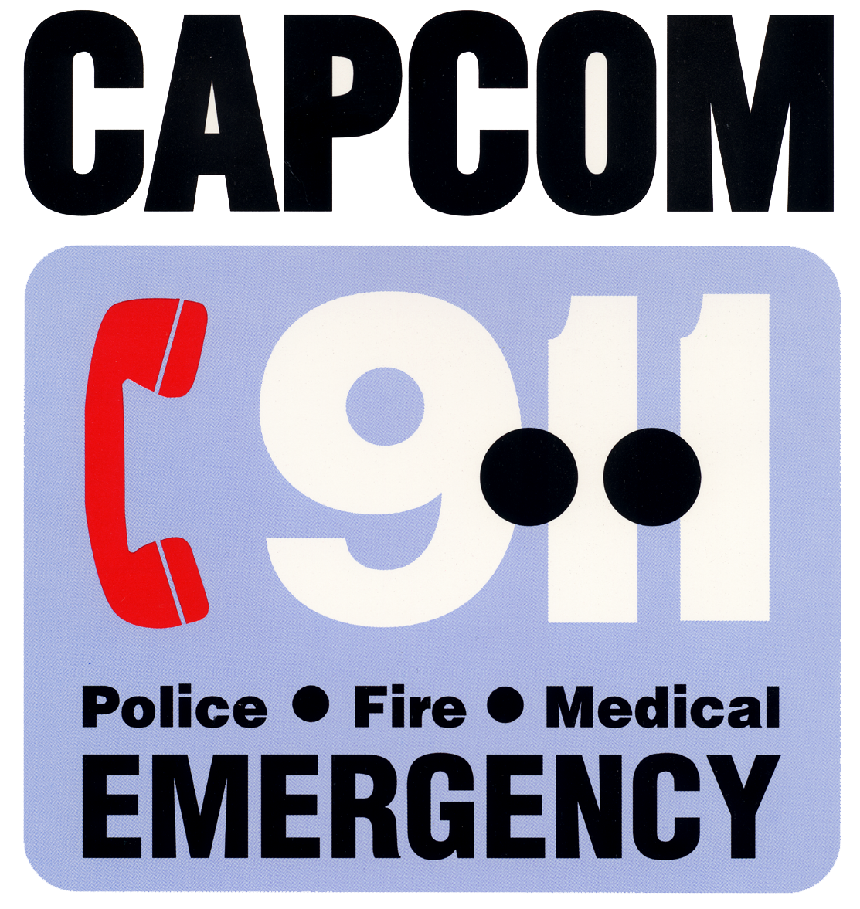
2703 Pacific Avenue SE
Olympia, WA 98501
Bus. (360) 704-2730
Fax (360) 704-2723

To: Washington Utilities & Transportation Committee
P.O. Box 47250
Olympia, WA 98504

From: James C. Quackenbush, Director
Thurston County Department of Communications/9-1-1
2702 Pacific Ave SE Suite A
Olympia, WA 98501

Date: February 2, 2005

Re: Docket # UT-041629

UTC Subject: E911 obligations of local exchange companies and amendment of WAC 480-120-450 to establish a uniform demarcation point in the E9-1-1 network for carrier cost recovery.

Comments on behalf of Thurston County 9-1-1:

Thurston County supports the amendment to WAC 480-120-450, creating a uniform demarcation point in the E9-1-1 network, thus establishing a method of cost allocation between local exchange carriers and the PSAP that has parity with the wireless carriers. As new technologies emerge that provide access to 9-1-1 systems, it is critical to have a clearly identified point of demarcation for cost allocations associated with cost recovery.

A change to WAC 480-120-450 would also assist in stabilizing 9-1-1 operational costs associated with connectivity funding. Revenues from wireline taxes are leveling out and anticipated to decrease in the near future. VoIP currently does not offer any financial support for the 9-1-1 system while requiring services be offered. This is unlike what has been legislatively enacted and the WUTC approves annually for traditional telephone service excise tax. A clear line of demarcation for all 9-1-1 service providers would greatly assist counties in planning for future costs and ensuring funding is available for the connectivity from the selective router to the PSAP.

cc: file

