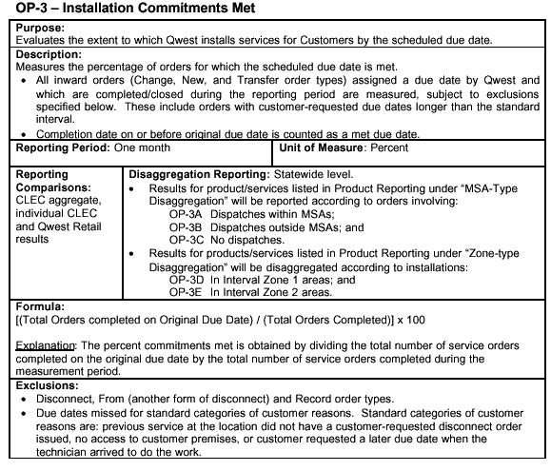

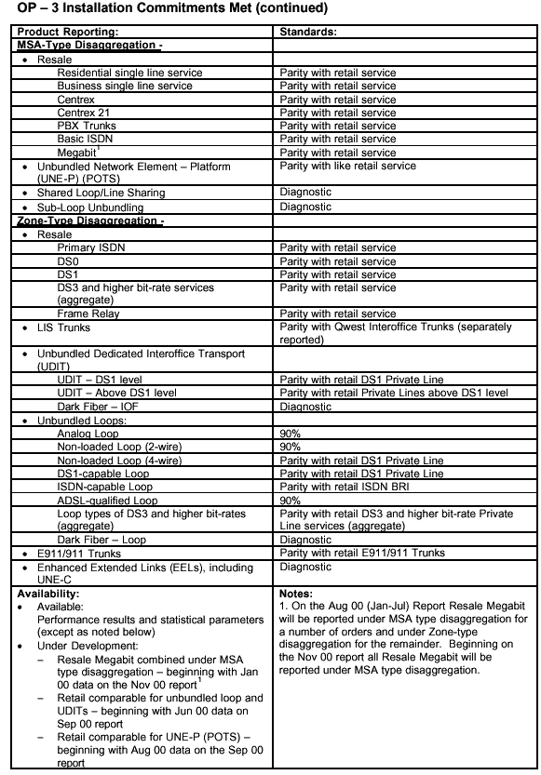
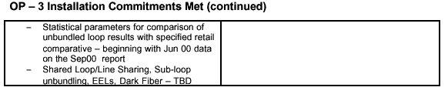

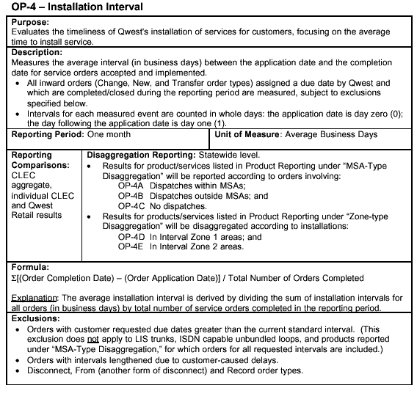

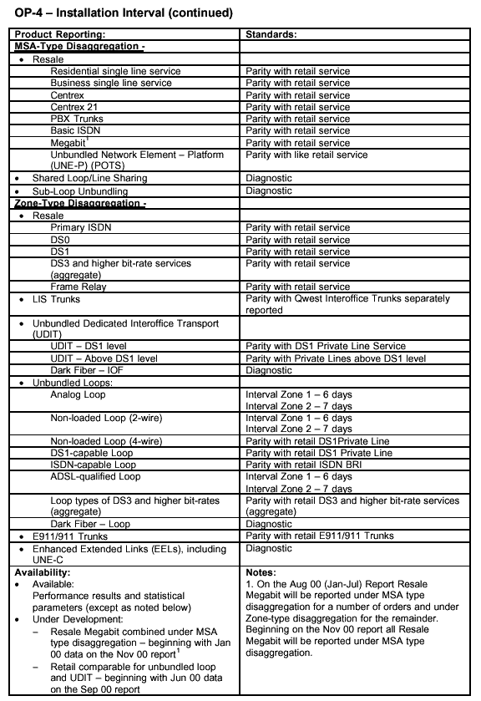

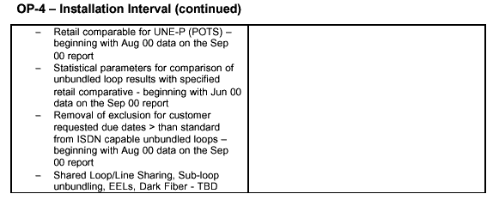

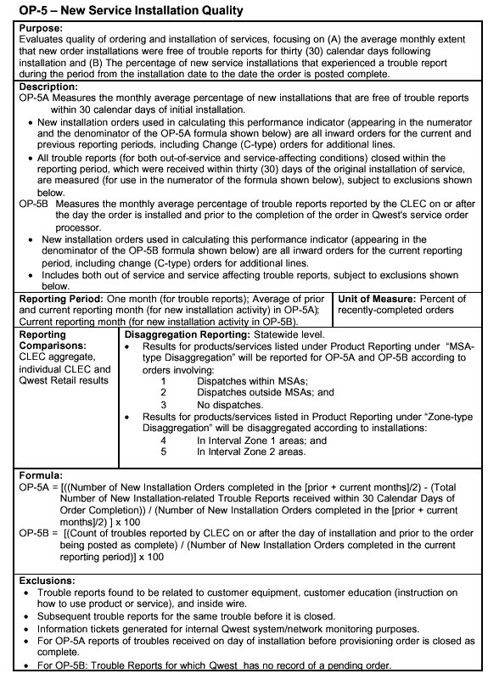
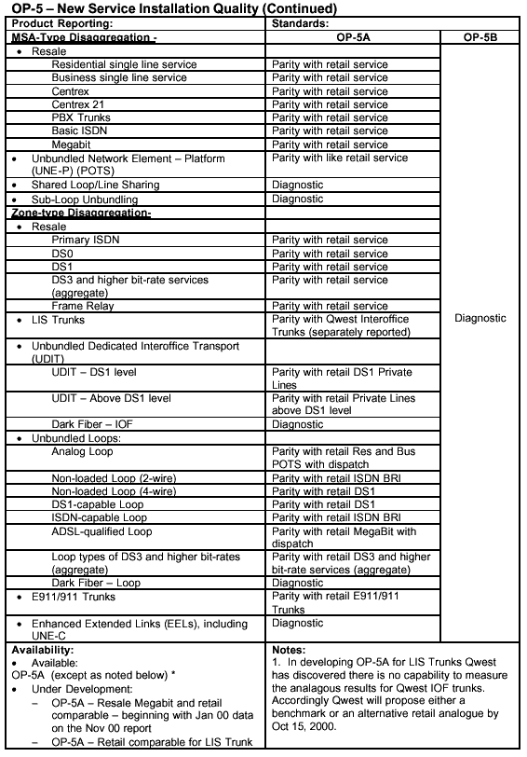

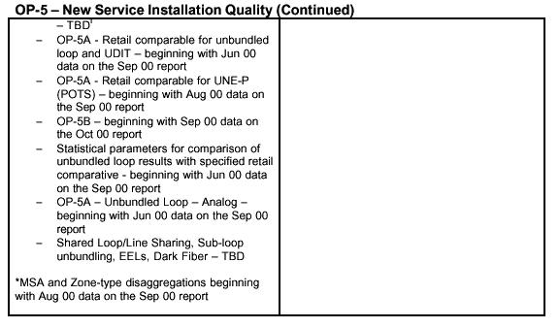

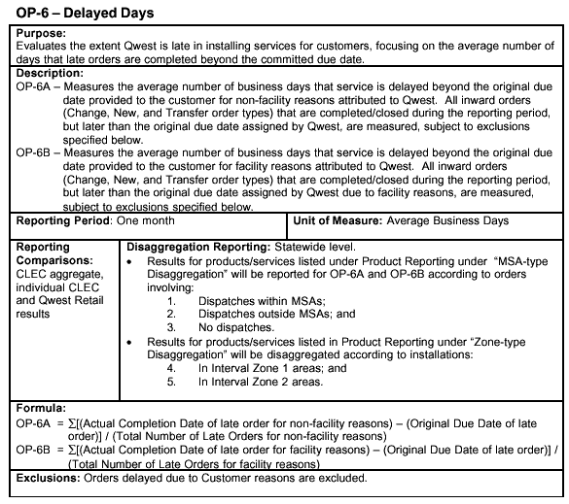

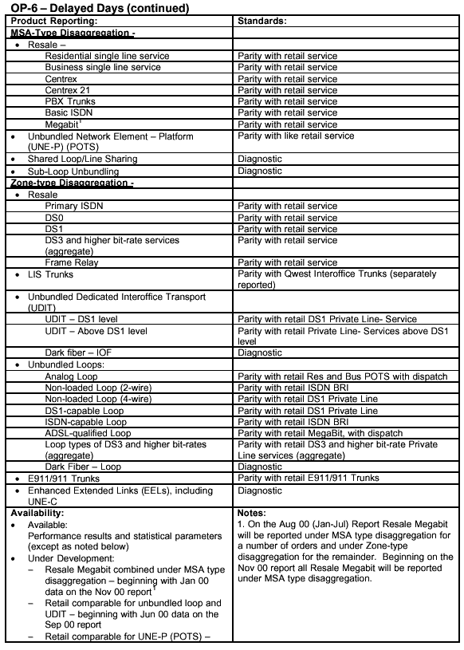

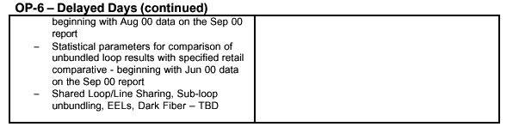

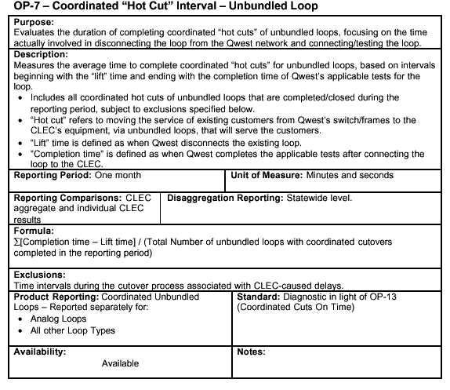

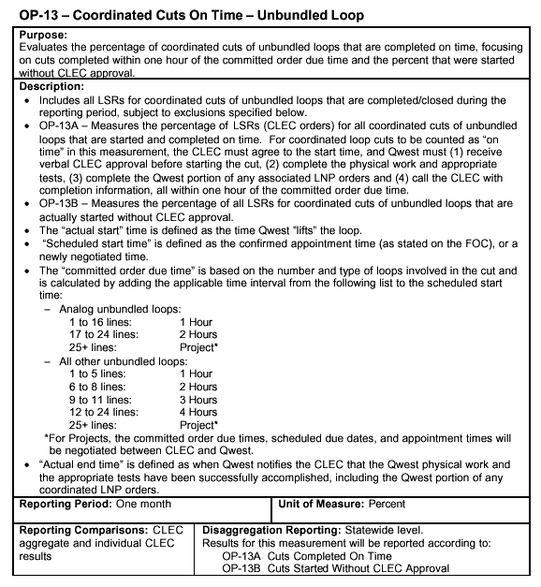

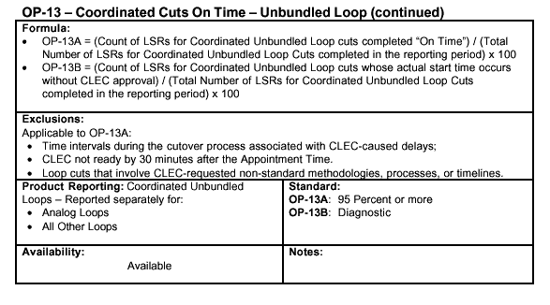
OP-15 - Interval for Pending Orders Delayed Past Due Date
Purpose:
Evaluates the extent to which U S WEST's pending orders are late, focusing on the average number of days the pending orders are delayed past the due date, as of the end of the reporting period.
Description:
OP-15A – Measures the average number of business days that pending orders are delayed beyond the original due date for reasons attributed to Qwest.
* Includes all pending inward orders (Change, New, and Transfer order types) for which the original due date assigned by Qwest has been missed, subject to exclusions specified below. Change order types for additional lines consist of all C orders with “I” and “T” action coded line USOCs, including changes to existing lines, such as conversions, number changes, PIC changes and class of service changes.
OP-15B – Reports the number of pending orders measured in the numerator of OP-15A that were delayed for Qwest facility reasons.
Reporting Period: One Month | Unit of Measure: (Average Days)
Reporting Comparisons: CLEC aggregate, individual CLEC,  Qwest retail | Disaggregation Reporting: Statewide level
Formula:
OP-15A Sum[(Last Day of Reporting Period) - (Original Due Date of Late Pending Order)] / (Total Number of Pending Orders Delayed as of the last day of Reporting Period)
OP-15B -Count of pending orders measured in numerator of OP-15A that were delayed for Qwest facility reasons.
Exclusions:
* Pending orders delayed due to Customer reasons are excluded.
* Disconnect, From (another form of disconnect)and record order types.
* Records involving official company services.
* Records with invalid due dates, or application dates.
* Records with invalid completion dates.
* Records with invalid product codes.
* Records missing data essential to the calculation of the measurement per the PID.
Standard: | Products:
Standard: | Business | 1841
Standard: | Centrex | 1842
Standard: | DS0 | 1793
Standard: | DS1 | 1794
Standard: | DS3 | 1795
Standard: | E911 | 1796
Standard: | Frame Relay | 1797
Standard: | ISDN Primary | 1798
Standard: | LIS Trunk | 1800
Standard: | PBX | 1844
Standard: | Residence | 1840
Standard: | UBL - Analog | 1807
Standard: | UBL ISDN Capable | 1809
Standard: | UDIT DS1 | 1810
Standard: | UDIT Above DS1 Level | 1811
Standard: | UDIT | 1812
Standard: | Megabit | 1846
Standard: | Basic Rate ISDN | 1799
Standard: | Centrex 21 | 1843
Standard: | UBL - 2 Wire Analog | 1803
Standard: | UBL - 2 Wire Non-Loaded | 1805
Standard: | UBL - ADSL Qualified | 1802
Standard: | UBL - 4 Wire Non-Loaded | 1806
Standard: | UBL - DS1 Capable | 1808
Standard: | UBL - 4 Wire Analog | 1804
Standard: | UBL - DS3 Capable | 1813
Standard: | UNE - P (POTS) | 1847
Standard: | Basic Rate Designed ISDN | 1845
Standard: | UBL Analog | 1814
Standard: | Line Sharing | 2051
Standard: | UBL - Feeder Loop | 2104
Standard: | UBL - Distribution Loop | 2105
Standard: | Enhanced Extended Links - DS0 Capable | 2106
Standard: | Enhanced Extended Links - DS1 Capable | 2107
Standard: | Enhanced Extended Links - DS3 Capable | 2108
Standard: | Dark Fiber - IOF | 2132
Standard: | Dark Fiber - Loop | 2133
Standard: | Sub-Loop Unbundling | 2157
Standard: | Enhanced Extented Links (EELs) | 2158
Availability: Available (except as noted below)
Under Development:
- Shared Loop/Line Sharing - beginning with Dec 00 data on the Jan 01 report.
- Sub-loop unbundling - beginning with Jan 01 data on the Feb 01 report.
- EELs - TBD
- Dark Fiber - beginning with Jan 01 data on the Feb 01 report.
Notes:

