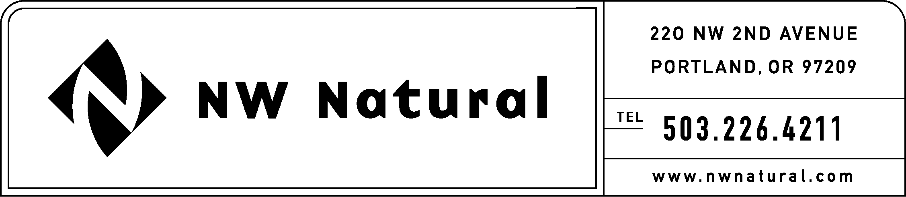

Rates and Regulatory Affairs
Facsimile: 503.721.2516

May 13, 2010

Dave Danner, Executive Director & Secretary
Washington Utilities and Transportation Commission
1300 S Evergreen Park Drive SW
Post Office Box 47250
Olympia, Washington 98504-7250

Re: U-100522, Supplemental Information
History of NW Natural’s Decoupling Mechanism in Oregon

Dear Mr. Danner:

Northwest Natural Gas Company, dba NW Natural (“NW Natural” or the “Company”), hereby supplements docket U-100522 with the following history of the Company’s decoupling mechanism applicable in the Company’s Oregon service territory.

On May 31, 2001, NW Natural filed Advice No. 01-10, which requested the implementation of full revenue-per-customer, weather-normalized decoupling and a public purpose charge. This filing was docketed as UG 143 and was repeatedly suspended for investigation.

On August 30, 2002, NW Natural signed a stipulation with interested parties that was adopted by Commission Order No. 02-634, issued September 12, 2002, and which is hereto attached. This agreement allowed NW Natural to pilot decoupling for three years. The Company was authorized to defer ninety percent of the distribution margin differential. The mechanism included price elasticity but did not include weather normalization.

Approval of decoupling was contingent upon: 1) the adoption of a public purpose charge; 2) the transfer of utility administered energy efficiency programs to a third party; 3) the application of service quality measures including an annual customer service performance metric and annual reporting requirements; 4) an agreement to file a rate case; and 5) a commitment to hire an independent contractor to assess the decoupling mechanism after three years.

NW Natural filed a rate case on November 29, 2002, which was docketed as UG 152. This rate case filing included a weather normalization adjustment schedule entitled WARM (Weather-Adjusted Rate Mechanism). WARM is a real-time annual adjustment applied to residential and commercial customers’ bills between December 1 through May 15. WARM was approved by Commission Order No. 03-507, issued on August 22, 2002, with the provision that customers could opt-out of the mechanism. The annual adjustments are limited for residential customers to no more than the lesser of either $12 or 25% of the usage portion of the bill, and for commercial customers, the lesser of either $35 or 25% of the usage portion of the bill.

In April 2005, Christensen prepared the attached evaluation of NW Natural’s decoupling mechanism. Christensen concluded that the mechanism effectively reduced the variability of distribution revenues, but recommended that full decoupling be adopted, or rather, that the Company be allowed to defer 100% of the distribution margin differential.

NW Natural filed Advice No, 05-9, which revised the decoupling mechanism in accordance with Christenson’s recommendation. Commission Order No. 05-934 approved the change, allowing the Company to defer 100% of the distribution margin differential. This change better aligned the decoupling mechanism with WARM.

On October 19, 2005, NW Natural filed Christenson’s independent review of the WARM program. Christenson found that WARM effectively reduces the variability of fixed costs, but they concluded the program is confusing to customers. Because of this, they recommended that participation be mandatory; this recommendation was not adopted.

Attached hereto is Commission Order No. 07-426, issued September 26, 2007, which extended NW Natural’s Decoupling and WARM tariffs until October 31, 2012. This extension was coupled with NW Natural’s agreeing to a rate moratorium until September 1, 2011.

At the Commission’s May 4, 2010, workshop for the subject docket, Northwest Industrial Gas Users (NWIGU) stressed the importance of understanding the larger regulatory context in which the Company’s decoupling mechanism is applied: The Oregon Commission requires an earnings review that is performed each spring for each local distribution company (LDC), described in attached Order No. 08-504. The earnings threshold applied to each fiscal year’s results corresponds to the sharing election made by the LDC the previous August, for the following Purchased Gas Adjustment (PGA) Year, as described below, e.g., the August 2008 election will apply to the 2009 Fiscal Year results which are the subject of the 2010 earnings review.

The sharing elections available are as follows (with the exception of Cascade Natural Gas Company):

1. Sharing Election 1--LDCs may choose to share at 67/33, where the earnings threshold is set at 175 basis points (bp) of return-on-equity (ROE) (as determined in the LDC’s last rate case), further modified by 20 percent of any change in the risk free rate for the 12 month calendar year preceding the annual earnings review.

2. Sharing Election 2--LDCs may choose to share at 80/20, where the earnings threshold will be set at 150 bp of ROE, further modified by 20 percent of any change in the risk free rate for the 12 month calendar year preceding the annual earnings review.

3. Sharing Election 3--LDCs may choose to share at 90/10, where the earnings threshold will be set at 100 bp of ROE, further modified by 20 percent of any change in the risk free rate for the 12 month calendar year preceding the annual earnings review.

The sharing percentages for earnings above the threshold are adjusted to account for the impact of Senate Bill 408. Based on current federal and state tax rates, the customers of LDCs subject to SB 408 will receive 20 percent of earnings above the threshold. It is within this context that the Company is prevented from over earning through its decoupling mechanism.

Regarding the Company’s third party administrator of energy efficiency programs, the Energy Trust of Oregon is a non-profit organization that was established as a result of Oregon electric restructuring legislation, adopted in 1999. The Energy Trust of Oregon began delivering energy efficiency for Oregon-based, independently-owned electric utilities in March 2002. When NW Natural was charged with finding a third party provider for energy efficiency, the Energy Trust was an obvious choice since they were already auditing our customers’ homes for the installation of efficient electric measures. Now that Energy Trust is providing both electricity and gas efficiency services, they are able to offer customers a whole house perspective.

If you have questions, please contact me at (503) 226-4211, extension 3590.

Sincerely,

NW NATURAL

/s/ Jennifer Gross

Jennifer Gross

Rates & Regulatory Affairs

A history of Docket UG 143 can be found at this site: http://apps.puc.state.or.us/edockets/docket.asp?DocketID=9074
See Article IV of Appendix A to Order No. 02-634 (attached).
A history of Docket UG 152 can be found at this site: http://apps.puc.state.or.us/edockets/docket.asp?DocketID=10209
See http://apps.puc.state.or.us/orders/2003ords/03-507.pdf

